

**MX Linux Users Manual**

**v. 20210925**

**manual AT mxlinux DOT org**

Ctrl-F = Search this Manual

Ctrl+Home = Return to top

**Translations from** [**DeepL**](https://www.deepl.com/translator)

Table of Contents

[1 Introduction 4](#__RefHeading___Toc16259_1598533455)

[1.1 About this Manual 4](#__RefHeading___Toc82209_4276181866)

[1.2 About MX Linux 5](#__RefHeading___Toc16261_1598533455)

[1.3 Get informed! 7](#__RefHeading___Toc16263_1598533455)

[1.4 Support and EOL 7](#__RefHeading___Toc16265_1598533455)

[Notes for translators 8](#__RefHeading___Toc16267_1598533455)

[2 Installation 9](#__RefHeading___Toc16269_1598533455)

[2.1 Introduction 9](#__RefHeading___Toc463_1293799291)

[2.2 Creating a bootable medium 11](#__RefHeading___Toc465_1293799291)

[2.3 Pre-Installation 15](#__RefHeading___Toc16271_1598533455)

[2.4 First look 20](#__RefHeading___Toc469_1293799291)

[2.5 The Installation process 31](#__RefHeading___Toc471_1293799291)

[2.6 Troubleshooting 37](#__RefHeading___Toc473_1293799291)

[3 Configuration 40](#__RefHeading___Toc16273_1598533455)

[3.1 Peripherals 40](#__RefHeading___Toc16275_1598533455)

[3.2 Basic MX Tools 46](#__RefHeading___Toc16277_1598533455)

[3.3 Display 61](#__RefHeading___Toc16279_1598533455)

[3.4 Network 66](#__RefHeading___Toc16281_1598533455)

[3.5 File management 74](#__RefHeading___Toc16283_1598533455)

[3.6 Sound 81](#__RefHeading___Toc16285_1598533455)

[3.7 Localization 83](#__RefHeading___Toc16287_1598533455)

[3.8 Customization 86](#__RefHeading___Toc16289_1598533455)

[4 Basic use 103](#__RefHeading___Toc16291_1598533455)

[4.1 Internet 103](#__RefHeading___Toc16293_1598533455)

[4.2 Multimedia 104](#__RefHeading___Toc16295_1598533455)

[4.3 Office 110](#__RefHeading___Toc16297_1598533455)

[4.4 Home 114](#__RefHeading___Toc16299_1598533455)

[4.5 Security 115](#__RefHeading___Toc16301_1598533455)

[4.6 Accessibility 116](#__RefHeading___Toc16303_1598533455)

[4.7 System 117](#__RefHeading___Toc16305_1598533455)

[4.8 Good practices 124](#__RefHeading___Toc16307_1598533455)

[4.9 Games 128](#__RefHeading___Toc16309_1598533455)

[4.10 Google tools 134](#__RefHeading___Toc16311_1598533455)

[4.11 Bugs, issues and requests 135](#__RefHeading___Toc16313_1598533455)

[5 Software Management 137](#__RefHeading___Toc16315_1598533455)

[5.1 Introduction 137](#__RefHeading___Toc16317_1598533455)

[5.2 Repos 138](#__RefHeading___Toc16319_1598533455)

[5.3 Synaptic 141](#__RefHeading___Toc16321_1598533455)

[5.4 Troubleshooting 146](#__RefHeading___Toc16323_1598533455)

[5.5 Other methods 147](#__RefHeading___Toc16325_1598533455)

[6 Advanced use 152](#__RefHeading___Toc16327_1598533455)

[6.1 Windows programs under MX Linux 152](#__RefHeading___Toc16329_1598533455)

[6.2 Virtual machines 153](#__RefHeading___Toc16331_1598533455)

[6.3 Alternate Window Managers 157](#__RefHeading___Toc16333_1598533455)

[6.4 Command Line 158](#__RefHeading___Toc16335_1598533455)

[6.5 Scripts 162](#__RefHeading___Toc16337_1598533455)

[6.6 Advanced MX Tools 168](#__RefHeading___Toc16339_1598533455)

[6.7 SSH 172](#__RefHeading___Toc16341_1598533455)

[6.8 Synchronization 173](#__RefHeading___Toc16343_1598533455)

[7 Under the hood 174](#__RefHeading___Toc16345_1598533455)

[7.1 Introduction 174](#__RefHeading___Toc545_951799360)

[7.2 The file system structure 174](#__RefHeading___Toc547_951799360)

[7.3 Permissions 178](#__RefHeading___Toc549_951799360)

[7.4 Configuration files 180](#__RefHeading___Toc551_951799360)

[7.5 Runlevels 181](#__RefHeading___Toc553_951799360)

[7.6 The kernel 183](#__RefHeading___Toc16347_1598533455)

[7.7 Our positions 186](#__RefHeading___Toc16349_1598533455)

[8 Glossary 188](#__RefHeading___Toc16351_1598533455)

# 1 Introduction

## 1.1 About this Manual

***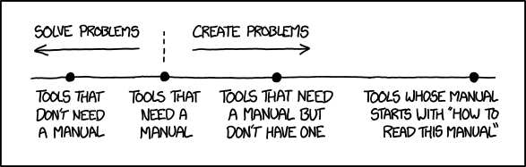***

***Figure 1-1: The \*need\* for manuals (xkcd.com)***

This Users Manual is the product of large group of volunteers from the MX Linux community. As such, it will inevitably contain errors and omissions, although we have worked hard to minimize them. Please send us feedback, corrections or suggestions using one of the methods listed below. Updates will occur as needed.

The Manual is designed to walk new users through the steps of obtaining a copy of MX Linux, installing it, configuring it to work with one’s own hardware, and putting it to daily use. It aims to provide a readable general introduction, and purposely gives preference to graphical tools when available. For detailed or infrequent topics, the user should consult the Resources or post on the Forum.

MX Fluxbox is not inluded here because it differs from Xfce and KDE so greatly that it would lengthen and complicate this Manual. A separate Help document is included with every MX Fluxbox installation.

New users may find some of the terms used in this Manual to be unfamiliar or confusing. We have tried to limit the use of difficult terms and concepts, but some are simply unavoidable. The **Glossary** located at the end of the document provides definitions and comments that will help in getting through difficult passages.

All content is © 2021 by MX Linux Inc. and released under GPLv3. Citation should read:

**MX Linux Community Documentation Project. 2021. Users Manual for MX Linux.**

Feedback:

* Email: manual AT mxlinux DOT org
* Forum: [MX Documentation and Videos](https://forum.mxlinux.org/viewforum.php?f=101)

## 1.2 About MX Linux

Users are highly varied in their attitude toward MX Linux--or any operating system. Some may just want an appliance that simply works, like a coffee pot that produces a hot drink upon demand. Others may be curious about how it actually works, i.e., why they get coffee and not some thick sludge. This section is intended to get the second group oriented. The first group might prefer to jump ahead to Section 1.3: ”Get informed!”.

MX Linux is a desktop version of the fusion of the [Gnu](https://www.gnu.org/) collection of free software and the Linux kernel, both begun in the early 1990s. [Gnu-Linux](https://en.wikipedia.org/wiki/Linux), or more simply and commonly referred to as ”Linux,” is a free and open-source Operating System that has a unique and very successful approach to everything from kernel to tools to file structure (Section 7). It is delivered to users through [distributions](https://en.wikipedia.org/wiki/Linux_distribution) or ”distros”, of which one of the oldest and most popular is [Debian](https://en.wikipedia.org/wiki/Debian) upon which MX Linux is built.

### 1.2.1 Linux

To provide a quick overview, here is a simplified diagram and description of a Linux OS, adapted from *Anatomy of the Linux kernel*.

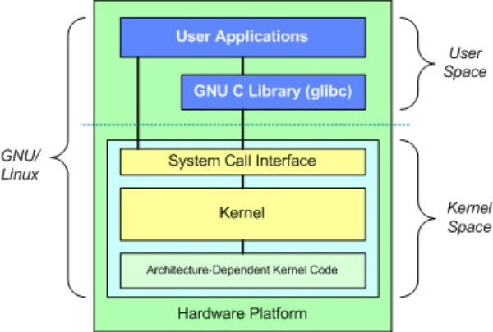

* At the top is the user space, AKA application space. This is where user applications provided by the distribution or added by the user are executed. There is also the GNU C Library (*glibc*) interface that connects applications with the kernel. (Hence the alternative name "GNU/Linux" seen in the diagram).
* Below the user space is the kernel space where the Linux kernel exists. The kernel is dominated by hardware drivers.

**File system**

One of the first problems many new Linux users struggle with is how the file system works. Many new users have looked in vain to find the C:\ drive or D:\ drive, for instance but Linux handles hard drives and other storage media differently than Windows. Rather than having a separate file system tree on every device, MX Linux has a single file system tree ( called the /root/ of the file system) which is marked “/” and contains every attached device. When a storage device is added to the system, its file system is attached to a directory or subdirectory of the file system; this is called mounting a drive or device. Also, every user has a dedicated subdirectory under **/home**, and by default this is where you would search for your own files. Details in Section 7.

Most program and system settings on MX Linux are stored in discrete plain text configuration files; there is no “Registry” which requires special tools to edit. The files are just simple lists of parameters and values that describe the behavior of programs when they launch.

**Cautions**

Brand new users come with expectations from their previous experience. This is natural, but it can lead at first to confusion and frustration. Two fundamental notions to keep in mind:

1. MX Linux is not Windows. As indicated above, there is no Registry, the C:\ drive does not exist and most drivers are already in the kernel.
2. MX Linux is not based on the Ubuntu family, but on Debian itself. This means that commands, programs and applications (especially those in “Personal Package Archives” or PPAs) from the Ubuntu family may not function correctly or even be missing.

### 1.2.2 MX Linux

MX Linux is a cooperative venture between the [antiX](https://antixlinux.com/) and former [MEPIS](https://en.wikipedia.org/wiki/MEPIS) communities first released in 2014, using the best tools and talents from each distro and including work and ideas originally created by Warren Woodford. It is a midweight OS designed to combine an elegant and efficient desktop with simple configuration, high stability, solid performance and medium-sized footprint.

Relying on the excellent upstream work by Linux and the open-source community, with MX-21 we deploy with our flagship [Xfce 4.16](https://docs.xfce.org/start) as Desktop Environment, along with KDE/plasma 5.20.5 and Fluxbox 1.3.7 as separate free-standing versions. All rest on top of a [Debian](http://www.debian.org/) [Stable](https://wiki.debian.org/DebianStable) (Debian 11, "Bullseye") base, drawing as well from the core antiX system. Ongoing backports and outside additions to our Repos serve to keep components current with developments as users require.

The MX Dev Team is composed of a group of volunteers of various backgrounds, talents and interests. Details: [About us](https://mxlinux.org/about-us). Special thanks for strong ongoing support of this project go to the MX Linux Packagers, to video producers, to our great volunteers and to all our Translators!

## 1.3 Get **informed**!

The desktop icons link to two helpful documents: the FAQs and the User Manual.

* The FAQs provides a quick orientation for new users by answering the questions most commonly asked on the Forum.
* The Users Manual provides a detailed look at the OS. Few people read it from front to back, but it can be consulted quickly 1) by using the outline to jump to the general topic that interests you, or 2) by pressing *Alt + F1* to open it and *Ctrl + F* to search for a particular item.
* Other information sources include the Forum, the Wiki, the online Video collection and various social media. Those sources are most easily reached through [the Home page](https://mxlinux.org/).

## 1.4 Support and EOL

What kind of support is available for MX Linux? The answer to this question depends on the type of support you mean:

* **User-based problems**. A raft of support mechanisms exists for MX Linux, from documents and videos to forums and search engines. See the [Community Support page](https://mxlinux.org/support) for details.
* **Hardware**. Hardware is supported in the kernel, where continuous development goes on. Very new hardware may not yet be supported, and very old hardware, though still supported, may no longer be sufficient for the demands of the desktop and applications. However, most users will find support for their hardware is available.
* **Desktop**. Xfce4 is a mature desktop that remains under development. The version shipped with MX Linux (4.16) is considered stable; important updates will be applied as they become available. KDE/plasma environment is maintained on an ongoing basis.
* **Applications**. Applications continue to be developed after the release of any version of MX Linux, meaning that the shipped versions will get older as time passes. This problem is addressed through a combination of sources: Debian (including Debian Backports), individual Developers including MX Devs, and the Community Packaging Team, which accepts users’ upgrade requests as much as possible. The MX Updater signals when new packages are available for download.
* **Security**. Security updates from Debian will cover MX Linux users well into the foreseeable future. Look to MX Updater again for notification of availability.

## Notes for translators

Some orientation for people translating the Users Manual:

* The English texts behind the latest release are in a [GitHub repo](https://github.com/jerry3904/mxum). Translations are stored in the directory "**tr**"
  + You can work within the GitHub system: [clone](https://help.github.com/articles/cloning-a-repository/) that main repo, make changes and then make a [pull request](https://help.github.com/articles/about-pull-requests/) to have it reviewed for merging with the source.
  + Alternatively, you can download what you are interested in and work on it locally before notifying that it is ready either with an email to *manual AT mxlinux DOT org* or by posting on the Forum.
* In terms of importance, it is recommended that you begin with Sections 1-3 that provide the information most relevant to the new user. Once those are done, they can be distributed to users as a partial translation while the later Sections are being translated.
* Available translations are tracked in the [MX/antiX Wiki](https://mxlinux.org/wiki/help-files-other/users-manual-translations).

# 2 Installation

## 2.1 Introduction

An MX Linux LiveMedium (USB or DVD) boots your computer without accessing the hard disk. It copies a virtual file system into RAM that acts as the center of a temporary operating system for the computer. When you end your Live session, everything about your computer is back to the way it was, unchanged (contrast Section 6.6.1).

This provides a number of benefits:

* It enables you to run MX Linux on your computer without installing it.
* It allows you to determine whether MX Linux is compatible with your hardware.
* It helps you to get a feel for how MX Linux works and to explore some of its features.
* You can decide whether MX Linux is what you want without permanently affecting your current system.

Running from a LiveMedium also has some disadvantages:

* Because the entire system is operating from a combination of RAM and the medium, MX Linux will require more RAM and may run more slowly than if it were installed on the hard drive.
* Some unusual hardware that requires specialized drivers or custom configuration may not work in a LiveMedium session that is read-only (like a DVD) where permanent files can’t be installed. Our LiveUSB with persistence solutions does not have that problem.

### 2.1.1 PAE or non-PAE?

MX Linux is available for two architectures: [32bit](https://en.wikipedia.org/wiki/32-bit) and [64bit](https://en.wikipedia.org/wiki/64-bit_computing), both of which have [PAE](http://en.wikipedia.org/wiki/Physical_Address_Extension) enabled. PAE stands for Physical Address Extension, a way of allowing 32 bit operating systems to access ram beyond around 4GB. It is possible to use a non-PAE version on a PAE system, but not vice versa. If your machine is unable to handle PAE (i.e., is very old), then we recommend that you install our sister distro [antiX Linux](https://antixlinux.com/) instead.

If unsure whether you need the PAE or non-PAE version, use the method below suitable for the OS you currently run.

* Linux. Open a terminal and enter this command (install **inxi** first if necessary): *inxi -f*. If the CPU Flags entry does not include PAE in the list, then you will not be able to install MX Linux.
* Mac. Intel versions of OS X support PAE.
* Windows®
  + Windows2000 and earlier: non-PAE
  + Windows XP and Vista. Right click My Computer > Properties, General tab. If it says Physical Address Extension (=PAE) at the bottom, then PAE is the correct version to install.
  + Windows 7. Open the Command Prompt window by clicking the Start button > All Programs > Accessories > Command Prompt. A terminal window will appear. Enter this code at the command prompt where the cursor is positioned:

*wmic os get PAEEnabled*

If PAE is enabled, you will get a return like this: *PAEEnabled.* That return may or may not be followed by the word TRUE.

* + Windows 8 and later. PAE enabled by default.

### 2.1.2 32 or 64 bit?

#### What is the architecture of your cpu?

Follow the appropriate method below to find out whether your machine is 32- or 64-bit.\*

* **Linux**. Open a terminal and enter the command ***lscpu***, then examine the first few lines for architecture, number of cores, etc.
* **Windows**. Consult [this Microsoft document](https://support.microsoft.com/en-us/kb/827218).
* **Apple**. Consult [this Apple document](https://support.apple.com/en-us/HT201948).

\*If you want to know the architecture of the OS instead, the command ***uname -m*** will probably work on all platforms.

In general, if you have a 64-bit cpu and the required RAM for your particular machine and processor, you should use the 64-bit version. This is because 64-bit is generally faster, though you may not actually notice the difference in daily use. In the long run, moreover, an increasing number of larger applications will likely be restricted to 64-bit versions. Note that a 32-bit application or OS can run on a 64-bit cpu, but not the reverse.

MORE: [here](https://www.techsupportalert.com/content/32-bit-and-64-bit-explained.htm)

#### How much memory (RAM) do you have?

* Linux. Open a terminal and enter the command ***free -h*** and look at the number in the Total column.
* Windows. Open the System window using whatever method is recommended for your version, and look for the entry “Installed memory (RAM).”
* Apple. Click the entry "About this Mac" in the Apple menu on Mac OS X and look for the RAM information.

### 2.1.3 System requirements

For an MX Linux system installed on a hard drive, you would normally need the following components.

**Minimum**

* A CD/DVD drive (and BIOS capable of booting from that drive), or a live USB (and BIOS capable of booting from USB)
* A modern i686 Intel or AMD processor
* 1GB of RAM memory
* 6 GB free hard drive space
* For use as a LiveUSB, 4 GB free.

**Recommended**

* A CD/DVD drive (and BIOS capable of booting from that drive), or a live USB (and BIOS capable of booting from USB)
* A modern i686 Intel or AMD processor
* 2 GB of RAM memory or more
* At least 20 GB free hard drive space
* A 3D-capable video card for 3D desktop support
* A SoundBlaster, AC97 or HDA-compatible sound card
* For use as a LiveUSB, 8 GB free if using persistence.

NOTE: Some MX Linux 64-bit users report 2GB of RAM to be sufficient for general use, although at least 4GB RAM is recommended if you will be running processes (such as remastering) or applications (such as an audio or video editor) that are memory-intensive.

## 2.2 Creating a bootable medium

### 2.2.1 Obtain the ISO

MX Linux is distributed as an ISO, a disk image file in the [ISO 9660](http://en.wikipedia.org/wiki/ISO_9660) file system format. It is available in two formats off the [Download page](http://www.mxlinux.org/download-links).

* The **original release** of a given version.
  + This is a *static* version that, once released, remains unaltered.
  + The longer the time since release, the less current it is.
* A **monthly update** of a given version. This monthly ISO is created from the original release using MX Snapshot (see Section 6.6.4).
  + It includes all upgrades since the original release, and thus removes the necessity of downloading a large number of files after installation.
  + It also enables users to run Live with the most recent version of the programs.
  + **Only available as direct download!**

 [Make a antiX/MX live-usb from Windows](https://youtu.be/GTxphqvKYss)

#### Purchase

It is unfortunately no longer possible to purchase a CD or USB (original release only) with the ISO already loaded and ready to use, as the company providing those has gone out of business. Other options exist:

* Preloaded and pretested laptops are available from [Starlabs](https://starlabs.systems/).
* Secure virtual desktop for use on any device from [Shells](https://www.shells.com/l/en-US/pricing?special=mx_linux).

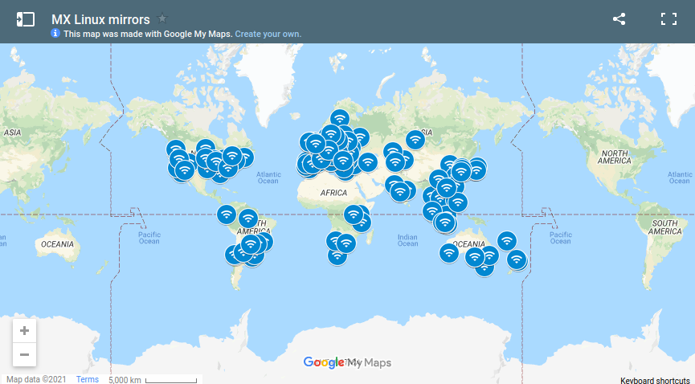

Figure 2-1: Distribution of MX Linux mirrors (Sep 2021)

#### **Download**

MX Linux can be downloaded in two ways from [the Download page](https://mxlinux.org/download-links).

* **Direct**. Direct downloads are available from our Direct Repo, or from our Mirrors. Save the ISO to your Hard Disk. If one source seems slow, try the other one. Available for both original release and monthly update.
* **Torrent**. [BitTorrent](http://en.wikipedia.org/wiki/BitTorrent) file sharing provides an internet protocol for efficient mass transfer of data. It decentralizes the transfer in such a way as to utilize good bandwidth connections and to minimize strain on low-bandwidth connections. An added benefit is all BitTorrent clients perform error checking during the download process, so there is no need to do a separate md5sum check after your download is complete. It has already been done!

The MX Linux Torrent Team maintains a seeded BitTorrent swarm of the latest MX Linux ISO (**original** **release only**), registered at archive.org within 24 hours at the latest of its official release. Links to the torrents will be on [the Download page](https://mxlinux.org/download-links).

* Go to the Download page and click on the correct Torrent link for your architecture. Your browser should recognize that it is a torrent, and ask you how you want to handle it.

If not, left-click the torrent for your architecture to see the page, right-click to save it. Clicking on the downloaded torrent will launch your torrent client (Transmission by default), showing the torrent in its list; highlight it and click Start to begin the download process. If you have already downloaded the ISO, make sure that it is in the same folder as the torrent you just downloaded.

### 2.2.2 Check validity of downloaded ISOs

After you have downloaded an ISO, the next step is to verify it. There are several methods available.

#### md5sum

Each ISO is accompanied by a matching md5sum file in the source, and you should check its **md5sum** against the official one. It will be identical to the official md5sum if your copy is authentic. The following steps will let you verify the integrity of the downloaded ISO on any OS platform.

* Windows

Users can check most easily with the [Rufus](https://rufus.akeo.ie/) bootable USB maker; a tool called [WinMD5FREE](http://www.winmd5.com/) is also available to download and use free of cost.

* Linux

In MX Linux, navigate to the folder where you have downloaded the ISO and the md5sum file. Right-click the md5sum file > Check data integrity. A dialog box will pop up saying “<name of ISO>: OK” if the numbers are identical. You can also right-click the ISO > Compute md5sum and compare it with another source.

For situations where that option is not available, open a terminal in the location where you downloaded the ISO (Linux File Managers usually have an Open Terminal Here option), then type:

*md5sum filename.iso*

Be sure to replace “filename” with the actual filename (type in the first couple of letters then hit Tab and it will be filled in automatically). Compare the number obtained by this calculation with the md5sum file downloaded from official site. If they are identical, your copy is identical to the official release.

* Mac

Mac users need to open up a console/terminal and change into the directory with the ISO and md5sum files. Then issue this command:

*md5 -c filename.md5sum*

Be sure to replace filename with the actual filename.

#### **sha256sum**

Increased security is provided by [sha256 and sha512](https://en.wikipedia.org/wiki/SHA-2) starting with MX-19. Download the file to check the integrity of the ISO.

* Windows: the method varies by version. Do a web search on "*windows <version> check sha256 sum*"
* Linux: follow the directions for md5sum, above, substituting "sha256sum" or "sha512sum"  for "md5sum."
* Mac: open a console, change to the directory with the ISO and sha256 files, and issue this command:

*shasum -a 256 /path/to/file*

#### **GPG signature**

As of March 16, 2016, MX Linux ISO files to be downloaded have been signed by their developers. This security method allows the user to be confident that the ISO is what is says it is: an official ISO from the developer. Detailed instructions about how to run this security check can be found in the [MX/antiX Technical Wiki](https://mxlinux.org/wiki/system/signed-iso-files).

### 2.2.3 Create the LiveMedium

#### DVD

Burning an ISO to a DVD is easy, as long as you follow some important guidelines.

* Do not burn the ISO onto a blank CD/DVD as if it were a data file! An ISO is a formatted and bootable image of an OS. You need to choose **Burn disk image** or **Burn ISO** in the menu of your CD/DVD burning program. If you just drag and drop it into a file list and burn it as a regular file, you will not get a bootable LiveMedium.
* Use a good quality writable DVD-R or DVD+R with a 4.7 GB capacity..

#### **USB**

You can easily create a bootable USB that works on most systems. MX Linux includes the tool **Live-usb maker** (see Section 3.2) for this work.

* If you want to create a USB on a Windows base, we suggest you use Rufus, which supports our bootloader, or a recent (post 625) Unetbootin version.
* If on a Linux base, we offer our Live-usb-maker-qt as a 64 bit appimage.
* If your USB starts but leaves you with an error message: *gfxboot.c32: not a COM32R image,* you should still be able to boot by typing "live" at the prompt in the next line. Reformatting the USB and reinstalling the ISO should remove the error.
* If the graphic USB creators fail, it is possible to use the command "dd," an option now in Live-usb maker.
  + WARNING: be careful to identify your destination USB correctly in the dd command line string listed above, as the dd command will completely write over the destination.
  + To ascertain the correct device name/letter for your destination USB, open a terminal, type *lsblk* and press Enter.  
    A list of all devices connected to your system will be listed. You should be able to identify your destination USB by its listed storage size.
* For details, see [the MX/antiX Wiki](https://mxlinux.org/wiki/system/dd-command).

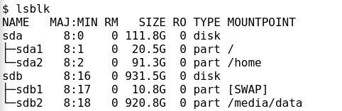

*Figure 2-3: typical output of the command lsblk, showing two harddisks each with two partitions*

## 2.3 Pre-Installation

### 2.3.1 Coming from Windows

If you are going to install MX Linux as a replacement for Microsoft Windows®, it is a good idea to consolidate and back up your files and other data currently stored in Windows. Even if you are planning to dual-boot, you should make a backup of this data in case of unforeseen problems during the install.

#### **Backing up files**

Locate all of your files, such as office documents, pictures, video, or music:

* Typically, most of these are located in My Documents folder.
* Search from the Windows Application Menu for various types of files to make sure you have found and saved them all.
* Some users back up their fonts for reuse in MX Linux with applications (such as LibreOffice) that can run Windows documents.
* Once you have located all such files, burn them to a CD or DVD, or copy them to an external device such as a USB thumb drive.

#### Backing up email, calendar, and contact data

Depending on the email or calendar program you use, your email and calendar data may not be saved in an obvious location or under an obvious file name. Most email or scheduling applications (such as Microsoft Outlook®) are able to export this data in one or more file formats. Consult your application’s help documentation to find out how to export the data.

* Email data: The safest format for email is plain text, since most mail programs support this feature; **be sure to zip the file** to ensure that all file attributes are maintained. If you are using Outlook Express, your mail is stored in a .dbx or .mbx file, either of which can be imported into Thunderbird (if installed) on MX Linux. Use the Windows search feature to locate this file and copy it to your backup. Outlook mail should be imported first into Outlook Express before being exported for use in MX Linux.
* Calendar data: export your calendar data to iCalendar or vCalendar format if you wish to use it in MX Linux.
* Contact data: the most universal formats are CSV (comma separated values) or vCard.

#### **Accounts and passwords**

Although not usually stored in readable files that can be backed up, it’s important to remember to make note of various account information you may have saved in your computer. Your automatic log-in data for websites or services like your ISP will have to be entered in all over again, so make sure to store off disk the information you need to access these services again. Examples include:

* ISP login information: You will need at least your username and password for your internet service provider, and the phone number to connect if you are on dial-up or ISDN. Other details might include a dial out number, dialing type (pulse or tone), and authentication type (for dialup); IP address and subnet mask, DNS server, gateway IP address, DHCP server, VPI/VCI, MTU, Encapsulation type, or DHCP settings (for various forms of broadband). If you are not sure what you need, consult your ISP.
* Wireless networking: You will need your passkey or passphrase, and network name.
* Web passwords: You will need your passwords to various web forums, online stores, or other secured sites.
* Email account details: You will need your username and password, and the addresses or URLs of the mail servers. You may also need the authentication type. This information should be retrievable from the Account settings dialog of your email client.
* Instant messaging: Your username and password for your IM account(s), your buddy list, and the server connection information if necessary.
* Other: If you have a VPN connection (such as to your office), a proxy server, or other configured network service, make sure you find out what information is necessary to reconfigure it in the event that you need to.

#### **Browser favorites**

Web browser favorites (bookmarks) are often overlooked during a backup, and they are not usually stored in a conspicuous place. Most browsers contain a utility to export your bookmarks to a file, which can then be imported into the web browser of your choice in MX Linux. Check the bookmarks division in the browser that you use for specific up-to-date directions.

#### **Software licenses**

Many proprietary programs for Windows are not installable without a license key or CD key. Unless you are set on doing away with Windows permanently, make sure you have a license key for any program that requires it. If you do decide to reinstall Windows (or if dual-boot setup goes awry), you will be unable to reinstall these programs without the key.

If you can not find the paper license that came with your product, you may be able to locate it in the Windows registry, or use a keyfinder such as [ProduKey](http://www.nirsoft.net/utils/product_cd_key_viewer.html). If all else fails, try contacting the computer’s manufacture for help.

#### Running Windows programs

Windows programs will not run inside a Linux OS, and MX Linux users are encouraged to look for native equivalents (see Section 4). Applications that are critical for a user may run under Wine (see Section 6.1), though it varies somewhat.

### 2.3.2 Apple Intel computers

Installing MX Linux on Apple computers with Intel chips can be problematic, though the situation varies to a certain degree with the exact hardware involved. Users interested in the question are advised to search and consult Debian materials and forums for recent developments. A number of Apple users have installed it successfully, so you should have good luck if you search or post questions on the MX Linux Forum.

#### **Links**

[Installing Debian on Apple Computers:](https://wiki.debian.org/InstallingDebianOn/Apple)

[Debian forums](http://forums.debian.net/)

### 2.3.3 Hard drive FAQs

#### Where should I install MX Linux?

Before starting the install, you need to decide where you are going to install MX Linux.

* Entire hard drive
* Existing partition on a hard drive
* New partition on a hard drive

You can simply select one of the first two during installation, but the third requires the creation of a new partition. You can do this during installation, but it is recommended that you do it before you start the installation. On MX Linux, you will usually be using **Gparted** (Xfce)or **PartitionManager** (KDE)to graphically create and manage partitions.

A traditional installation format for Linux has serveral partitions, one each for root, home and Swap, as in the Figure below, and you should begin with this if you are new to Linux. You may also need a fat-32 formatted ESP partition for UEFI-capable machines. Other partition arrangements are possible, for example some experienced users combine root and home, with a separate partition for data.

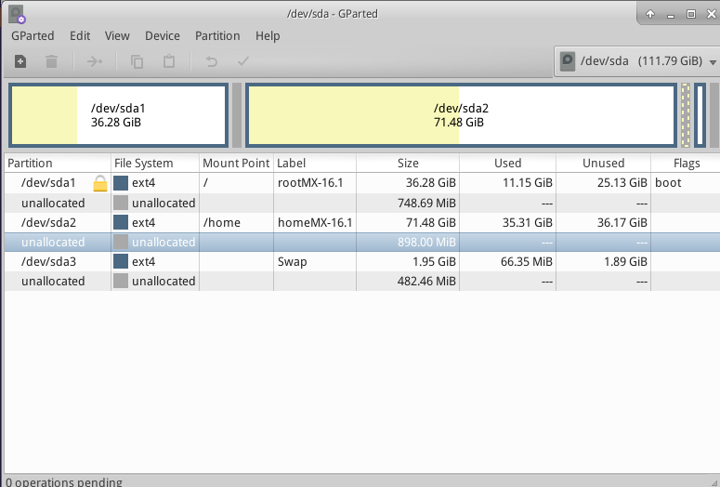

*Figure 2-2: Gparted showing three partitions (sda1), (sda2)* *and swap (sda3). Drive sizes are the user's preference (See Section 1.3 for minimum requirements)*

***MORE:*** [***GParted Manual***](http://gparted.org/display-doc.php?name=help-manual)



[Create a new partition with GParted](https://www.youtube.com/watch?v=lf8eXhCKghg)

******

[Partition a Multi-boot system](https://www.youtube.com/watch?v=khg6_sdrOBQ)

#### How can I edit partitions?

The very handy tool used in the past for such actions,Disk manager, is no longer available. In its place is recommended **Gnome Disks** (part of gnome-disk-utility). This utility provides a graphical presentation of all the partitions on the machine (excluding swap) with a simple interface for quickly and easily mounting, unmounting and editing some properties of disk partitions. Changes are automatically and immediately written to /etc/fstab and are thus preserved for the next boot.

HELP: [Gnome disks](https://linuxhint.com/gnome_disk_utility/)

#### **What are those other partitions on my Windows installation?**

Recent home computers with Windows are sold with a diagnostic partition and restore partition, in addition to the one that contains the OS installation. If you see multiple partitions showing up in GParted that you were not aware of, they are probably those and should be left alone.

#### Should I create a separate Home?

You do not have to create a separate home partition, since the Installer will create a /home directory within / (root). But having a separate partition makes upgrades easier and protects against problems caused by users filling up the drive with a lot of pictures, music, or video data.

#### How big should / (root) be?

* (In Linux, the slash mark "/" indicates the root partition.) The installed base size is a little under 5 GB, so we recommend a minimum of 6 GB to allow for basic functions.
* This minimum size will not allow you to install many programs, and may cause difficulty doing upgrades, running VirtualBox, etc. Recommended size for normal use is therefore 20 GB.
* If you have your Home (/home) located within the Root directory (/) and store a lot of big files, then you will need a larger root partition.
* Gamers playing big games (e.g., Wesnoth) should note that they will need a bigger root partition than usual for data, images, sound files; an alternative is to use a separate Data drive.

#### Do I need to create a SWAP partition?

SWAP is disk space used for Virtual Memory. This is similar to the "Page" file that windows uses for Virtual Memory. The Installer will create a SWAP partition for you (see Section 2.5.1). If you intend to hibernate (and not just suspend) the system here are the recommendations for the size of the swap space:

* For less then 1GB of physical memory (RAM), the swap space should at least be equal to the amount of RAM and a maximum twice the amount of RAM depending upon the amount of hard disk space available for the system.
* For systems with larger amounts of physical RAM, your swap space should at least be equal to the memory size.
* Technically a linux system can operate without swap, although some performance problems may occur even on systems with large amounts of physical RAM.

#### What do names like “sda” mean?

Before you begin installation, it is critical that you understand how Linux operating systems treat hard drives and their partitions.

* **Drive names**. Unlike Windows, which assigns a drive letter to each of your hard drive partitions, Linux assigns a short device name to each hard drive or other storage device on a system. The device names always start with **sd** plus a single letter. For instance, the first drive on your system will be sda, the second sdb, etc. There are also more advanced means of naming drives, the most common of which is the [UUID](https://en.wikipedia.org/wiki/Universally_unique_identifier) (Universally Unique IDentifier), used to assign a permanent name that will not be changed by the addition or removal of equipment.
* **Partition names**. Within each drive every partition is referred to as a number appended to the device name. Thus, for instance, **sda1** would be the first partition on the first hard drive, while **sdb3** would be the third partition on the second drive.
* **Extended partitions**. PC hard disks were originally permitted only four partitions. These are called primary partitions in Linux and are numbered 1 to 4. You can increase the number by making one of the primary partitions into an extended partition, then dividing that into logical partitions (limit 15) that are numbered from 5 onward. Linux can be installed into a primary or logical partition.

## 2.4 First look

**Live Medium** **login**

In case you want to log out and back in, install new packages, etc., here are the usernames and passwords:

* Regular user
  + name: demo
  + password: demo
* Superuser (Administrator)
  + name: root
  + password: root

### 2.4.1 Boot the LiveMedium

#### LiveCD/DVD

Simply place the DVD in the tray and reboot.

#### LiveUSB

You may need to take a few steps to get your computer to boot correctly using the USB.

* To boot with the USB Drive, many computers have special keys you can press during booting to select that device. Typical Boot Device Menu keys are Esc, one of the Function keys, Return or the Shift key. Look carefully at the first screen that shows up when rebooting to find the correct key.
* Alternatively, You may have to go into the BIOS to change the boot device order:
  + Boot the computer, and hit the required key (e.g., F2, F10 or Esc) at the beginning to get into the BIOS
  + Click on (or arrow over to) the Boot tab
  + Identify and highlight your USB device (usually, USB HDD), then move it to the top of the list (or enter, if your system is set for that). Save and exit
  + If unsure or uncomfortable about changing the BIOS, ask for assistance in the Forums.
* On older computers without USB support in the BIOS, you can use the [Plop Linux LiveCD](http://www.plop.at/) that will load USB drivers and present you with a menu. See the website for details.
* Once your system is set to recognize the USB Drive during the boot process, just plug in the Drive and reboot the machine.

#### UEFI

 [UEFI Boot Issues, and some settings to check!](https://www.youtube.com/watch?v=cLFUZ6LtqiE)

If the machine already has Windows 8 or later installed, then special steps must be taken to deal with the presence of [(U)EFI](https://en.wikipedia.org/wiki/Unified_Extensible_Firmware_Interface) and Secure Boot. Most users are urged to turn off Secure Boot by entering the BIOS as the machine starts to boot. Unfortunately, the exact procedure after that varies by manufacturer:

*Despite the fact that the UEFI specification requires MBR partition tables to be fully supported, some UEFI firmware implementations immediately switch to the BIOS-based CSM booting depending on the type of boot disk's partition table, effectively preventing UEFI booting to be performed from EFI System partitions on MBR-partitioned disks. (Wikipedia, “Unified Extensible Firmware Interface”, retrieved 10/12/19)*

UEFI booting and installation is supported on 32 bit and 64 bit machines, as well as 64 bit machines with 32 bit UEFI. Although the 32 bit UEFI implementations can still be problematic. For troubleshooting, please consult the [MX/antiX Wiki](https://mxlinux.org/wiki/system/uefi), or ask on the Forum.

#### **The Black Screen**

Occasionally it may happen that you end up looking at an empty black screen that may have a blinking cursor in the corner. This represents a failure to start X, the windows system used by Linux, and is most often due to problems with the graphics driver being used. Solution: reboot and select Safe Video or Failsafe boot options in the menu; details on these boot codes in [the Wiki](https://mxlinux.org/wiki/system/boot-parameters). See Section 3.3.2.

### 2.4.2 The standard opening screen

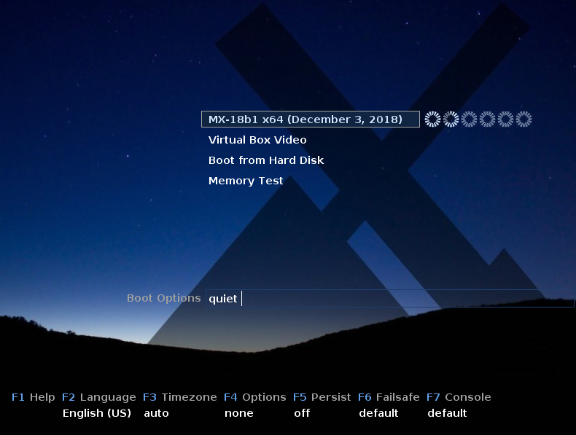

***Figure 2-3: LiveMedium boot screen of x64 ISO***

When the LiveMedium boots up, you will be presented with a screen similar to the Figure above; the *installed* screen looks quite different. Custom entries may also appear in the main menu.

#### Main Menu entries

**Table 1: Menu entries in Live boot**

|  |  |
| --- | --- |
| Entry | Comment |
| MX-XX.XX (<RELEASE DATE>) | This entry is selected by default, and is the standard way that most users will boot the Live system. Simply press Return to boot the system. |
| Boot from Hard Disk | Boots whatever is currently installed on the system's hard disk |
| Memory Test | Runs a test to check RAM. If this test passes then there may still be a hardware problem or even a problem with RAM but if the test fails then you know something is wrong. |

In the bottom row the screen displays a number of vertical entries, below which is a row of horizontal options; **press F1 when looking at that screen for details**.

#### **Options**

* **F2 Language**. Set the language for the bootloader and the MX system. This will automatically transfer to the hard drive when you install.
* **F3 Time Zone**. Set the timezone for the system. This will automatically transfer to the hard drive when you install.
* **F4 Options**. Options for checking and booting the Live system. Most of these options do not transfer to the hard drive when you install.
* **F5 Persist**. Options for retaining changes to the LiveUSB when the machine shuts down.
* **F6 Safe/Failsafe Video Options**. Options for machines that will not boot to X by default.
* **F7 Console**. Set resolution of virtual consoles. May conflict with Kernel Mode Setting. Can be useful if you are booting into Command Line Install or if you are trying to debug the early boot process. This option will transfer when you install.

Other cheat codes for LiveUSB can be found in the [MX/antiX Wiki](https://mxlinux.org/wiki/system/boot-parameters). The cheat codes for booting an installed system are different, and can be found in the same location.

MORE: [Linux startup process](http://en.wikipedia.org/wiki/Linux_startup_process)

### 2.4.3 The UEFI opening screen

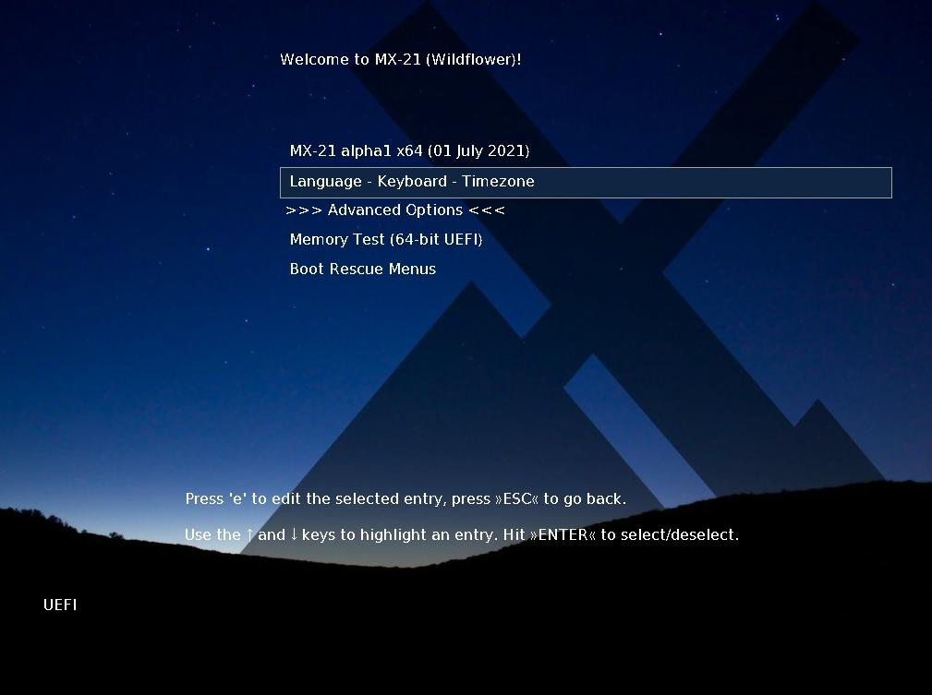

***Figure 2-4: LiveMedium boot screen of x64 (MX-21 and up) when UEFI detected***

If the user is using a computer set for UEFI boot (see [MX/antiX Wiki](https://www.mxlinux.org/wiki/system/uefi)), the opening screen for UEFI Live boot will appear instead with different choices.

* Menus are used to set boot options instead of F key menus
* The top option will launch the OS with any selected options enabled.
* Advanced Options sets things like Persistence and other items present in the legacy boot F menus.
* Language – Keyboard – Timezone sets those options

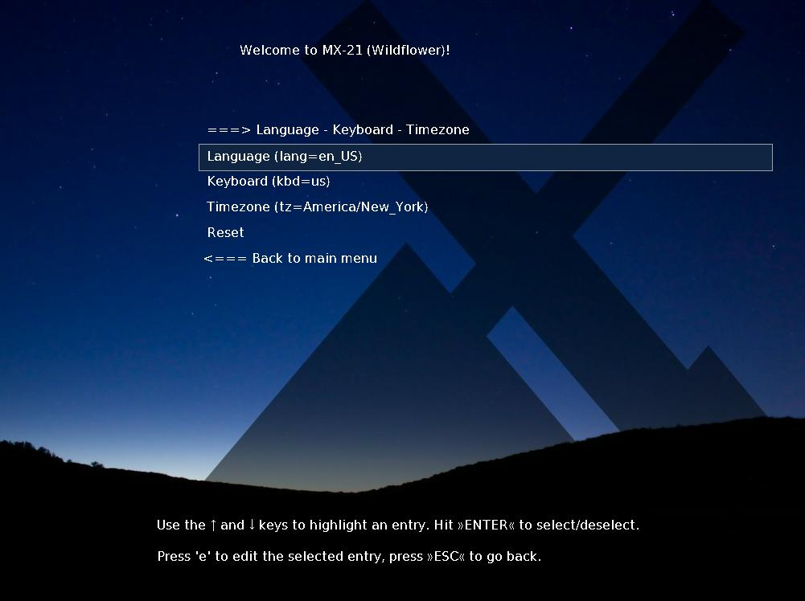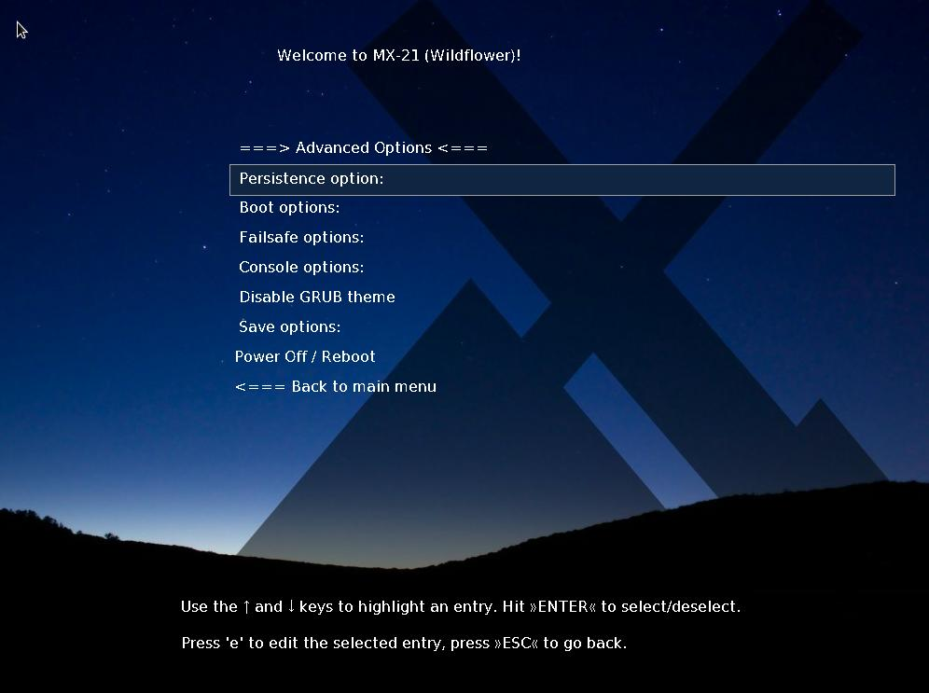

***Figure 2-5: Screen examples for LiveMedium (left) and installed options.***

If you want you boot options to be persitent, make sure to select a save option.

### 2.4.4 Login screen

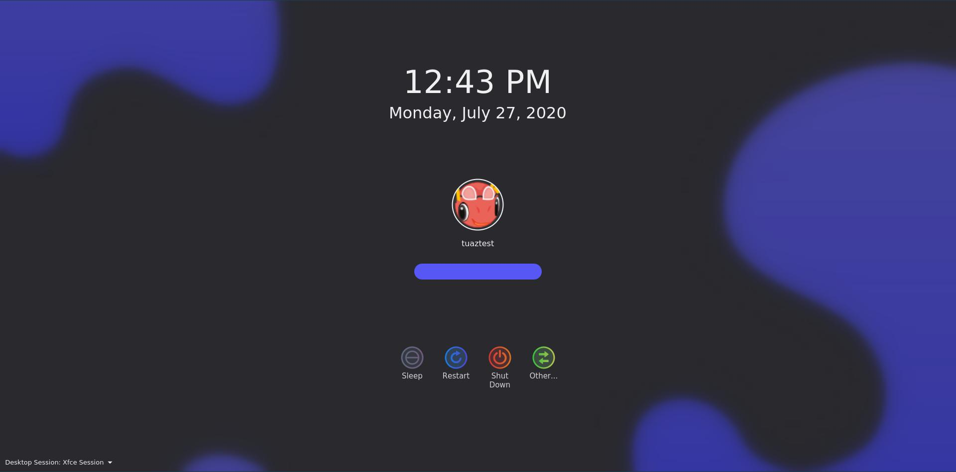 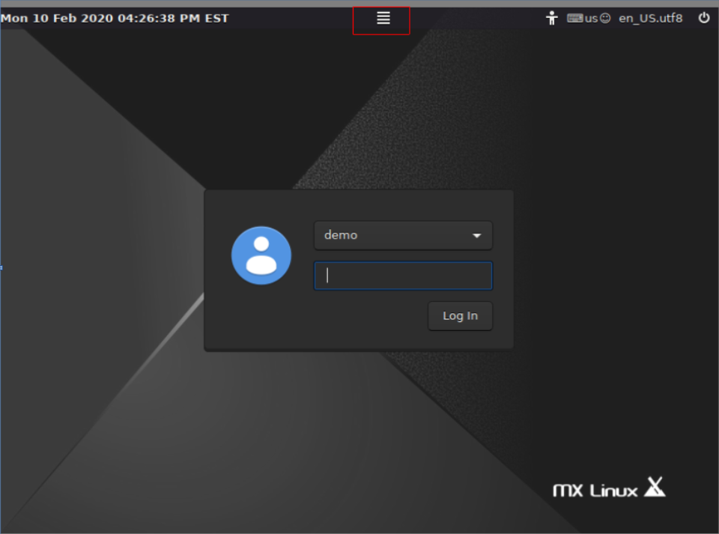

***Figure 2-6: Left: Xfce login screen, with session button top center Right: KDE/plasma login screen***

Unless you have selected autologin, the installed boot process finishes with the login screen; in a Live session only the background image is shown, but if you log out from the desktop you will see the complete screen. (The layout of the screen varies from MX version to version.) On small screens, the image may appear zoomed; this is a property of the display manager that is used by MX Linux.

You can see three small icons at the right end of the top bar; from right to left:

* The **power button** at the edge contains options to suspend, restart and shut down.
* The **language button** allows the user to select the appropriate keyboard for the login screen
* The **visual aids button** that accommodates special needs of some users.

In the middle there is the **session button** that allows you to choose which desktop manager you wish to use: Default Xsession, Xfce Session, along with any other you may have installed (Section 6.3). Fluxbox is no longer included by default, though it can be installed with MX Package Installer.

If you wish to avoid having to log in each time you boot up (not recommended where there are security concerns), you can change to autologin” on the “options” tab of MX User Manager.

MX KDE/plasma versions ship with a different login screen, containing a session chooser, onscreen keyboard, and power/shutdown/reboot functions.

### 2.4.5 Different Desktops

#### MX-Xfce

***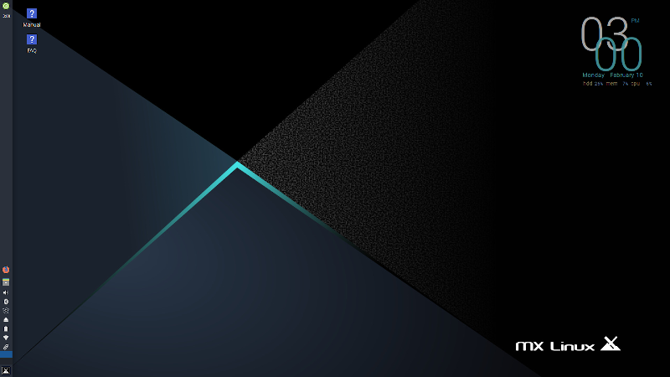***

***Figure 2-7: The default Xfce desktop***

#### ***MX-KDE***

***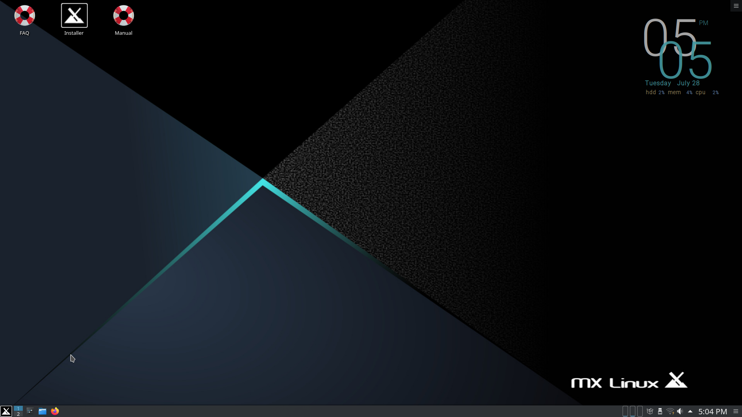***

***Figure 2-8: the default KDE/plasma desktop***

The desktop is created and managed by [Xfce](http://docs.xfce.org/xfce/getting-started) or KDE/plasma, and each appearance and arrangement have been heavily modified for MX Linux. Note the two dominant features of your first look: panel and Welcome screen.

#### Panel

The default desktop of MX Linux has a single vertical panel on the screen. Panel orientation is easily changeable in **MX Tools > MX Tweak**. Common panel features are:

* Power button, opens to a dialog box for log out, restart, shut down, and suspend. (xfce)
* Clock in LCD format–click for a calendar (xfce)
* Taskswitcher/Window Buttons: area where open applications are shown
* Firefox browser
* File manager (Thunar)
* Notification Area
  + Update manager
  + Clipboard manager
  + Network manager
  + Volume manager
  + Power manager
  + USB ejector
* Pager: displays available workspaces (by default 2, right-click to change)
* Application menu (“[Whisker](http://gottcode.org/xfce4-whiskermenu-plugin)” on Xfce)
* Other applications may insert icons in the Panel or Notification Area when running.

To change the properties of the Panel, see Section 3.8.

#### Welcome screen

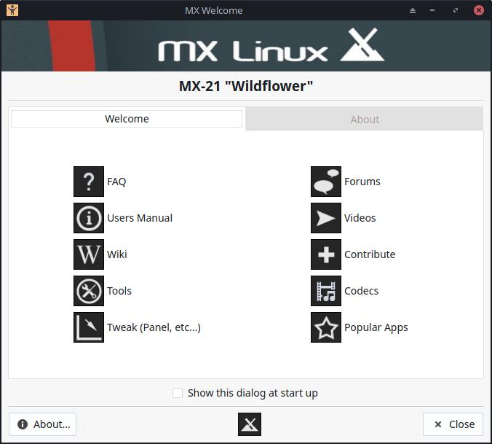

**[[ADD SECOND TAB]]**

***Figure 2-9: The Welcome and About screens in MX linux (installed)***

When the user boots up for the first time, a Welcome screen appears in the center of the screen with two tabs: „Welcome” offers quick orientation and help links (Figure 2-7). while „About” displays a digest of information about the OS, the running system, etc.. When running Live, the passwords for demo and root users will be shown at the bottom. Once closed, running live or installed, it can be displayed again using the menu or MX Tools.

It is very important for new users to work carefully through the buttons, as it will save much confusion and effort in the future use of MX-Linux. If time is limited, it is recommended that you scan through the FAQ document linked on the Desktop, where the most common questions are answered.

### Tips & Tricks

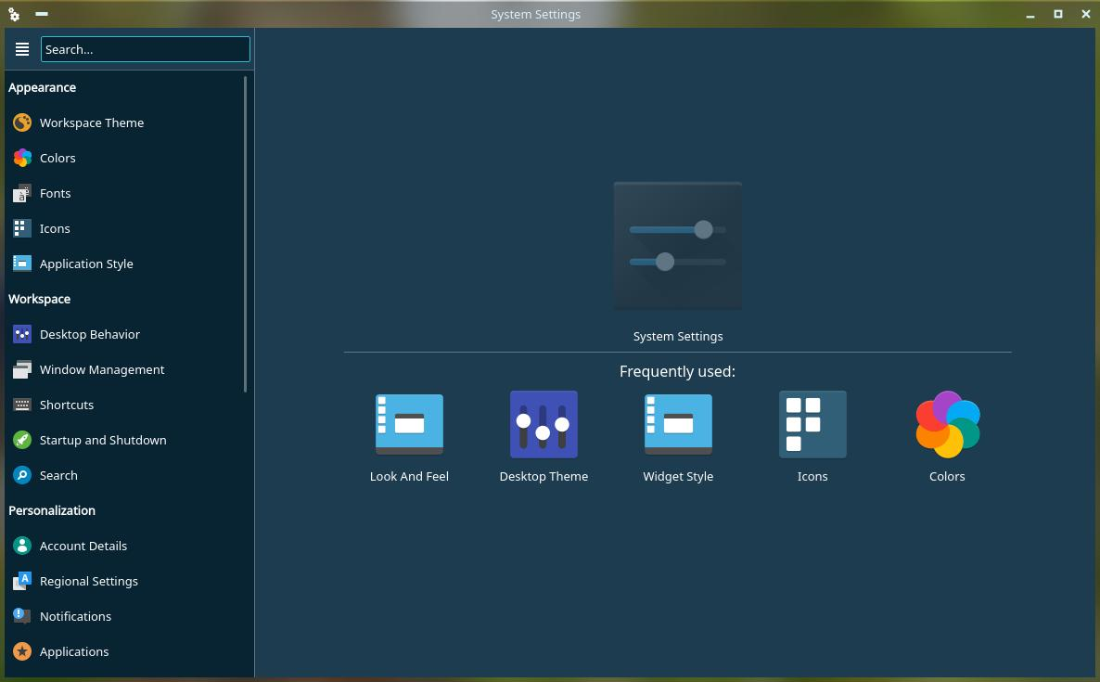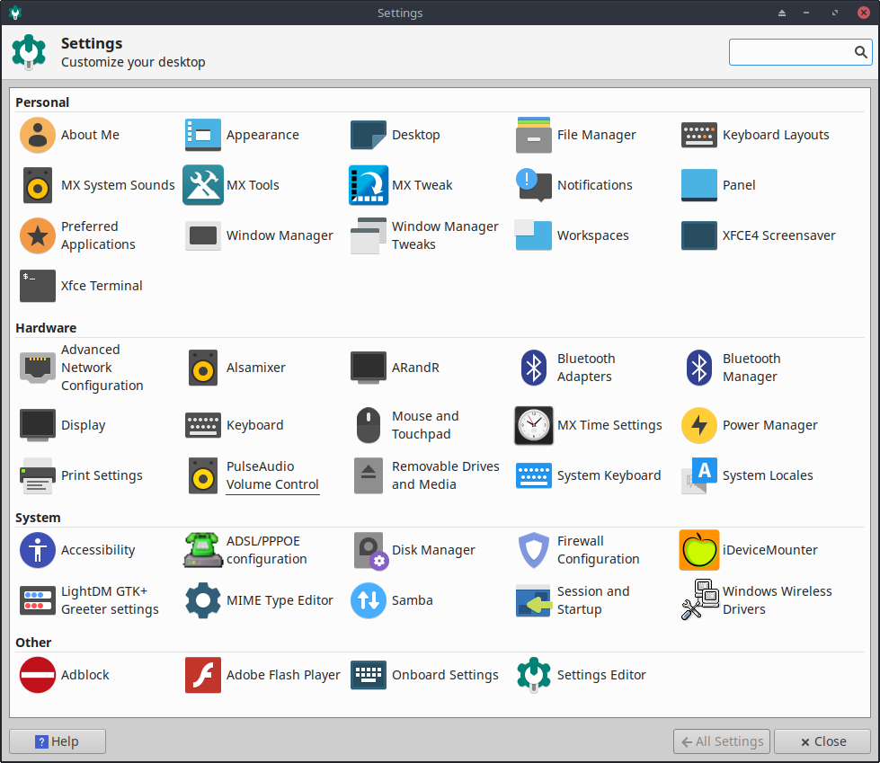

***Figure 2-10: Settings is your one-stop location to make changes. Contents vary.***

Some handy things to know at the beginning:

* If you are having problems with sound, network, etc., see Configuration (Section 3).
* Adjust sound general loudness by scrolling with the cursor over the speaker icon, or by right-clicking speaker icon > Open Mixer.
* Set the system to your particular keyboard layout by clicking **Application Menu > Settings > Keyboard**, Layout tab, and selecting the model with the pull-down menu. This is also where you can add other language keyboards.
* Adjust preferences for mouse or touchpad by clicking **Application Menu > Settings > Mouse and Touchpad**.
* Trash can be easily managed in the File Manager, where you will see its icon in the left pane. Right-click to empty. It can also be added to the Desktop or Panel. It is important to realize that using delete, whether by highlighting and hitting the delete button or via a context menu entry, removes the item forever and it will not be recoverable.
* Keep your system current by watching for the indicator (outlined box) of available updates on the MX Updater to turn green. See Section 3.2 for details.
* Handy key combinations (managed in All Settings > Keyboard > Application Shortcuts).

***Table 2: Handy key combinations***

|  |  |
| --- | --- |
| ***Keystrokes*** | ***Action*** |
| F4 | Drops a terminal down from top of screen |
| Windows key | Brings up the Application menu |
| Ctrl-Alt-Esc | Changes the cursor into a white x to kill any program |
| Ctrl-Alt-Bksp | Closes the session (without saving!) and returns you to the login screen |
| Ctrl-Alt-Del | Locks the desktop on Xfce. logout on KDE/plasma |
| Ctrl-Alt-F1 | Drops you out of your X session to a command line; use Ctrl-Alt-F7 to return. |
| Alt-F1 | Opens this MX Linux Users Manual (Xfce only, menu on KDE/plasma) |
| Alt-F2 | Brings up a dialog box to run an application |
| Alt-F3 | Opens the Application Finder which also allows some editing of menu entries (Xfce only) |
| Alt-F4 | Closes an application in focus; over the desktop, brings up the exit dialog. |
| PrtScr | Opens the Screenshooter for screen captures |

#### Applications

Applications can be started in various ways.

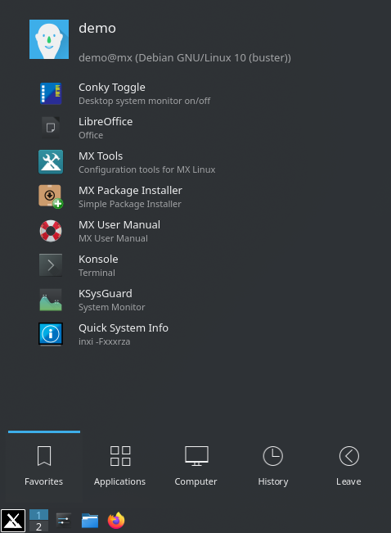

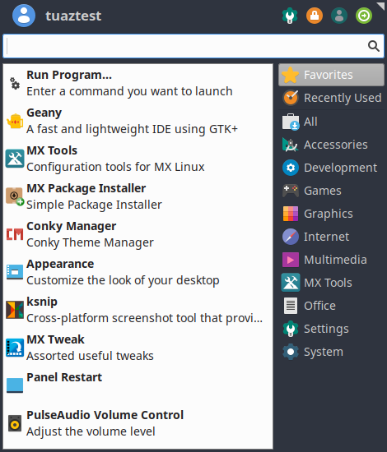

Figure 2-11: LEFT: Xfce Whisker menu (contents vary) RIGHT: KDE/plasma menu

* Click the Application menu icon, in lower left corner.
  + It opens to Favorites category, and you can hover mouse over other categories on right side to see contents in the left pane.
  + At the top is a powerful incremental search box: just type in a few letters to find any application without needing to know its category.
* Right-click the desktop > Applications.
* If you know the name of the application, you can use Application Finder, started easily in one of two ways.
  + Right-click the desktop > Run command ...
  + Alt-F2
  + Alt-F3 (Xfce) brings up an advanced version that lets you check commands, locations etc.
  + On KDE/plasma desktop, just start typing
* Use a keystroke you have defined to open a favorite application.
  + Xfce- Click **Application Menu > Settings**, then Keyboard, Application shortcuts tab.
  + KDE/plasma – Global Shortcuts in menu

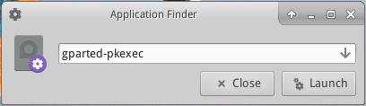

***Figure 2-12: Application Finder identifying application***

#### Other

##### System information

* Click **Application Menu > Quick System Info** that will put the results of the command *inxi -Fxrz* onto your clipboard ready to paste in Forum posts, text files, etc.
* KDE/plasma - Click **Application Menu > System > Infocenter** for a nice graphic display

##### **Video and audio**

* For basic monitor settings, click **Application Menu> Settings > Display**
* Sound adjustment is done through **Application Menu > Multimedia > PulseAudio Volume Control** (or right-click Volume manager icon)

**NOTE**: for troubleshooting areas such as display, sound or internet, consult Section 3: Configuration.

Links

* [Xfce documentation](http://www.xfce.org/about)
* [Xfce FAQs](https://wiki.xfce.org/faq)
* [KDE](https://userbase.kde.org/Welcome_to_KDE_UserBase)

### 2.4.7 Exiting

When you open Application menu, you will see by default four command buttons in the upper right corner (change what shows with a right click on the menu icon > Properties, Commands tab). From left to right:

* All Settings (All Settings)
* Lock Screen
* Switch Users
* Log Out

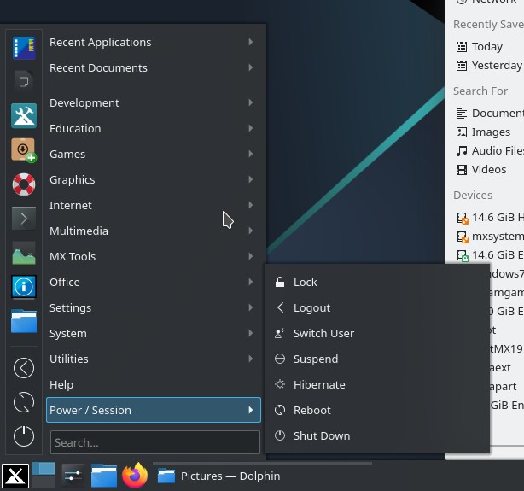



***Figure 2-13: command buttons***

***Top: Xfce***

***Right: KDE/plasma***

It is important to exit MX Linux correctly when you have finished your session so that the system can be brought down in a secure way. All running programs are first notified that the system is going down, giving them the time to save any file being edited, exit from mail and news programs, etc. If you just turn the power off, you risk the possibilities of damaging the operating system.

Similar options to the command buttons are available in the KDE/plasma LEAVE menu.

#### **Permanent**

To leave a session for good, select one of the following on the Log Out dialog box:

* **Log out**. Choosing this will terminate everything you are doing, asking you about saving open work if you have not closed the files yourself, and bring you back to the login screen with the system still running.
  + The command at the bottom of the screen, “Save session for future logins,” is checked by default. Its task is to save the state of your desktop (opened applications and their location) and restore it during the next startup. If you have had problems with your desktop function, you can uncheck this to get a fresh start; if that does not solve the problem, click All Settings > Session and Startup, Session tab, and press the Clear saved sessions button.
* **Restart** or **Shut Down**. Self-explanatory options that alter the system state itself. Also available using the icon in the upper right corner of the top bar on the login screen.

TIP: In the event of a problem, **Ctrl-Alt-Bksp** will kill your session and return you to the login screen, but any open programs and processes will not be saved.

#### **Temporary**

You can temporarily leave your session in one of the following ways:

* **Lock screen**. This option is easily available from an icon in the top right corner of the Application Menu. It protects your Desktop from unauthorized access while you are away by requiring your user password to return to the session.
* **Start a parallel session as a different user**. This is available from the Switch User command button in the top right corner of the Application Menu. You choose this to leave your current session where it is and allows a session for a different user to be started.
* **Suspend** using Power Button. This option is available from the Log Out dialog box, and places your system into a low-power state. Information on system configuration, open applications, and active files is stored in main memory (RAM ), while most of the system’s other components are turned off. It is very handy and generally works very well in MX Linux. Invoked by the Power Button, suspend works well for many users, though its success varies according to the complex interaction among a system’s components: kernel, display manager, video chip, etc. If you have problems, consider trying the following changes:
  + Switch graphical driver, e.g. from radeon to AMDGPU (for newer GPU's), or from nouveau to the proprietary Nvidia driver.
  + Adjust the settings in Application Menu > Settings > Power Manager. For instance: on the System tab, try unchecking "Lock screen when system is going for sleep."
  + Click Application Menu > Settings > Screensaver, and adjust the Display Power Management values on the Advanced tab.
  + AGP cards: add ***Option "NvAgp" "1"*** to the Device section of xorg.conf
* **Suspend** using laptop lid close. Some hardware configurations may experience trouble with this. Action on lid closing can be adjusted on the General tab of Power Manager, where “Switch off display” has proved reliable in MX users’ experience.
* **Hibernation.** The hibernation option was removed from the logout box in earlier MX Linux versions because users experienced multiple problems. It can be enabled in MX Tweak, Other tab. Consult also [the MX/antiX Wiki](https://mxlinux.org/wiki/system/hibernate).

## 2.5 The Installation process

### 2.5.1 Detailed installation steps

 [Basic Install of MX Linux (with partitioning)](https://youtu.be/jSYycsZPm_Q)

 [Encrypted Install of MX Linux (with partitioning)](https://youtu.be/tQjftZsoySg)

 [My Home Folder Setup](https://www.youtube.com/watch?v=twDhZFBMgJ0)

To begin, boot to the LiveMedium, then click on the Installer icon in the upper left corner. If the icon is missing, click F4 and enter: *minstall-pkexec* (root password on LiveMedium: **root**).

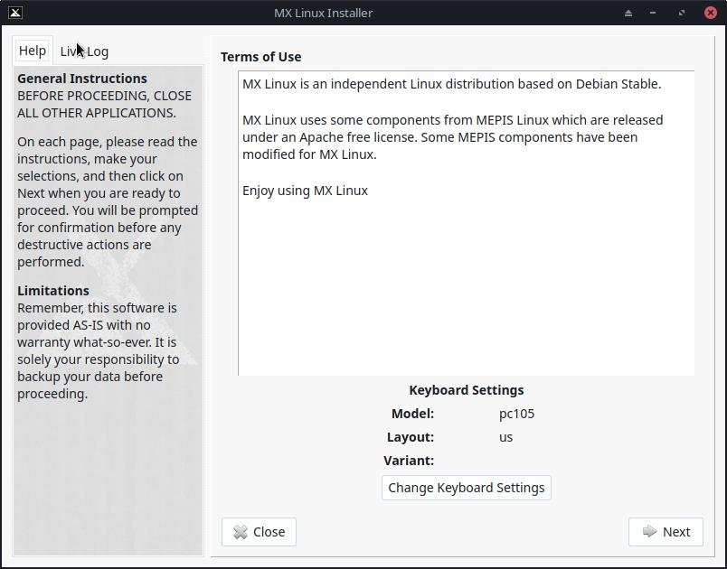

F***igure 2-14: Installer Screen Home***

#### Comments

* The right side of the Installer screen presents user choices as the installation proceeds; the left side provides clarification of the content of the right side.
* Keyboard Settings permits changing the keyboard for the installation process.

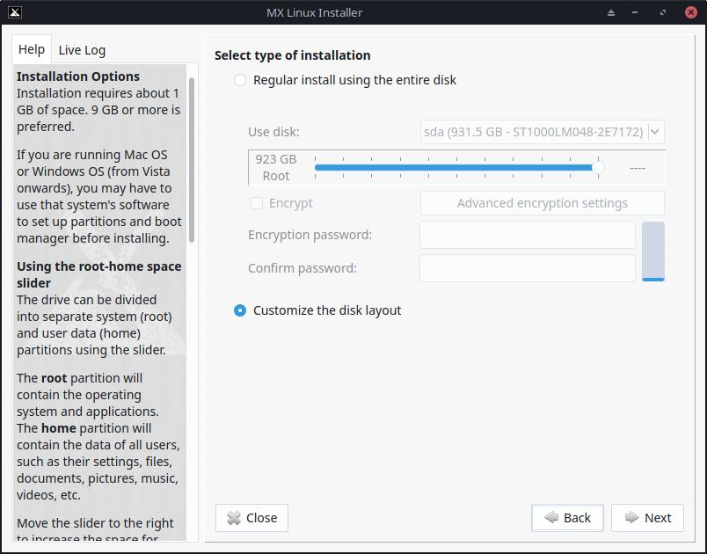

***Figure 2-15: Installer set to use existing partitions***

#### **Comments**

* **Use disk**. If unsure which is the partition you want, use the names you see in GParted. The disk you select will be examined cursorily for reliability by [SMART](https://en.wikipedia.org/wiki/S.M.A.R.T.). If problems are detected, you will see a warning screen. You will need to decide whether to accept that risk and continue, select another disk or terminate the installation. For more information, click **Application Menu > System > GSmartControl** and “Perform tests” on the drive.

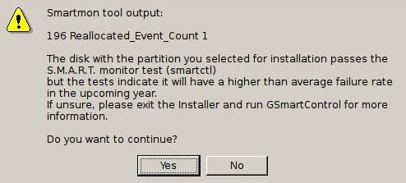

***Figure 2-16: SMART warning of risk of failure***

* **Regular install using entire disk**. Select this option if you plan to use the entire hard drive for MX Linux. The disk will be repartitioned and any existing data will be lost.
  + By default a root and swap partition will be created. A /boot partition will also be created if you choose to use encryption.
  + If you wish a seperate home partition, you can use the slider to divide the available space between root and home partitions.
  + A pop-up message asks you to confirm using the entire disk.
* **Customize the Disk Layout:** If existing partitions are detected on disk, this option will be the default. You will be able to use the partition selection screen to use existing partitions.

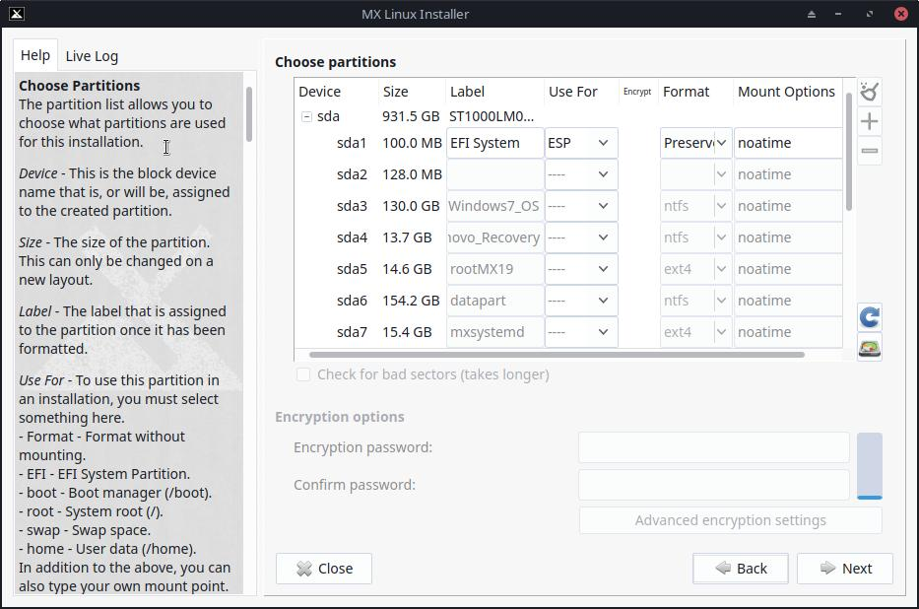

***Figure 2-17: Partition Selection***

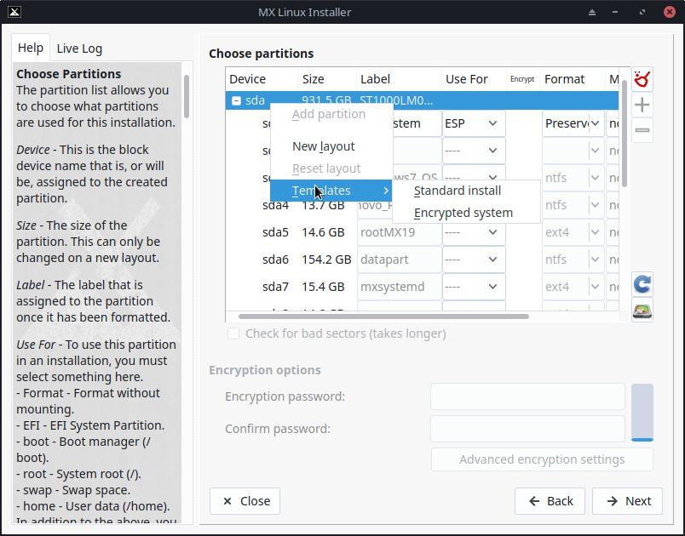

***Figure 2-18: Right click on a disk to show template options.***

#### **Comments**

* **Choose Partitions**. Specify the root and swap partitions you want to use. Use the **USE FOR** column to chose what you want to use a partition for. If you set up a separate partition for your home directory, specify it here, otherwise leave /home set to root.
  + Many users prefer to locate their home directory in a different partition than that of / (root), so that any problem with — or even total replacement of — the installation partition will leave all the user’s individual settings and files untouched.
  + Unless you are using encrpytion or know what you are doing, leave boot set to root.
  + There is simple partition management available on this screen. Right click a disk to show partition templates. The templates are only suitable for whole disk changes, so if you want to resize or otherwise fine tune partition layouts, use an external partition manager (ie: gparted) availabe by clicking the Partition Manager button in the lower right of the Partition Chooser.
* **Preferences**.
  + Check Preserve data in /home if you are doing an upgrade and already have data in an existing partition or folder. This option is not generally recommended because of the risk that old configurations will not match the new installation, but can be useful in specific situations, e.g. repairing an installation.
  + Select Check for bad blocks if you want to do a scan for physical defects on the hard drive during formatting. This is recommended for users with older drives.
  + You can change the label of the partition where you want to install (e.g., to “MX-21 Testing Installation”) in the **Label** colun.
  + Finally, you can optionally select the type of file system you want to use on the hard drive. The default ext4 is recommended in MX Linux if you have no particular choice.
  + You can fine-tune your encryption cipher settings with the "Advanced Encryption Settings” button or just keep the defaults.

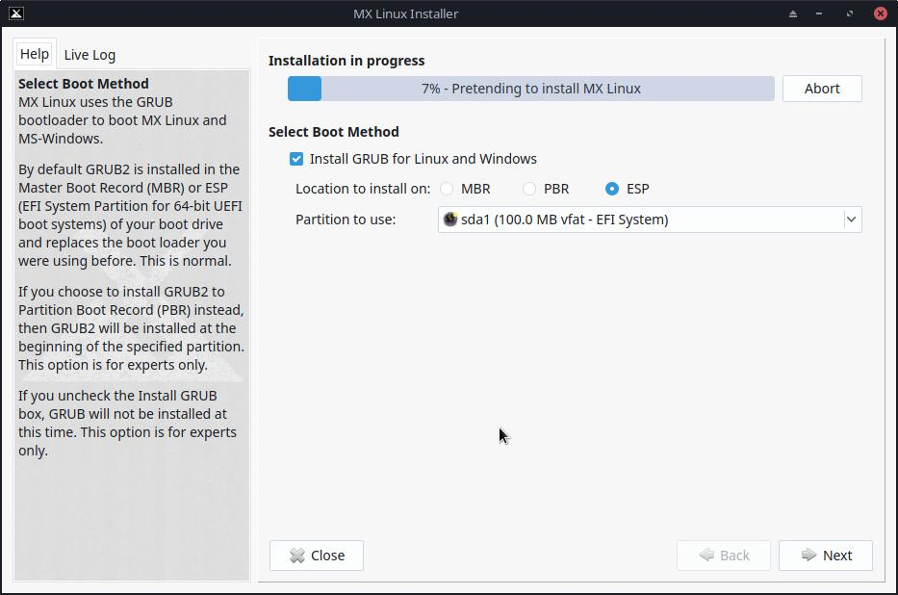

***Figure 2-19: Installer asking about boot method***

**Comments**

* While the main linux OS is being copied to hard drive, you can click the ”Next” button to fill in some additional configuration information. Figure 2-18 shows the GRUB bootloader installation options.
* Most average users will accept the defaults here, which will install the bootloader into the very beginning of the disk. This is the usual location and will cause no harm.
* UEFI users should choose whatever ESP partition they wish to use. Default is the first one found.
* When you click Next, a pop-up message will check to see that you accept the location of the bootloader GRUB. Installing GRUB can take a few minutes in some situations.
* Note that the partition shown (sda) is just an example; your particular selection of partition may well differ.

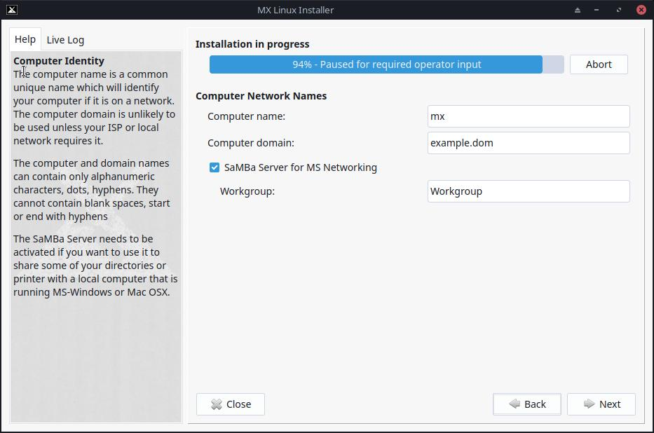

***Figure 2-20: Computer Network Names Setup***

#### **Comments**

* Many users choose a unique name for their computer: laptop1, MyBox, StudyDesktop, UTRA, etc. You may also just leave the default name as it is.
* You can just click Next here if you have no computer network.
* If you are not going to *host* shared network folders on your PC, then you can disable samba. This will not affect your PC's ability to access shares hosted elsewhere on your network.

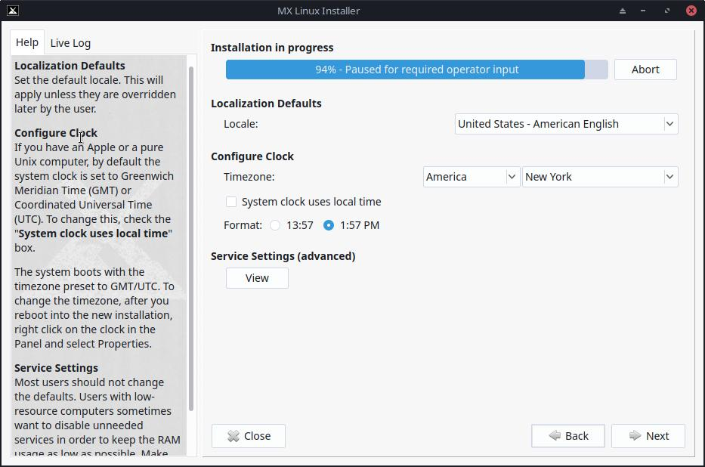

***Figure 2-21: Locale, Timezone, and Service Settings***

#### **Comments**

* The default settings will usually be correct here, as long as you were careful to enter any exceptions at the LiveMedium boot screen.
* The settings can be changed again once you have booted into Xfce.

***Figure 2-22: Enable/Disable Services***

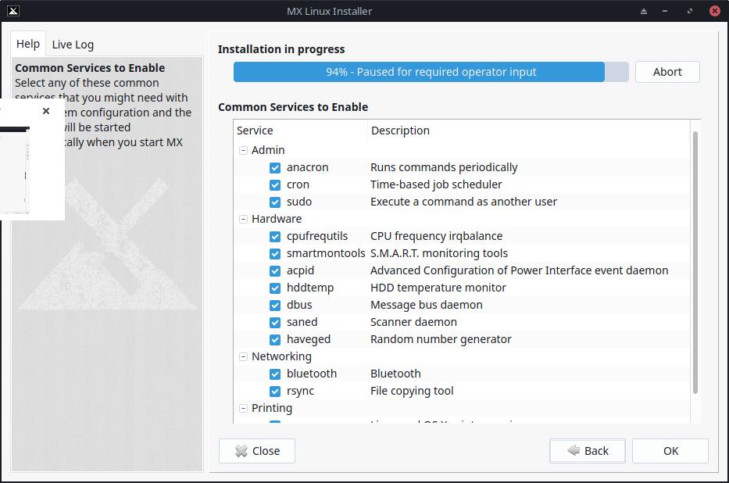

#### **Comments**

* This screen only shows if “View” was clicked on the Locale, Timezone & Services Setting screen.
* Services are applications and functions associated with the kernel that provide capabilities for upper-level processes. If you are not familiar with a service, you should leave it alone.
* These applications and functions require time and memory, so if you are concerned about the capacity of your computer, you can look at this list for items that you are sure you do not need.
* If you later want to change or adjust the startup services you can use a command-line tool called **sysv-rc-conf.** Sysv-rc-conf is installed by default and must be run as root.

***Figure 2-23: User Configuration***

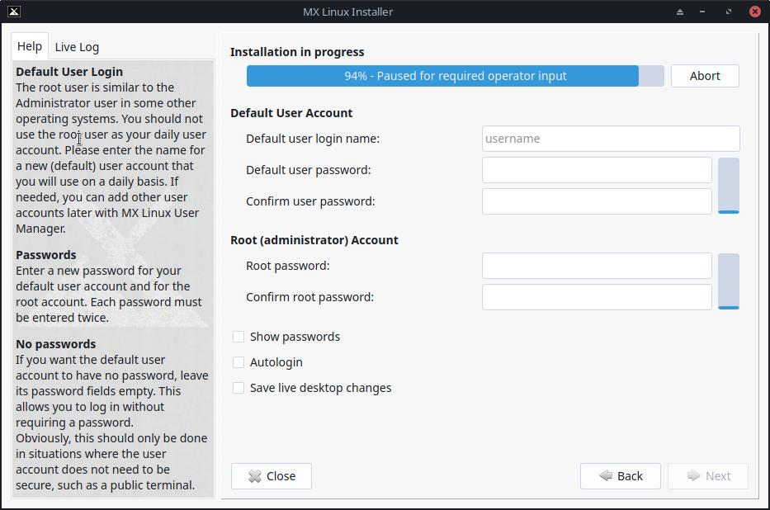

#### **Comments**

* The level of security on the passwords you choose here will depend greatly on the setting of the actual computer. A home desktop is generally less likely to be broken into.
* If you check Autologin, you will be able to bypass the login screen and speed up the boot process. The downside of that choice is that anyone with some kind of access to your computer would be able to log directly into your account. You can later change your autologin preferences on the “Options” tab of the MX User Manager.
* You can transfer any changes you make to your Live desktop to the HD installation by checking the last box. A small amount of critical information (e.g., the name of your wireless Access Point) will be translated automatically.
* If you do not set a root password, gui authentications will be set to user password if they haven't been already.

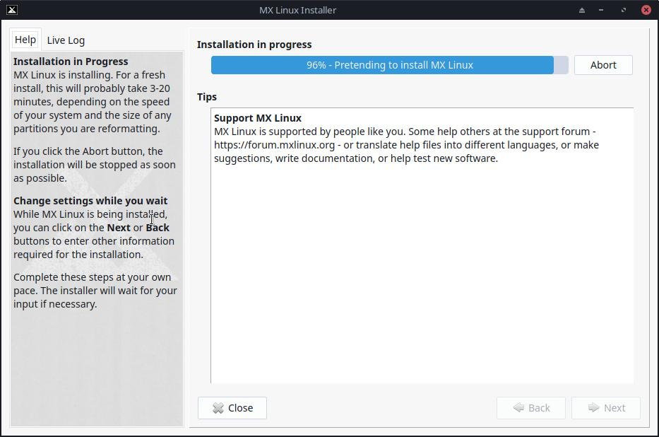

***Figure 2-24: Installation Complete***

#### **Comments**

* After the system copy is finished and the configuration steps are complete, an "Installation Complete” screen will be presented and you are ready to go!
* If you don't want to reboot after finishing installation, uncheck the automatic reboot option before clicking Finish.

## 2.6 Troubleshooting

### 2.6.1 No operating system found

When rebooting after an installation, it sometimes happens that your computer reports that no operating system or bootable disc was found. It also may not show another installed OS such as Windows. Usually, these problems mean that GRUB did not install properly, but that is easy to correct.

* If booting with UEFI, make sure Secure Boot is turned off in your system bios/UEFI settings.
* If you can boot into at least one partition, open there a root terminal and run this command:

*update-grub*

* Otherwise, proceed with MX Boot Repair.
  + Boot to the LiveMedium.
  + Launch **MX Tools > Boot Repair**.
  + Make sure that “Reinstall GRUB Bootloader” is selected, then click OK.
  + If this still does not fix it, you may have a faulty hard drive. Usually, you will have seen a SMART warning screen about it when you began your installation.

### 2.6.2 Data or other partition not accessible.

Partitions and drives other than the one designated as boot may not be booted or require root access after installation. There are a couple of ways to change this.

* For internal drives, use Start > Settings > MX Tweak, Other tab: check "Enable mounting of internal drives by non-root users."
* **GUI**. If you have installed Gnome Disks, click Application Menu > System > Disks. Check anything you want mounted at boot and save; when you reboot it should be mounted and you will have access in Thunar.
* **CLI**. Open a File Manager and navigate to the file /etc/fstab; use the right-click option to open it as root in a text editor. Look for the line containing the partition or drive to which you want access (you may need to type *blkid* in a terminal to identify the UUID). Change it following this example for a data partition.

*UUID=9501<snip>912 /data ext4 users 0 2*

This entry will cause the partition to be automatically mounted at boot time, and also allow you to mount it and umount it as a normal user. This entry will also cause the file system to be checked periodically at boot time. If you don’t want it mounted automatically at boot time then change the options field from "*user*" to "*user,noauto*".

* If you don’t want it checked regularly then change the final "2" to a "0". Since you have an ext4 filesystem it is suggested that you enable the automated checking.
* If the item is mounted but not showing in File Manager, add an additional "*comment=x-gvfs-show*" to the line in your fstab file, which will force the mount to be visible. In the example above, the change would look like this:

UUID=9501<snip>912 /data ext4 users,comment=x-gvfs-show 0 2

NOTE: neither of these procedures will change Linux permissions, which are enforced on the folder and file level. See Section 7.3.

### 2.6.3 Keyring problems

A default key ring should be created automatically and the user will not need to do anything. If using autologin, when an app accesses the keyring the user would be asked to enter a new password to create a new default keyring. Details in the [MX/Antix Technical Wiki](https://mxlinux.org/wiki/system/gnome-keyring).

Note that if malevolent agents get physical access to your machine, using a blank password will make it easier to break into. But it seems pretty clear that if a malevolent agent has physical access to your machine it’s all over anyway.

### 2.6.4 Locking up

If MX Linux is locking up during installation, it is usually due to a problem with faulty computer hardware, or a bad DVD. If you have determined that the DVD is not the problem, it may be due to faulty RAM, a faulty hard drive, or some other piece of faulty or incompatible hardware.

* Add one of the Boot Options using F4 at boot or consulting the [MX/antiX Wiki](https://mxlinux.org/wiki/system/boot-parameters). The most common problem arises from the graphic driver .
* Your DVD drive may be having problems. If your system supports it, create an MX Linux bootable USB flash drive and install from that.
* Systems often lock up due to overheating. Open the computer’s case and ensure that all the system’s fans are running when it is turned on. If your BIOS supports it, check the CPU and Motherboard temperatures (enter **sensors** in a root terminal if possible) and compare them to the temperature specifications for your system.
* Shut down your computer and remove any non-essential hardware, then attempt the installation again. Non-essential hardware may include USB, serial, and parallel-port devices; removable PCI, AGP, PCIE, modem slot, or ISA expansion cards (excluding video, if you do not have onboard video); SCSI devices (unless you are installing to or from one); IDE or SATA devices that you are not installing to or from; joysticks, MIDI cables, audio cables, and any other external multimedia devices.

# 3 Configuration

[Things to do after installing MX Linux](https://youtu.be/aESEb8lTvz4)

This section covers configuration instructions in order to get your system running correctly from a fresh installation of MX Linux, and a short guide to personal customization.

## 3.1 Peripherals

### 3.1.1 Smartphone

[Smartphones & MX-16 (samsung galaxy s5 and iphone 6s)](https://www.youtube.com/watch?v=YoMRRXP3Pic)

#### Android

Sharing files with an Android device.

* Most phones running Android 4.xx and later include [**mtp**](http://en.wikipedia.org/wiki/Media_Transfer_Protocol) capability, and you can use the following procedure.
  + Connect phone, and tap on the link that appears to make sure storage option id is set to “file exchange” or something similar.
  + Open File Manager. When the Devices shows your phone’s name (or: Storage), click on it. If you don’t see it, reboot the phone. Your phone may then show a dialog box asking if you allow access.
  + Navigate to the location you are looking for.
* Some files can be viewed and managed with MX Linux applications: click on Device in the left pane, then double-click CD Drive if necessary.
  + Music: use **the default music player (clementine)**
  + Pictures: use the default **image viewer application** **(gthumb, gwenview)** or install a different application like **Shotwell or digikam.**
* If problems, Android phones can be accessed via a web browser by installing an app from Google’s Play Store such as [AirDroid](http://web.airdroid.com/).

***Figure 3-1: Thunar connected to an Android phone***

#### iPhone

A dedicated MX iDevice Mounter provides access through Thunar. See Section 3.2.

### **3.1.2** Printer

***Figure 3-2: Print Setting’s New Printer screen***

#### Attached

MX Linux offers two utilities for configuring and managing printers. Print Settings usually works well, but if problems arise it is recommended that you switch to CUPS in a browser by entering “localhost:631: in a web browser address bar.

* Print Settings application
  + Click **Start menu > System > Print Settings**
  + Click on the “+Add” button
  + Wait on the New Printer screen while the application searches for attached and wireless printers.
  + It will show recommended software for any printer found.
  + Follow the prompts to conclude the printer installation.

HELP: [the Debian Wiki](https://wiki.debian.org/SystemPrinting).

#### Network

[Samba](https://wiki.samba.org/index.php/Main_Page) on MX Linux allows printing via the network to shared printers on other computers (Windows, Mac, Linux) and NAS (Network Attached Storage) devices offering Samba services (Section 3.5).

##### Using Print Settings

* Click **Start menu > System > Print Settings**
* Select **Server > New> Printer**
* Select Network Printer > Windows Printer via SAMBA
* In the dialog window for smb:// enter either servername/printername or server-ipaddress/printername. For example: *bigserver/usbprinter1* or *192.168.0.100/printer2*
* If you have trouble identifying the server and printer names, click **Start menu > System > Samba** for details.
* Leave the button selected for Prompt user if authentication is required, then click Forward
* Leave the button selected for Select printer from database and then click Forward
* Select the driver and then Forward
* Describe Printer if necessary and then Apply
* When the printer appears in the window, right-click Properties > Print Test Page to make sure the connection and driver are operating correctly.

**Troubleshooting**

* There is a troubleshooting utility integrated into the Print Settings application. Click Help > Troubleshoot.
* For HP printers, the extra package **hplip-gui** will install a useful applet into the Notification Area which provides troubleshooting tools.
* If your printer suddenly stops printing, check that it is still enabled by clicking **Start menu > System > Print settings**, then right-click your printer and enable it again.
* If your printer is not recognized or does not function correctly, consult the [MX/antiX Wiki](https://mxlinux.org/wiki/hardware/printer-drivers) for detailed help on getting the correct driver.

### 3.1.3 Scanner

Scanners are supported in Linux by SANE (Scanner Access Now Easy), which is an application programming interface (API) that provides standardized access to any raster image scanner hardware (flatbed scanner, hand-held scanner, video- and still-cameras, frame-grabbers, etc.).

#### Basic steps

You can manage your scanner in MX Linux with the default **Simple Scan**. It is very easy to use and can export to PDF with a single click.

#### Troubleshooting

* Some scanners require a different frontend (system interface to the scanner): you can install gscan2pdf, click Edit > Preferences, and use the pull-down menu to select another (e.g., scanimage).
* Make sure your scanner is listed as supported by SANE on [this list](http://www.sane-project.org/sane-mfgs.html).
* If you continue to have problems, check [the MX/antiX Wiki](https://mxlinux.org/wiki/hardware/scanner) for solutions.

### 3.1.4 Webcam

Most likely your webcam video will work in MX Linux; you can test it by launching **Start menu > Multimedia > webcamoid** and using the settings at the bottom of the window to adjust for your system. If it does not appear to work, there is a recent detailed discussion of drivers and setup in [the Arch Wiki](https://wiki.archlinux.org/index.php/Webcam). Webcam audio is sometimes trickier, see Section 4.1 about Skype.

### 3.1.5 Storage

Disk drives (such as SCSI, SATA and SSD), cameras, USB drives, phones, etc. – these are all different forms of storage.

#### Mounting

By default, storage devices that are plugged into the system mount automatically in the */media/<username>/* directory, and then a file browser window opens for each (that behavior can be changed in Thunar: Edit > Preferences or KDE: System Settings > Removable Storage).

Not all storage devices, especially extra internal drives and partitions, are mounted automatically when they are plugged into a system and may require root access. Options can be adjusted with MX Tweak > Other, and Settings > Removable Drives and Media.

#### Permissions

The extent of the user’s access to storage will depend on the file system that it contains. Most commercial external storage devices, especially hard drives, will come preformatted as fat32 or ntfs.

|  |  |
| --- | --- |
| ***Storage Filesystem*** | **Permissions** |
| **fat32** | None. |
| **ntfs** | By default, permissions/ownerships are granted to the user that mounts the device. |
| **ext2, ext4, and most Linux**  **fileystems** | Mounted by default with ownership **set to Root**. Permission adjustment: see Section 7.3. |

You can change the need to be Root for accessing internal storage devices with Linux filesystems by using MX Tweak, Other tab (Section 3.2).

#### SSDs

Newer machines may have an internal [SSD](https://en.wikipedia.org/wiki/Solid-state_drive): a solid state drive that has no moving components. These drives tend to accumulate blocks of data that are no longer considered in use, slowing down this very fast drive. To prevent this from happening, MX Linux runs a [TRIM](https://en.wikipedia.org/wiki/Trim_(computing)) operation on a weekly schedule that you can view by opening the file **/var/log/trim.log**.

### **3.1.6 Bluetooth devices**

External bluetooth devices such as a keyboard, speaker, mouse, etc. will normally work automatically. If not, follow these steps:

* Click Start menu > Settings > Bluetooth Manager (or: right-click the Bluetooth icon in the Notification Area > Devices)
* Check that your adapter is enabled and it is visible by clicking Start menu > Settings > Bluetooth Adapters
* Make sure the device you want is visible; in Bluetooth Manager click Adapter > Preferences and select your visibility setting.
* If the device you want is in the Devices window, select it and then click Setup.
* If not, click the Search button, and press Connect on the line for the device to initiate pairing.
* For a phone, you will likely have to confirm the pairing number on both device and desktop.
* After pairing with the Bluetooth device, the Setup dialog asks you to confirm the type of bluetooth configuration to associate with it.
* When the Setup process is finished, the device should be working.

#### Object transfer

To be able to pass objects (documents, photos, etc.) back and forth between an MX Linux desktop and a device such as a phone using bluetooth, take the following steps:

* Install **obex-data-server** from the repos.
  + It will bring in libopenobex2 with it.
  + In rare cases, the obex-data-server package may block Bluetooth mouse or keyboard usage.
* Confirm that the phone and desktop both have bluetooth enabled and are visible.
* Send file
  + From the MX Linux desktop: right-click the Bluetooth icon in the Notification Area > Send file (or use Bluetooth Manager)
  + From the phone: follow the appropriate instructions for your device.
* Keep your eye on the receiving device to confirm acceptance of the object being transferred.

It is also possible to [make use of hcitool](http://www.linuxjournal.com/content/bluetooth-hacks) on the command line.

#### Links

* [Blueman Troubleshooting](https://github.com/blueman-project/blueman/wiki/Troubleshooting)
* [Arch Wiki](https://wiki.archlinux.org/index.php/Blueman)
* [Debian Wiki on Pairing](https://wiki.debian.org/BluetoothUser" \l "Pairing)

### 3.1.7 Pen tablets

[Wacom](https://www.wacom.com/en-us/) pen tablets are auto-detected and natively supported on Debian. Details in t[he MX/antiX Wiki](https://mxlinux.org/wiki/hardware/wacom/).

#### Links

* [The Linux Wacom Project](https://linuxwacom.github.io/)

## 3.2 Basic MX Tools

A number of applications have been developed specifically for MX Linux, adapted or brought over from antiX, or adapted from outside sources to save the user effort with important tasks often involving unintuitive steps. (Snapshot and other Advanced tools are treated in Section 6.6)

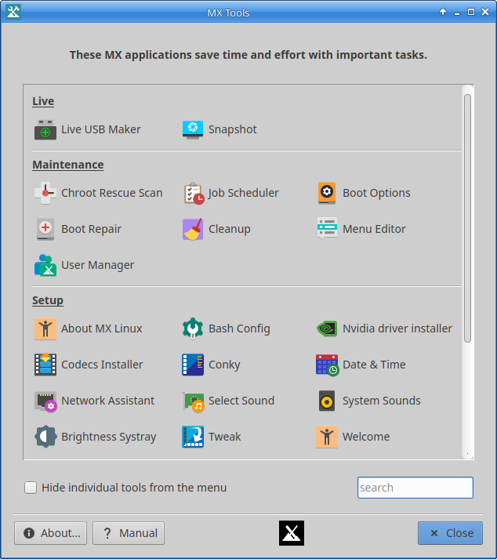

***Figure 3-3: MX Tools dashboard (Xfce installed). Live and KDE dashboards somewhat different.***

### 3.2.1 MX Updater (former Apt-Notifier)

This versatile applet (Xfce only, KDE uses [Discover](https://userbase.kde.org/Discover)) sits in the Notification Area where it notifies you when packages are available. Be sure to check the important options available through the context (right-click) menu. If it doesn’t appear, launch MX Updater to refresh. Xfce only, KDE uses

***Figure 3-4: View and upgrade screen from MX Updater***

Notice the choice between upgrade and dist-upgrade.

* **full-upgrade (dist-upgrade)**: the default action. Will upgrade all packages that have updates, even those where an update will result in the automatic removal of other existing packages or cause new packages to be added to your installation in order that all dependencies are resolved.
* **upgrade**: recommended only for more experienced users. Will only upgrade updateable packages that don't result in other packages being removed or installed. Using this option means some updateable packages may remain “held back” on your system.
* An option for unattended upgrade is available in Preferences. It happens in the background, and neither add new or remove existing packages, using the “upgrade” method rather than dist-upgrade.

HELP: [here.](https://mxlinux.org/wiki/help-files/help-mx-apt-notifier)

### 3.2.2 Bash config

Bash (the default shell language in MX Linux) can now be set up with this small application. It allows the advanced user to make changes to the aliases and terminal prompt theming in the user’s hidden *bashrc* file.

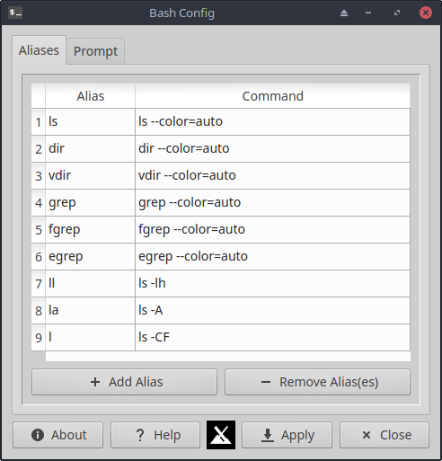

***Figure 3-5: the tab to add or change an alias***

Help: [here](https://mxlinux.org/wiki/help-files/help-bash-config/).

### 3.2.3 Boot options

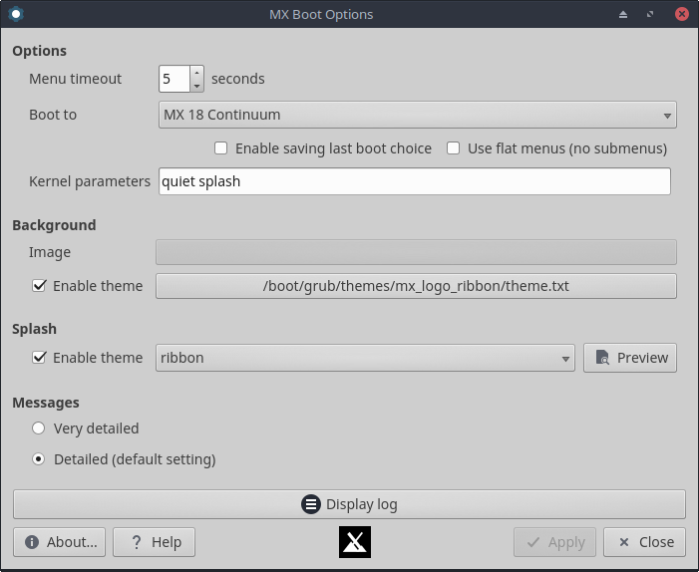

***Figure 3-6: Main screen showing various options***

Boot options include kernel parameters, GRUB themes, Splash images and other items. This app makes it quick qnd easy for users to manage these.

HELP: [here.](https://mxlinux.org/wiki/help-files/help-mx-boot-options)

### 3.2.4 Boot repair

The bootloader is the first software program to run and is responsible for loading and transferring control to the kernel. It sometimes happens that the bootloader on a conventional installation (GRUB2) becomes dysfunctional, and this tool allows you to restore the bootloader to a functional state from a LIVE boot.

***Figure 3-7: Boot Repair main screen, with the most common option selected***

HELP: [here.](https://mxlinux.org/wiki/help-files/help-mx-boot-repair)

### 3.2.5 Brightness Systray

This tool places an icon in the systray that displays a small app with which the user can adjust screen brightness.

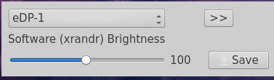

***Figure 3-8: ready to adjust brightness***

### 3.2.6 Chroot Rescue Scan

This tool allows you to get into a system even if its initrd.img is broken.

HELP: [here](https://mxlinux.org/wiki/system/chroot-rescue-scan/).

### 

***Figure 3-9: results of scan for Linux systems***

### 3.2.6 Fix GPG keys (formerly Check apt GPG)

If you try to install non-authenticated packages, you will run into an apt error: *The following signatures couldn’t be verified because the public key is not available.* This helpful utility saves carrying out the many steps necessary to obtain that key.

***Figure 3-10: Results of checking repo public keys with Fix GPG keys***

HELP: [here.](https://mxlinux.org/wiki/help-files/help-mx-check-apt-gpg)

### 3.2.**7** Cleanup

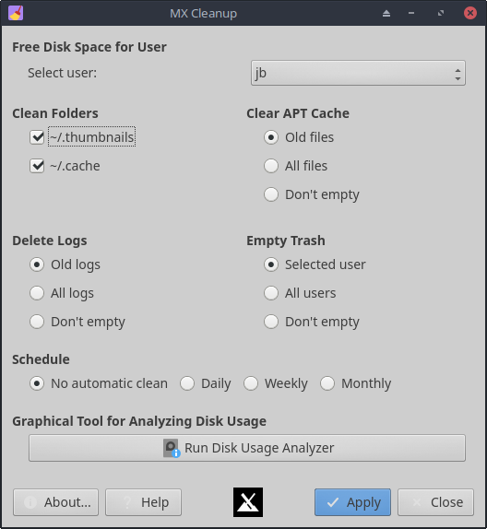

***Figure 3-11: Cleanup ready to go to work***

This handy little app offers an easy and safe way to remove unneeded files and restore space.

HELP: [here](https://mxlinux.org/wiki/help-files/help-mx-cleanup/).

### 3.2.**8** Codecs **Installer**

A codec is a piece of software that enables encoding/decoding a digital data stream or signal. Most codecs will be installed in MX Linux, but some are restricted. Libdvdcss2 (for reading commercial dvds) and libtxc-dxtn0 (for certain 3D game textures) will be installed as well. This tool allows easy installation of certain restricted codecs while transferring the responsibility to the user.

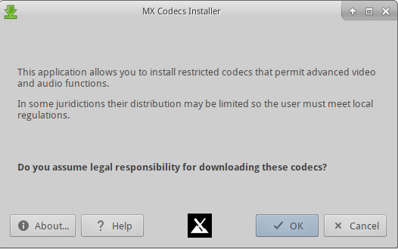

***Figure 3-12: Codecs installer main screen***

HELP: [here.](https://mxlinux.org/wiki/help-files/help-mx-codecs-installer)

### 3.2.**9** Conky

The app called **MX Conky** works in conjunction with [Conky Manager](https://teejeetech.in/conky-manager/) to manipulate details of a conky, especially color, in the MX conky collection very easily. A “conky-toggle” application to turn off and on any configured conky is also in the menu.

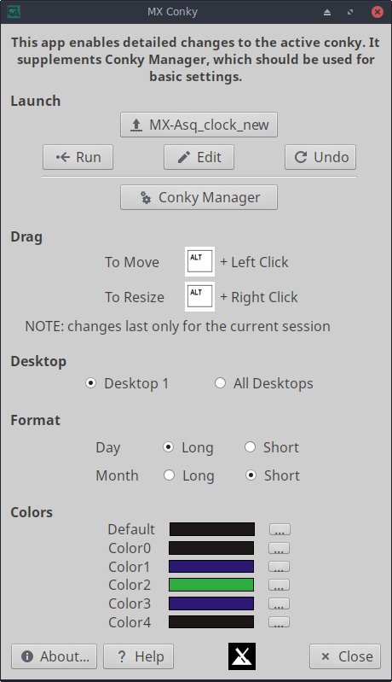

***Figure 3-13: Conky ready to edit details of a default conky***

**HELP:** [**here.**](https://mxlinux.org/wiki/help-files/help-mx-conky)

### 3.2.**10** iDevice Mounter

This app is able to show the contents of an iPhone or iPad in Thunar, a feat otherwise often difficult.

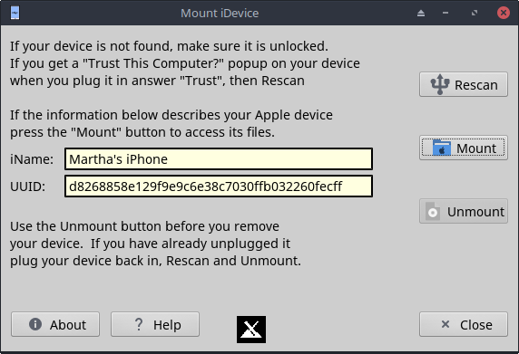

***Figure 3-14: iDevice Mounter ready to mount an iPhone 6***

HELP**:** [here**.**](https://mxlinux.org/wiki/help-files/help-mx-idevice-mounter)

### 3.2.1**1**  Job Scheduler

This handy app presents a graphic frontend to the command-line app [crontab](https://mxlinux.org/wiki/system/crontab/), easing the setup of jobs.

### 

***Figure 3-15: Job Scheduler***

HELP: local file: */usr/share/job-schduler/locale/*.

### 3.2.12 Live-usb Maker

This straightforward tool allows you to create quickly a live-usb starting from an iso file, a live -cd/dvd or an existing live-usb or even a running live system.

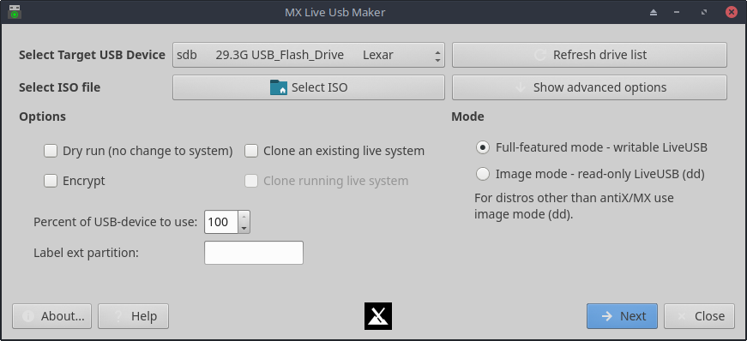

***Figure 3-16: Live USB Maker***

HELP: [here.](https://mxlinux.org/wiki/help-files/help-live-usb-maker)

### 3.2.13 Menu Editor

[MX Menu Editor](https://mxlinux.org/mx-menu-editor)

This simple menu editor makes it easy to edit, add or delete menu items. Any edits are saved to the user’s directory **/.local/shared/applications/**. Xfce only. KDE has its own Menu Editor.

Figure 3-17: Menu Editor with the category Multimedia expanded

HELP: [here.](https://mxlinux.org/wiki/help-files/help-mx-menu-editor)

### 3.2.14 Network Assistant

This application renders the process of troubleshooting network problems much easier by detecting hardware, changing the state of a hardware switch, permitting Linux and Windows drivers to be managed, and providing general network tools.

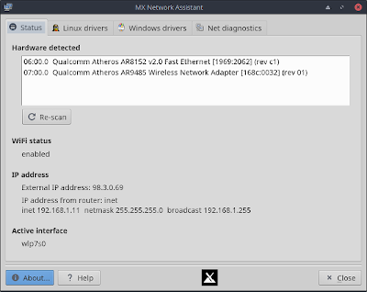

***Figure 3-18: Network Assistant detecting wireless and wired hardware***

HELP: [here.](https://mxlinux.org/wiki/help-files/help-mx-network-assistant)

### 3.2.15 Nvidia driver installer

The nvidia graphics driver installer vastly simplifies an important procedure: to install a proprietary graphic driver using the underlying ddm-mx script.. Clicking on the Nvidia driver installer icon brings up a terminal, and all the user need do in most cases is accept the default.

***Figure 3-19: MX Nvidia driver installer finding no need to continue***

HELP: [here](https://mxlinux.org/wiki/help-files/help-amdati-and-nvidia-installers).

### 3.2.16 Package Installer

[Install Apps with MX Package Installer](https://www.youtube.com/watch?v=4kXSMfPkQSA)

The custom simple package manager for MX Linux allows you to can search for, install, or remove both popular packages and any package in the MX/Debian Stable, the MX Test, Debian Backports, and Flatpak repositories quickly, safely, and easily.

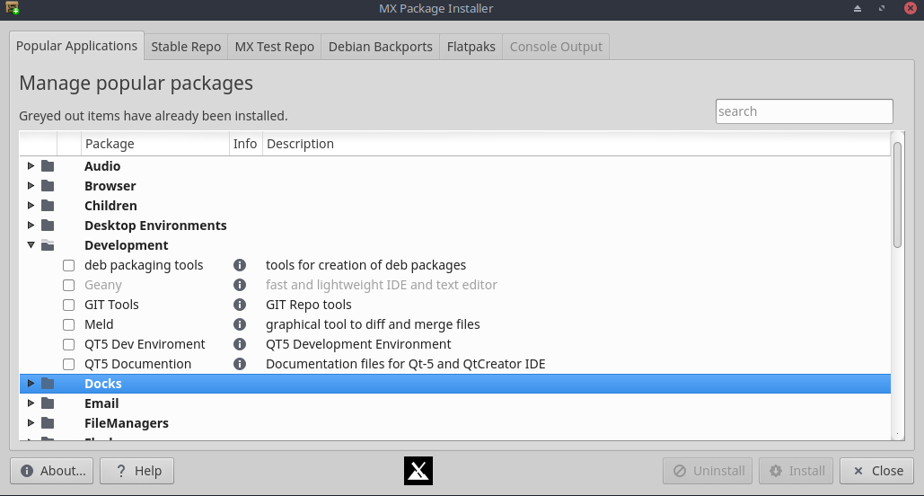

***Figure 3-20: Package Installer, showing popular packages for Development***

HELP: [here.](https://mxlinux.org/wiki/help-files/help-mx-package-installer)

### 3.2.17 Repo Manager

There are many reasons why the user might want to change the default mirror being used, ranging from a server being offline to a change in the physical location of the computer. This great tool provides one-click switching of repos, saving a lot of time and effort. It also provides a button that will test all repos (MX or Debian) and select the fastest.

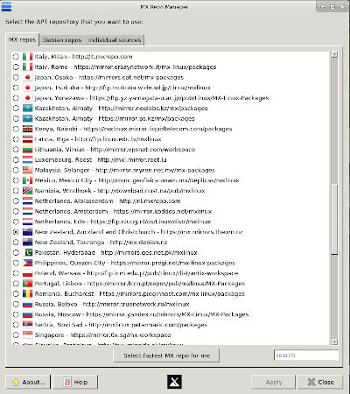

***Figure 3-21: Choosing a repository to use in Repo Manager***

HELP: [here.](https://mxlinux.org/wiki/help-files/help-mx-repo-manager)

### 3.2.1**8** Sound Card

Computers frequently have more than one sound card available, and the user who hears nothing may conclude that sound is not working. This clever little application allows the user to select which sound card should be used by the system.

***Figure 3-22: Making the selection in Sound Card***

HELP: [here.](https://mxlinux.org/wiki/help-files/help-sound-card)

### 3.2.1**9** System Keyboard

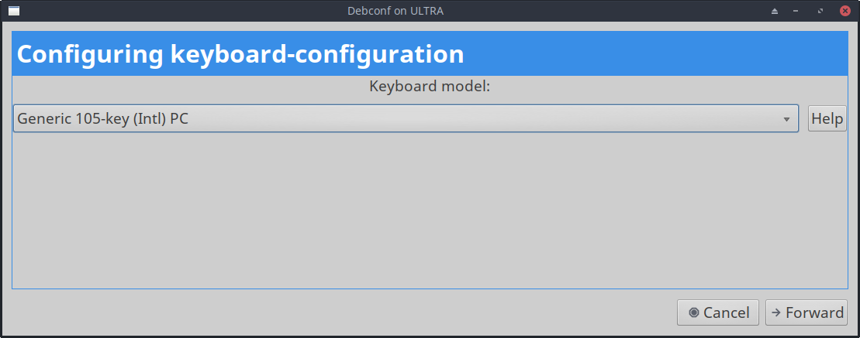

***Figure 3-23: Main screen ready for the user to select a different keyboard***

In case the user neglected to select system keyboard from the Login menu, missed setting it up on the Live session, or just needs to make a change, this little app provides an easy way to carry out that operation from the Start menu.

HELP: [here.](https://mxlinux.org/wiki/help-files/help-mx-system-keyboard)

### 3.2.20 System Locales

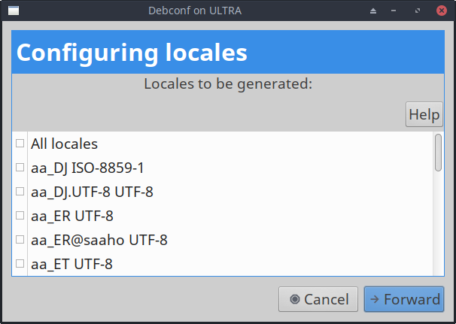

***Figure 3-24: Presentation of locales to be generated for the user.***

In case the user neglected to select system locale from the Login menu, missed setting it up on the Live session, or just needs to make a change, this little app provides an easy way to carry out that operation from the Start menu.

HELP: [here.](https://mxlinux.org/wiki/help-files/help-mx-system-locales)

### 3.2.21 System Sounds (Xfce only)

This little tool gathers into a single location the various actions and choices involved in setting up system sounds such as login/logout, actions, etc.

***Figure 3-25: Setting up login and logout sounds in System Sounds***

HELP: [here.](https://mxlinux.org/wiki/help-files/help-mx-system-sounds)

### 3.2.22 Date & Time

MX Date & Time requires root access, and allows adjustments of all kinds to be made from a single app.

***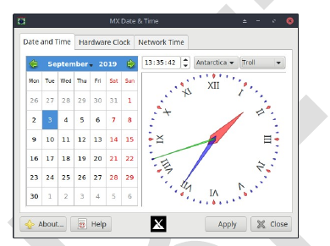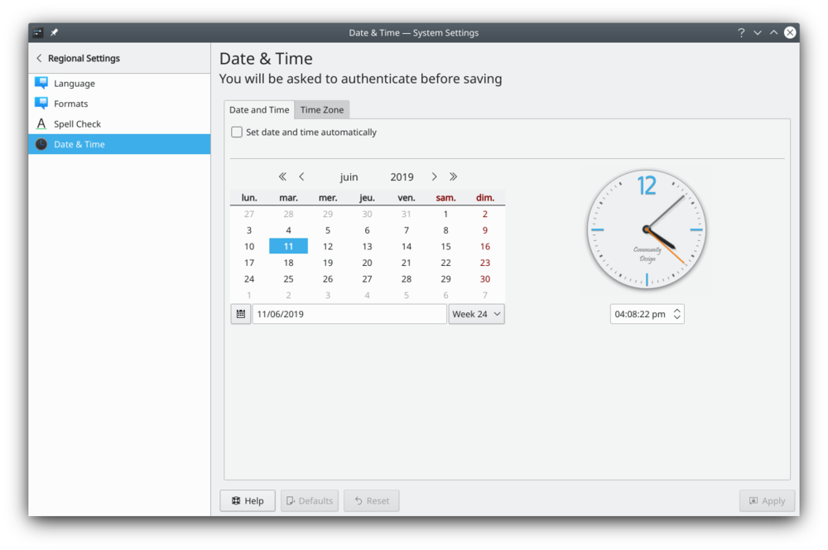***

***Figure 3-26: The main tab of Date & Time. Left: Xfce, Right: KDE***

HELP: [here](https://mxlinux.org/wiki/help-files/date-time/) and [here](https://userbase.kde.org/System_Settings/Date_%26_Time).

### 3.2.23 Tweak

MX Tweak brings together a number of small but often used customizations such as panel management, theme selection, compositor enabling and setup, etc. on a per-desktop basis.

***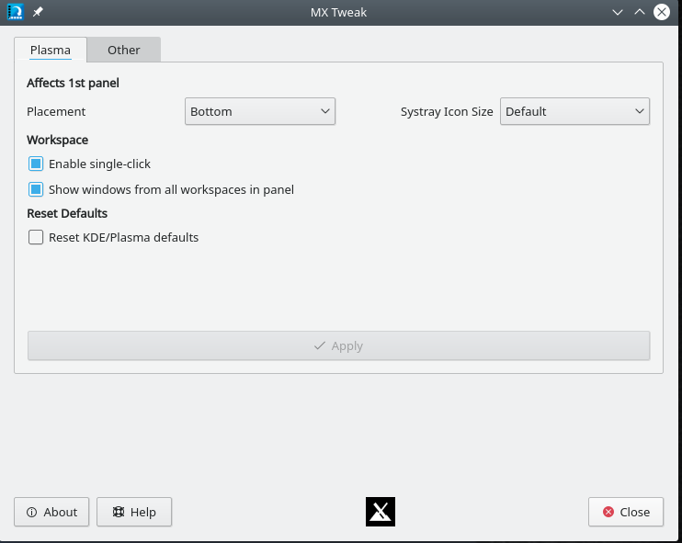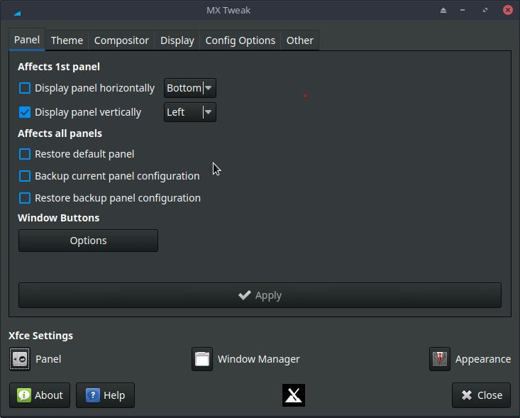***

***Figure 3-27: The faces of MX-Tweak. Right: Plasma, Left: XFCE***

HELP: [here](https://mxlinux.org/wiki/help-files/help-mx-tweak).

### 3.2.2**4** Format USB

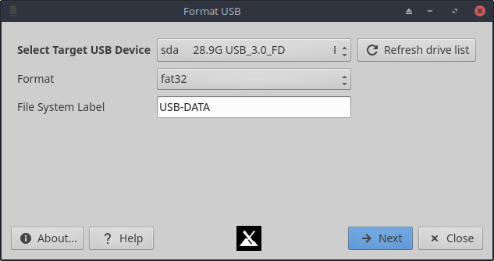

***Figure 3-28: USB Formatter ready to reformat with fat32***

This convenient little tool will clean out and reformat a USB drive in order to make it available for new purposes.

HELP: [here](https://mxlinux.org/wiki/help-files/help-mx-format-usb/).

### 3.2.25 USB Unmounter

This tool for quickly unmounting USB and optical media sits in the Notification Area when enabled (default). A single click displays available media for unmounting with a double-click.

***Figure 3-29: USB Unmounter with a device highlighted for unmounting***

HELP: [here](https://www.mxlinux.org/wiki/help-files/help-mx-usb-unmounter).

### 3.2.26 User Manager

This application aids in adding, editing and removing users and groups in your system.

***Figure 3-30: User Manager, Administration tab***

HELP: [here.](https://mxlinux.org/wiki/help-files/help-mx-user-manager)

### 3.2.3 Deprecated Tools

Some users will look for tools that either no longer exist or have been incorporated into new tools.

* ATI/AMD Driver Installer: removed for lack of suitable driver candidate.
* Broadcom Manager: rewritten for more general needs as Network Assistant.
* Compton Manager: incorporated into MX Tweak.
* Debian Backports Installer: incorporated into Package Installer.
* Default Look: incorporated into MX Tweak.
* Find Network Shares: removed because of licensing concerns.
* Flash Manager: Adobe® Flash® Player is now deprecated and has been completely removed.
* Panel Orientation: incorporated into MX Tweak.
* Test Repo Installer: incorporated into Package Installer .

## **3.3 Display**

### **3.3.1 Resolution**

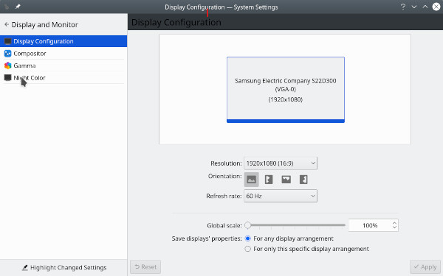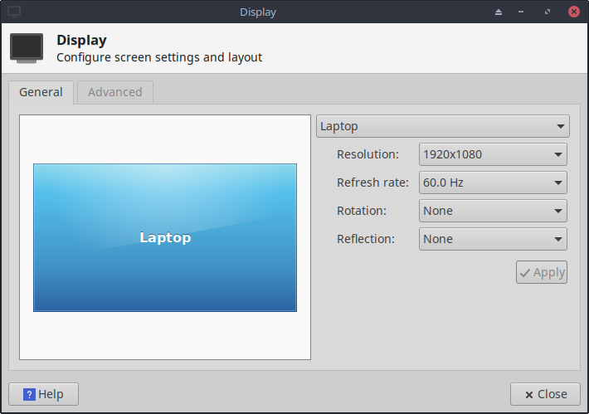

***Figure 3-31: Display utility . Left: Xfce, Right: KDE/plasma.***

Resolution refers to the physical number of columns and rows of pixels creating the display (e.g., 1920x1200). In most cases, the resolution is correctly set by the kernel during installation or when a new monitor is connected. If not, you can change it in the following ways:

* Click Start Menu > Settings > Display. Use the pull-down menus to set the correct values for the monitor you want to adjust. For more options and finer control, install [xrandr](https://xorg-team.pages.debian.net/xorg/howto/use-xrandr.html) from the repos.
* 4.16 Xfce’s Display now makes fractional scaling for HiDPI monitors possible. Click on the pull-down menu for “Scale” and select Custom.
* For Nvidia cards, you can install the package **nvidia-settings** that will give you a graphic tool that you can use to alter settings as root with the command: nvidia-settings
* In difficult situations, it is possible to manually alter the configuration file /etc/X11/xorg.conf. It may not exist, so you might need to [create it](https://wiki.debian.org/Xorg" \l "What_if_I_do_not_have_a_xorg_config_file.3F) first. Always back up the file before you change it, and check the Forum for help about the use of that file.

### 3.3.2 Graphic drivers

If you are not satisfied with your display’s performance, you may need/want to upgrade your graphic driver (make sure to first back up the file /etc/X11/xorg.conf, if used). Note that after a kernel upgrade you may have to repeat this, see Section 7.6.3.

There are various methods available to do this.

* For most **Nvidia** cards, by far the easiest method is to use the installers accessible from the MX Tools dashboard (see Section 3.2).
  + Some older or less common video cards require drivers (such as openchrome, mach64 & fbdev) that are only easily installable with **sgfxi** (Section 6.5.3).
  + Some Nvidia cards are no longer supported in Debian Stable (“Jessie”), see [the MX/antiX Wiki](https://mxlinux.org/wiki/hardware/unsupported-nvidia-gpus). They are, however, supported by the [nouveau](https://en.wikipedia.org/wiki/Nouveau_(software)) and vesa drivers.
* Consult [the Debian Wiki](https://wiki.debian.org/AtiHowTo) about open-source ati, radeon,and amdgpu drivers. Note that open drivers for AMD are no longer avalable.
* It is also possible, but more complicated, to download directly from the manufacturer. This method will require you to select and download the correct driver for your system; for system info, open a terminal and enter: *inxi -Gxx*.

Here are driver websites for the most popular brands (do a web search on “<brandname> linux driver” for others):

* + [Nvidia](http://www.nvidia.com/Download/index.aspx)
  + [Intel](https://www.intel.com/content/www/us/en/download-center/home.html)

Intel drivers *must* be [compiled](https://mxlinux.org/wiki/applications-system/compiling-software), but downloaded Nvidia drivers are easily installed:

* + Navigate in Thunar to the folder where the driver was downloaded
  + Right-click the file, select the Permissions tab, check Is **executable**
  + Press CTRL-ALT-F1 to exit X (the graphical environment) and get to a terminal prompt
  + Log in as root
  + Type: *service lightdm stop*
  + Type: *sh <filename>.run* (make sure to use the actual name of the file)
  + Allow the NVIDIA driver to turn off the nouveau kernel
  + When it finishes, type: *service lightdm start* to start lightdm and xorg again.
* Another important driver option is [**mesa**](https://docs.mesa3d.org/)**,** an open-source implementation of the [OpenGL](http://www.opengl.org/) specification - a system for rendering interactive 3D graphics. Users on high-performance machines report that upgrading this brings a significant stabilization to their system.
  + A more recent version may be available in the Test Repo; use the MX Package Installer (Section 3.2) to get it. Uncheck the box that hides the lib and dev packages, search for "mesa", and check off the packages that are upgradeable for installation.
* Hybrid graphics cards combine two graphic adapters on the same unit. A popular example is the [NVidia Optimus](https://en.wikipedia.org/wiki/Nvidia_Optimus), which is supported on Linux with Bumblee. Newer graphics cards can also use the primus functions built-in to the nvidia-driver through without the bumblee system. To run an application under primus functions use “nvidia-run-mx APP” to start an app with the graphics acceleration enabled.

### 3.3.3 Fonts

#### Basic adjustment

1. XFCE- Click **Start Menu > All Settings > Appearance**, Fonts tab
2. KDE/plasma - Click **Start Menu > SystemSettings >** Fonts
3. Click on the pull-down menu to see the list of fonts and point sizes
4. Select the one you want, and click OK

#### Advanced adjustments

1. A number of options are available by running in a root terminal: ***dpkg-reconfigure fontconfig-config***
2. Individual apps may have their own controls, often found in Edit (or Tools) > Preferences
3. For further adjustment, see [the MX/antiX Wiki](https://www.mxlinux.org/wiki/system/font-adjustment).
4. High Resolution Displays have special needs, see [the MX/antiX Wiki](https://mxlinux.org/wiki/other/high-resolution-displays).

#### Adding fonts

1. There are a few in MX Package Installer available with a single click. For more possibilities, click **Start Menu > System > Synaptic/Muon Package Manager**.
2. Use the search function for fonts.
3. Select and download the ones you want. The Microsoft core fonts package **ttf-mscorefonts-installer** (installed by default) provides easy installation of the Microsoft True Type Core Fonts for use with websites and MS applications that run under Wine.
4. Extract if necessary, then copy as root (easiest in a root Thunar) the font folder to **/usr/share/fonts/**.
5. Your new fonts should be available in the pull-down menu in All Settings > Appearance, Fonts tab.

### 3.3.4 Dual monitors

Multiple monitors are managed in MX Linux Xfce with Start menu > Settings > Display. You can use it to adjust resolution, select whether one clones the other, which ones will be turned on, etc. It is often necessary to log out and back in to see the display you select. Users should also look at the Display tab of MX Tweak. Finer control of some features is sometimes available with **xrandr**.

Xfce 4.16 has improved handling multiple monitors greatly, with settings on the Advanced tab of Display that permit detailed settings for each monitor and the ability to save monitor profiles and have them automatically used when the same hardware is connected again. If problems persist, search [the Xfce Forum](https://forum.xfce.org/), the MX Linux Forum and [the MX/antiX WIki](https://mxlinux.org/wiki/xfce/xfce-commands-and-other-useful-stuff) if you are having unusual problems.

in KDE/Plasma dual monitors are set up with the Display configuration tool.

Links

* [Xfce Docs: Display](https://docs.xfce.org/xfce/xfce4-settings/4.14/display)

### 3.3.5 Power management

Click the Power Manager plugins icon in the Panel. Here you can easily switch to Presentation mode (Xfce), or go to the Settings to set when a display shuts down, when the computer goes into suspension, the action initiated by closing the lid of a laptop, brightness, etc. On a laptop, battery status and information is displayed and a brightness slider is available.

### 3.3.6 Monitor adjustment

There are several tools available for adjusting the display for particular monitors.

* Screen brightness can be set with Start menu > Settings > Power Manager, Display tab or with MX Tweak. There is a new MX Tool called “Brightness systray” (3.that will place a handy widget in the systray.
* For users with Nvidia, use **nvidia-settings** as root for fine-tuning the display.
* To change the [gamma](https://en.wikipedia.org/wiki/Gamma_correction) (contrast), open a terminal and enter:

*xgamma -gamma 1.0*

1.0 is the normal level; change it up or down to decrease/increase contrast.

* Color of the display’s adaptation to the time of day can be controlled with [fluxgui](https://justgetflux.com/linux.html) or [Redshift](http://jonls.dk/redshift/).
* For more advanced adjustment and profile creation, install [DisplayCAL](https://displaycal.net/).
* Color profiles can be created: Start > Settings > Color Profiles. A color profile is a set of data that characterizes a color input or output device, and most are derived from [ICC profiles](https://en.wikipedia.org/wiki/ICC_profile).

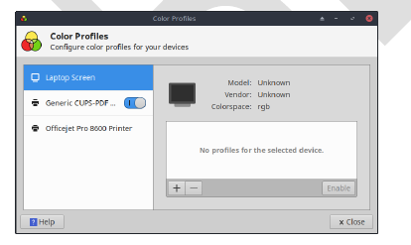

***Figure 3-32: Getting ready to add a color profile***

HELP: [here](https://docs.xfce.org/xfce/xfce4-settings/4.16/display).

### 3.3.7 Screen tearing

Screen tearing is a visual artifact in video display where a display device shows information from multiple frames in a single screen draw (Wikipedia). It tends to vary greatly depending on factors that include graphics hardware, particular application and user sensitivity. This problem has been greatly relieved with the release of Xfce 4.14 and later by default.

In MX Linux, various solutions are available:

* Click the Compositor tab in MX Tweak, and use the pull-down menu to switch from the default [xfwm](https://docs.xfce.org/xfce/xfwm4/start) to Compton, a free-standing [compositor](https://en.wikipedia.org/wiki/Compositing).
* Use the pull-down menu to alter the vertical spacing (vblank).
* When an Intel graphics driver is detected, a check box becomes available in MX Tweak > Config Options tab that switches the system away from the default "modesetting," a switch that enables the Intel driver's TearFree option. Tearfree options also exist for nouveau, radeon, and amdgpu, and are displayed as appropriate.

Links

* [MX/antiX Wiki](https://mxlinux.org/wiki/hardware/screen-tearing)

## 3.4 Network

Internet connections are handled by Network Manager:

--Left-click the applet in the Notification Area to see status, connect and explore options.

--Right-click the applet > Edit Connections to open up a Settings box with five tabs.

* Wired. In most situations this requires no attention; highlight and click the Edit button for special setups.
* Wireless
  + Network Manager will usually automatically detect your network card and use it to find available access points. In some situations, the command-line tool Ceni in the repos may be helpful.
  + For details, see Section 3.4.2 below.
* Mobile Broadband. This tab allows you to use a 3G/4G mobile device for access to the web. Click the Add button to set up.
* VPN. Click the Add button to set up. If you experience setup problems, consult [the MX/antiX Wiki](https://mxlinux.org/wiki/networking/vpn).
* DSL. Click the Add button to set up.

***Figure 3-33: Network Manager main screen***

MORE: [Ubuntu Wiki: Network Manager](https://help.ubuntu.com/community/NetworkManager)

### 3.4.1 Wired access

MX Linux typically picks up wired internet access upon boot without much problem. If a Broadcom driver is required (rare), then use MX Network Assistant (Section 3.2)

#### Ethernet and cable

MX Linux comes preconfigured for a standard LAN (Local Area Network) that uses DHCP (Dynamic Host Configuration Protocol) to assign IP addresses and DNS (Domain Name System) resolution. This will work in most cases as-is. You can change the configuration with Network Manager.

When you boot MX Linux, your network adapters are assigned a short interface name by udev, the kernel’s device manager. For normal wired adapters this is usually eth0 (with subsequent adapters eth1, eth2, eth3, etc). USB adapters often come up on the eth0 interface in MX Linux, but the interface name can also depend on the adapter’s chipset. For instance, atheros cards often show up as ath0, while ralink usb adapters may be rausb0. For more a detailed list of all found network interfaces, open a terminal, become root, and enter: *ifconfig -a*.

It is wise to connect to the Internet through a router, as nearly all wired routers contain optional firewalls. In addition, routers use NAT (Network Address Translation) to translate from big Internet addresses to local IP addresses. This affords another layer of protection. Connect to the router directly, or through a hub or switch, and your machine should autoconfigure via DHCP.

#### ADSL or PPPoE

If you use ADSL or PPPoE, connecting to the internet is easy in MX Linux. Right-click the Network Manager icon, then the DSL tab. Click the Add... button and fill in the required information, checking to connect automatically if you want.

NOTE: if you encounter problems when using a USB device to connect, plug the unit into the computer, open a terminal and type:

*dmesg* ***|*** *tail*

Post the output on the Forum with to get some help in finding the driver you need.

Figure 3-34: Setting up DSL service

#### Dial-Up

On the Device tab you will need to set up the serial information. Accepting the default /dev/modem may work, but you might need to try another interface. These are the Linux equivalents of the COM ports under MS-DOS and MS-Windows:

***Table 3: Linux equivalents for COM ports***

|  |  |
| --- | --- |
| ***Port*** | ***Equivalent*** |
| **COM 1** | /dev/ttyS0 |
| **COM 2** | /dev/ttyS1 |
| **COM 3** | /dev/ttyS2 |
| **COM 4** | /dev/ttyS3 |

### 3.4.2 Wireless access

MX Linux comes preconfigured to autodetect a WiFi card, and in most cases your card will be found and set up automatically. There are two standard ways wireless can be supported in MX Linux:

* With a native driver. That usually comes as part of the Linux kernel (example: ipw3945 for Intel), but on some, especially newer machines it may be necessary to download a driver using the information in Quick System Info > Network.
* With a Windows driver using the application Ndiswrapper (available from the repos), which “wraps” your Windows driver so that it can be used in a Linux system (example: bcmwl5 for some Broadcom chipsets). See below for more.

Sometimes there is both a native Linux driver and a Windows driver available. You may want to compare them for speed and connectivity, and you may have to blacklist or remove the one you are not using to prevent a conflict. Wireless cards can be either internal or external. USB modems (wireless dongles) usually show up on the wlan interface, but if not then check others on the list. NOTE: The successful method varies for users because of the complicated interactions among the Linux kernel, wireless tools, and the local wireless card chipset and router.

#### Basic Wireless Steps

Click **Start menu > Settings > Network Connections** (or just click on the Network Manager icon in the Notification Area), and then the Wireless tab. One of 3 situations will arise.

–**A wireless network has been found**.

* Click on the name of the network to use it.
  + Right-click the icon to access further options.
  + When done, click OK.

–**The found network does not function**.

If wireless networks are seen but your computer cannot connect them, this means that either 1) the wireless card is managed correctly by the right driver but you have problems concerning the connection to your modem/router, the firewall, the provider, DNS, etc.; or 2) the wireless card is managed abnormally because the driver is not the most appropriate for that card or there are problems of conflict with another driver. In this case you should gather information on your wireless card to see if the card drivers may have problems and then try to test the network with a set of diagnostic tools.

* Find out basic information by opening a terminal and entering one at a time:

*inxi -n*

*lsusb | grep -i net*

*lspci | grep -i net*

And as root:

*iwconfig*

The output from these commands will give you the name, model and version (if any) of your wireless card (example below), as well as the associated driver and the mac address of the wireless card. The output of the fourth will give you the name of the access point (AP) you are linked to and other connection information. For example:

*Network  
Card-2:Qualcomm Atheros AR9462 Wireless Network Adapter driver: ath9k   
IF: wlan0 state: up mac: 00:21:6a:81:8c:5a*

Sometimes you need the mac number of the chipset in addition to that of your wireless card. The easiest way to do that is to click **Start menu > System > MX Network Assistant**, Introduction tab. For example:

*Qualcomm Atheros AR9485 Wireless Network Adapter [168c:0032](rev 01)*

The number in brackets identifies the type of chipset in your wireless card. The numbers before the colon identify the manufacturer, those after it the product.

Use the information you have gathered in one of the following ways:

* Do a web search using that information. Some examples using the above lspci output.

*linux Qualcomm Atheros AR9462*

linux 168c:0032

debian stable 0x168c 0x0034

* + Consult the Linux Wireless and the Linux Wireless LAN Support sites below to find out which driver your chipset needs, what conflicts might exist, and whether it needs firmware installed separately. Post your information on the Forum and ask for help.
  + Turn off the firewall, if any, until the linkage occurs between computer and router.
  + Try restarting the router.
  + Use the Diagnostic Section in MX Network Assistant to ping your router using the mac address, ping to any website such as Google or run [traceroute](https://en.wikipedia.org/wiki/Traceroute). If you can ping a site using its IP (gotten from a web search) but you can not reach it with its domain name, then the problem may be in the configuration of the DNS. If you don’t know to interpret the results of ping and traceroute do a web search or post the results on the Forum.
  + Sometimes using the terminal application **Ceni** (in the repos) can reveal hidden access points and other difficult factors. **NOTE**: using Ceni to configure your network interface in MX Linux will interfere and/or disable management of that interface by the default Network Manager. Ceni stores its configuration info in /etc/network/interfaces. Any interface defined in /etc/network/interfaces will be ignored by Network Manager, as Network Manager assumes that if a definition exists, you want some other application managing the device.

–**No wireless interface is found.**

* Open a terminal and type the 4 commands listed at the beginning of the previous section. Identify the card, chipset and driver you need by doing a web search and consulting the sites reported, according to the procedure described above.
  + Look for the network entry, and note the detailed information on your specific hardware, and look for more information about that from the LinuxWireless site listed below, or ask on the Forum.
  + If you have an external wifi device and no information on a network card is found, unplug the device, wait a few seconds then plug it back in. Open a terminal and enter:

 dmesg | tail

Examine the output for information about the device (such as the mac address) that you can use to pursue your issue on the web or the Forum.

* + Probably the most common example of this situation arising is with the **Broadcom wireless chipsets**; see the [MX/antiX Wiki](https://mxlinux.org/wiki/hardware-networking/broadcom-wireless).

#### Firmware

For some cards it is necessary to install firmware (for example, **firmware-ti-connectivity** for Texas Instruments WL1251). MX Linux comes with a good deal of firmware already available, either installed or in the repos, but you may have to track down your particular need, again using the LinuxWireless website linked below or check the Forum.

#### Ndiswrapper

[Ndiswrapper](http://en.wikipedia.org/wiki/NDISwrapper) is an open-source software driver “wrapper” that enables the use of Windows drivers for wireless network devices in Linux. It does not come pre-installed in MX Linux, but is in the repos. **NOTE**: the Windows driver you use must match the OS architecture (e.g., Windows 32-bit driver for MX Linux 32-bit edition). In general, Windows XP drivers are required.

The easiest method of managing Ndiswrapper is to use **MX Network Assistant** (Section 3.2). See also the extended discussion in [the MX/antiX Wiki](https://mxlinux.org/wiki/applications-networking/ndiswrapper).

#### Security

Wireless security is handled by Network Manager. Here are the basic steps you need to follow:

* Right-click the Network Manager icon in the Notification Area > Edit connections
* Click on the Wireless tab, and highlight the name of the access point you want to connect to (for example, “linksys” or “starbucks 2345”)
* Click the Edit button and then the Wireless Security tab
* Use the pull-down menu to select the security you want (for example: WPA and WPA2 Personal)
* Enter the password and click Save.

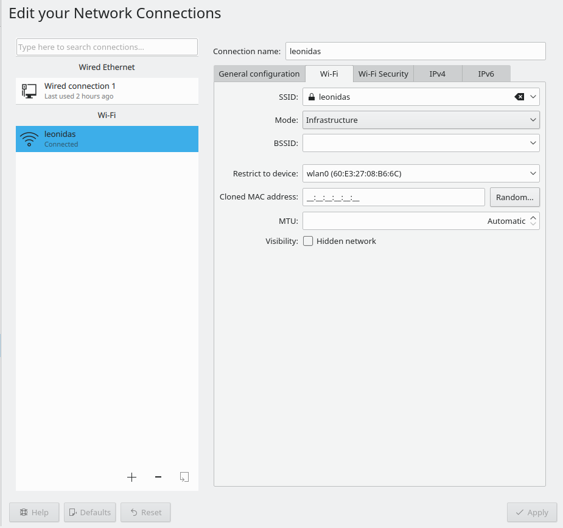

Figure 3-35: Wireless security in Network Manager (Left: Xfce, Right: KDE/plasma)

It is equally possible to use Ceni to handle wireless security, as long as subsequently you will not be using Network Manager, with which it interferes.

#### **Links**

* [Linux Wireless](https://wireless.wiki.kernel.org/)
* [Linux Wireless LAN Support](http://linux-wless.passys.nl/)
* [Debian Wiki: Wifi](http://wiki.debian.org/WiFi)
* [Arch Wiki: Wireless](https://wiki.archlinux.org/index.php/Wireless)

### 3.4.3 Mobile Broadband

For wireless internet access using a 3G/4G modem, please refer to the Debian Wiki’s 3G pages linked below for compatibility information. Many 3G/4G modems will be recognized on MX Linux by Network Manager.

### 3.4.4 Tethering

Tethering refers to the use of a device like a mobile phone or mobile wifi hotspot to provide mobile internet access to other devices, such as a laptop. A "hotspot" needs to be created on the device with access for the other device to use. It is easy to set up an Android phone as a hotspot, though directions vary to some extent depending on the Android version. In Android 9: Settings > Connections > Mobile Hotspot and Tethering > Mobile Hotspot. To make the laptop the hotspot, consult [this video](https://www.youtube.com/watch?v=WeKcWTQc7mY&feature=youtu.be).

#### Troubleshooting

On some systems, modem connections fail due to an upgrade of the packages **udev** and **libudev1**. To solve this, open Synaptic, highlight the packages, and then click Package> Force version... Use the pull-down menu to drop to a lower version and click the Apply icon.

In some cases this solution has not worked consistently for users, but they have found that the complete removal of **Network Manager** solved the problems.

MORE: [Debian Wiki: 3G modem](http://wiki.debian.org/Modem/3G)

### 3.4.5 Command line utilities

Command line utilities are useful for seeing detailed information, and are also commonly used in troubleshooting. Detailed documentation is available in the man pages. The most common ones below must be run as root.

***Table 4: Wireless utilities***

|  |  |
| --- | --- |
| ***Command*** | ***Comment*** |
| **ifconfig** | Main configuration utility for network interfaces. |
| **ifup <interface>** | Brings up the specified interface. For example:  **ifup eth0** will bring up the ethernet port eth0 |
| **ifdown <interface>** | The opposite of ifup |
| **iwconfig** | Wireless network connection utility. Used by itself, displays wireless status. Can be applied to a specific interface, e.g. to select a particular access point |
| **rfkill** | Disable softblock for wireless network interfaces (e.g., **wlan**). |
| **depmod -a** | Probes all modules and, if they have changed, enables new configuration. |

### 3.4.5 Static DNS

It is sometimes desirable to change your internet setup from the default automatic [**DNS**](https://en.wikipedia.org/wiki/Domain_Name_System) (Dynamic Name Service) configuration to a manual static one. Reasons for doing this may include greater stability, better speed, parental control, etc. You can make such a change either for the whole system or for individual devices. In either case, get the static DNS settings you are going to use from OpenDNS, Google Public DNS, etc., before you start.

#### System

You can make the change for everyone using your router using a browser. You will need:

* the router’s URL (list [here](http://www.techspot.com/guides/287-default-router-ip-addresses/) if you have forgotten)
* its password, if you set one

Find and change your router’s configuration panel, following the directions for your particular router (list of guides [here](https://support.opendns.com/forums/21618374)).

#### Individual

For single user change, you can use Network Manager.

* Right-click the connection icon in the Notification Area > Edit connections...
* Highlight your connection and click the Edit button.
* On the IPv4 tab, use the pull-down menu to change the Method to “Automatic (DHCP) addresses only”
* In the box for “DNS Servers” enter the static DNS settings you are going to use.
* Click Save to exit.

## 3.5 File management

File management in MX Linux is carried out through Thunar on Xfce and dolphin on KDE/plasma. Much of their basic use is self-evident, but here are good things to know:

* Hidden files are out of sight by default, but can be made visible via the menu (View > Show Hidden Files); or by pressing Ctrl-H
* The Side Pane can be hidden, and directory (folder) shortcuts can be placed there by right-clicking > Send To or drag-and-drop
* The context menu has been populated with common procedures (“Custom Actions” on Xfce and “Actions” & “Root Actions” on KDE/plasma) that vary by what is present or under focus.
* Root action is available via the context menu to open a terminal, edit as root, or open an instance of File Manager with root privileges.
* The File Managers easily handle FTP transfers, see below.
* [Custom Actions](http://docs.xfce.org/xfce/thunar/custom-actions) greatly increase the power and utility of the File Managers. MX Linux comes with many pre-installed, but there are others available to copy and the individual can create them for individual needs. See Tips and Tricks (Section 3.5.1), below; and [the MX/antiX Wiki](https://mxlinux.org/wiki/applications/thunar-custom-actions).

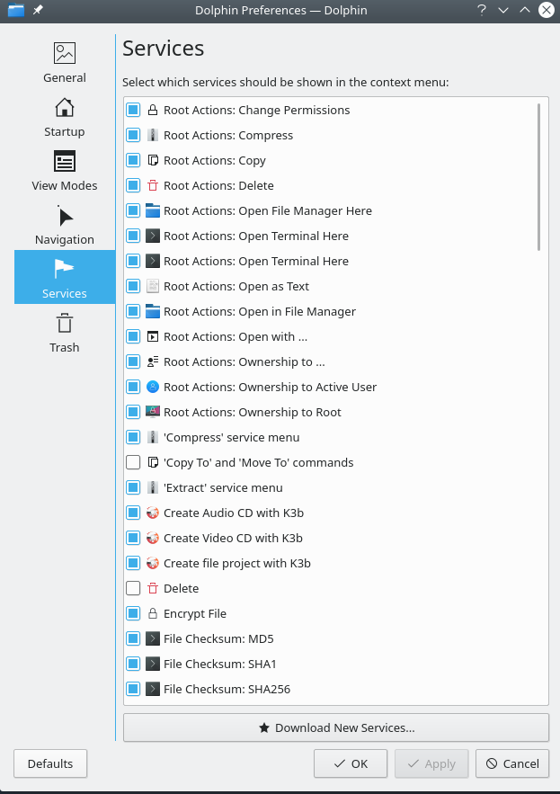

***Figure 3-36: Left: Custom actions set up in Thunar*** Right: Custom Services in Dolphin

### 3.5.1 Tips and Tricks

* When working in a directory that requires superuser privileges, you can right-click > Open root Thunar here (or File > Open root Thunar here) or the similar “Root Action” in dolphin.
* Superuser privilege can be changed in MX Tweak > Other tab from using either the user’s password (default) or an administrative password, if one has been set up.
* You can set up tabs with File > New Tab (or Ctrl-T), then move items from one location to another by dragging them to a tab and releasing it.
* You can assign a keyboard shortcut key to the Custom Action “Open terminal here.”

--Thunar/Xfce

* + - Enable editable accelerators in All Settings > Appearance > Settings.
    - In Thunar, hover your mouse over the File > Open in Terminal menu item and press the keyboard combination that you would like to use for that action.
    - Then when browsing in Thunar, use the keyboard combination to open a terminal window in your active directory.
    - This applies equally to other items on Thunar’s File menu; for instance, you could assign Alt-S to create a symlink for a highlighted file, etc.
    - Actions listed in the context menu can be edited/deleted, and new ones added, by clicking Edit > Configure custom actions...
* dolphin/KDE-plasma: select Settings > Configure Keyboard Shortcuts and find Terminal entry.
* Various options and hidden commands are also visible, see Links below.
* Both Java and Python are sometimes used to produce applications, carrying the ending \*.jar and \*.py, respectively. These files can be opened with a single click, like any other file; no more need to open a terminal, figure out what the command is, etc. CAUTION: be careful of potential security issues.
* Compressed files (zip, tar, gz, xz, etc…) can be managed by a right-click on the file.
* To find files:

--Thunar/Xfce: open Thunar and right-click any folder > Find files here. A dialog box will pop up to give you options. Running in the background is catfish (Start menu > Accessories > Catfish).

--dolphin/KDE-plasma: Use Edit > Search in the dolphin toolbar.

* Links/symlinks

--Thunar/Xfce: To set up a soft link (AKA symlink)--a file that points to another file or directory--right-click the target (file or folder you want the link to point to) > Create symlink. Then right-click the new symlink, cut it and paste it to where you want it.

--dolphin/KDE-plasma: Right click on on empty spot in the dolphin window and use Create New > Basic link to file or directory

* Thunar custom actions. This is a powerful tool to expand the file manager’s functions. To see the ones that are predefined during MX Linux development, click Edit > Configure Custom Actions. The dialogue box that pops up will show you what is predefined and give you an idea of what you can do yourself. To create a new Custom Action, click on the “+” button on the right. Details in [the MX/antiX wiki](https://mxlinux.org/wiki/applications/thunar-custom-actions).
* Folders can be displayed with images by placing an image that ends in \*.jpg or \*.png into the folder and renaming it “folder”

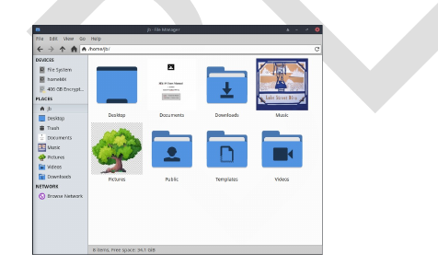

***Figure 3-37: using images to label folders***

### 3.5.2 FTP

Figure 3-38: Using Thunar to access an FTP site

The File Sharing Protocol (FTP) is used to transfer files from one host to another host over a network.

Xfce

* Open File Manager and click on Browse Network at the bottom of the left pane. Then click the Address bar at the top of the browser (or use Cntrl+L) and backspace to
* Backspace in the address field to delete what is there (network:///), then type the server name with the **ftp://** prefix. For example, to reach the MX documentation (if you have permission) you would enter this address: *ftp://mxlinux.org*
* Up pops an authorization dialog box. Fill in username and password, and let it save password if you are comfortable with that.
* That’s it. Once you have navigated to the folder you are always going to use, you can right-click the folder and in Thunar > Send to > Side Pane or in dolphin > Add to Places to create a very simple way to connect.

KDE

* Consult [the KDE userbase](https://userbase.kde.org/File_transfers).

Dedicated FTP applications such as Filezilla can be used as well. For a discussion of how FTP works, see [this page](http://www.ncftp.com/libncftp/doc/ftp_overview.html).

### 3.5.3 File sharing

There are various possibilities to share files between computers or between a computer and a device

* Samba. SAMBA is the most complete solution to share files with Windows machines on your network without making changes to the Windows machines. SAMBA can also be used by many network media players and Network-attached storage (NAS)] devices. SAMBA offers some other services for interfacing with Windows networks, such as domain authentication, messaging services, and netbios name resolution. For details, see below.
* NFS. This is the standard Unix protocol for sharing files. Many feel it is better than Samba for sharing files, and it can be used with Windows (2000 & XP) machines if you install “Services for Unix” or a third-party NFS client on them. Details: see [MX/antiX Wiki](https://mxlinux.org/wiki/networking/nfs).
* Bluetooth: For file exchange, install **blueman** from the repos, reboot, pair with the device, then right-click the bluetooth icon in the Notification Area > Send Files to Device.

### 3.5.4 Shares (Samba)

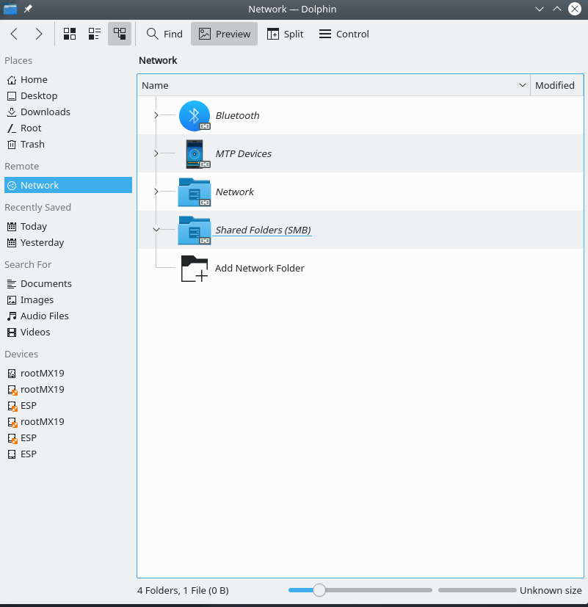

***Figure 3-39: Browing network shares*** Left: Thunar, Right: Dolphin

File Managers can connect to shared folders (AKA Samba Shares) on Windows, Mac, Linux computers and NAS (Network Attached Storage) devices. For printing with Samba, see Section 3.1.2.

* Click on Browse Network in the left pane to show various networks, including Windows Network
* Click the Network you want to see available Workgroups (often called WORKGROUP by default). Now drill down to find what you are looking for.
* Select a Workgroup for available Samba Servers
* Select a Server for available Samba Shares
* Select a Samba Share to see all the available folders
* A shortcut for the selected Share will be created in the Network sidebar section
* Sometimes browsing doesn’t work, especially in mixed environments (e.g., Linux-Windows). You can direct access a remote share by using the File Manager location bar (Ctrl+L) and using smb://servername/sharename. These places are bookmarkable in the side panes.

### 3.5.5 Creating shares

On MX, Samba can also be used to create Shares for other computers (Windows, Mac, Linux) to access. Creating Public Shares is fairly straightforward, but keep in mind that creating Samba Shares is a complex area from a configuration perspective. For example, the task of creating Shares that are specific to individual users and are authenticated properly is beyond the scope of this Manual. Comprehensive reference guides can be found at Using Samba and Samba.org.

#### Basic method

Thunar and KDE/plasma dolphin users can also use the “share” tab in the folder’s Properties dialog to set up a samba share.

**NOTE**: users often find that the configuration tool must be augmented with the manual method, below.

#### Manual method

[Create a share manually](https://www.youtube.com/watch?v=l3KYukPvP7U)

If for some reason you need or want to create shares manually, follow these steps.

* In your Home, use an existing folder or create a new one and right-click it to make it Read & Write for Owner, Group: users, and Others. In other words, make it open to the world. Starting with a simple Public Share is a good place to learn. **NOTE**: If you are concerned about network security do not use this approach. Instead, study the references above to learn how to create secure shares.
* To establish the Samba Share, you must edit the configuration file as root. It can be found at: **/etc/samba/smb.conf** Edit the line: *workgroup = xxxxx* to match whatever Windows Workgroup name you are using (default is WORKGROUP)
* At the very end of the file add the following lines to establish your Share

*[SHARENAME]*

*path = /home/username/foldername*

*guest ok = yes*

*read only = no*

*browseable = yes*

*force create mode = 777*

*force directory mode = 777*

* Save the file. When adding a share, the Samba daemon should read it and implement the changes immediately. If you make changes to an existing share, you will need to restart Samba to make sure your changes take effect by going to the terminal and becoming root and entering: *service samba restart*
* You can also check for mistakes in smb.conf by running *testparm* from the terminal
* Go to another computer and test your ability to see your Samba Share by browsing the network and testing read & write to the Share

MORE: [Xfce Docs: Thunar](http://docs.xfce.org/xfce/thunar/start)

## 3.6 Sound

[How to enable HDMI audio with Linux](https://youtu.be/gjqcmZK5SnE)

MX Linux sound depends at the kernel level on Advanced Linux Sound Architecture (ALSA), and at the user level on [PulseAudio](http://www.freedesktop.org/wiki/Software/PulseAudio/). In most cases sound will work out of the box, though it may need some minor adjustment. Click on the speaker icon to mute all audio, then again to restore--if that is how Preferences are set. Place cursor over speaker icon in the Notification Area and use scroll wheel to adjust volume. See also Sections 3.6.4, 3.6.5 and 3.8.9.

### 3.6.1 Sound Card Set-up

If you have more than one sound card, be sure to select the one you want to adjust using the tool MX Select Sound (Section 3.2). The sound card is configured and volume of selected tracks adjusted by right-clicking the speaker icon in the Notification Area > Open Mixer. If problems persist after logging out and back in, see Troubleshooting, below.

### 3.6.2 Simultaneous card use

There may be times when you would like to use more than one card simultaneously; for instance, you may want to hear music both through headphones and through speakers in another location. This is not easy to do in Linux, but check the PulseAudio [FAQ](http://www.freedesktop.org/wiki/Software/PulseAudio/FAQ/). Also, the solutions on [this MX/antiX Wiki page](https://mxlinux.org/wiki/sound-not-working) may work, if you are careful to adjust the card references to your own situation.

Sometimes it is necessary to switch sound cards, for instance when one is HDMI and the other analog. This can be done in PulseAudio, Configuration tab; be sure to select the Profile option that works for your system. To make that switch automatic, see the script on [this GitHub site](https://gist.github.com/3v1n0/ad3ad73e0bdd466d7f4a95b3aa376285).

### 3.6.3 Troubleshooting

* [Sound not working](https://mxlinux.org/wiki/sound-not-working)
* No sound, though speaker icon is in the Notification Area.
  + Try raising all controls to a higher level. For a System Sound such as a login, use the Playback tab in Pulseaudio.
  + Edit the configuration file directly: see Section 7.4.
* No sound, and no speaker icon is in the Notification Area. It could be that the sound card is missing or unrecognized, but the most common problem is that of multiple sound cards, which we address here.
  + Solution 1: click **Start menu > Settings > MX Sound Card**, and follow the screen to select and test the card you want to use.
  + Solution 2: use the volume control of PulseAudio (pavucontrol) to select the correct sound card
  + Solution 3: enter the BIOS and turn off HDMI
  + Check the ALSA sound card matrix listed below.

### 3.6.4 Sound servers

Whereas the Sound Card is a hardware item accessible to the user, the Sound Server is software that works largely in the background. It permits general management of sound cards, and provides the ability carry out advanced operations on the sound. The most commonly used by individual users is PulseAudio. This advanced open-source sound server can work with several operating systems, and is installed by default. It has its own mixer that allows the user to control the volume and destination of the sound signal. For professional use, [Jack audio](http://jackaudio.org/) is perhaps the best known.

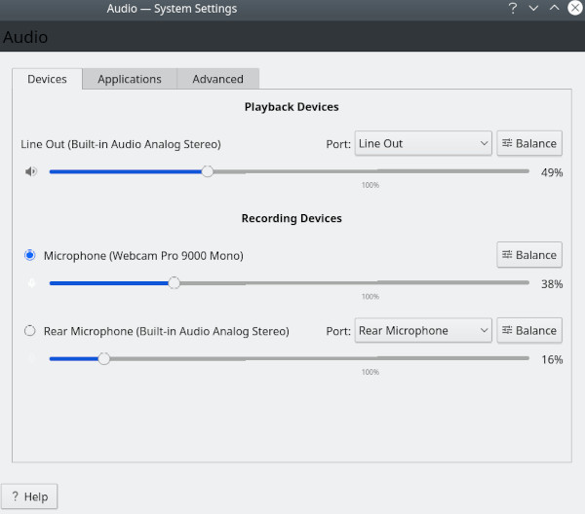

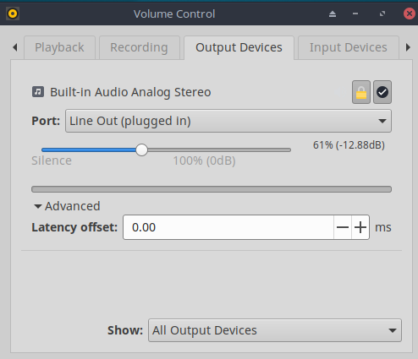

Figure 3-40: Using PulseAudio Mixer Left: Pavucontrol Right: KDE Audio Volume

### 3.6.5 Links

* [MX/antiX Wiki: Sound not working](https://mxlinux.org/wiki/sound-not-working)
* [ALSA: SoundCard Matrix](http://www.alsa-project.org/main/index.php/Matrix:Main)
* [ArchLinux Wiki: PulseAudio Information](https://wiki.archlinux.org/index.php/PulseAudio)
* [PulseAudio Documentation: Free desktop](http://www.freedesktop.org/wiki/Software/PulseAudio/Documentation/User/)

## 3.7 Localization

MX Linux is maintained by an international Dev Team that constantly works to improve and expand the options for localization. There are many languages into which our documents have not yet been translated, and if you can help with this effort please [register on Transifex](https://forum.mxlinux.org/viewtopic.php?f=96&t=38671) and/or post on the [Translation Forum](https://forum.mxlinux.org/viewforum.php?f=96).

### 3.7.1 Installation

The primary act of localization occurs during the use of the LiveMedium.

* When the boot screen first comes up, make sure to use the function keys to set your preferences.
  + F2. Select the language
  + F3. Select the timezone you wish to use.
  + If you have a complicated or alternative setup, you can use boot cheat codes. Here is an example to set a Tartar keyboard for Russian: *lang=ru kbvar=tt .* A full list of the boot parameters (=cheat codes) can be found in the [MX/antiX Wiki](https://mxlinux.org/wiki/system/boot-parameters).
* If you set the locale values at the boot screen, then Screen 7 should show them during installation. If not, or if you want to change them, select the language and timezone you want.

Two other methods are available after the boot screen.

* The first screen on the installer allows the user to select a particular keyboard for use.
* The login screen has pull-down menus in the upper right corner where where both keyboard and locale can be selected.

### **3.7.2 Post-installation**

MX Tools includes two tools for changing keyboard and locale. See Sections 3.2.15 and 3.2.16 above.

Xfce4 and KDE/plasma have their own methods as well:

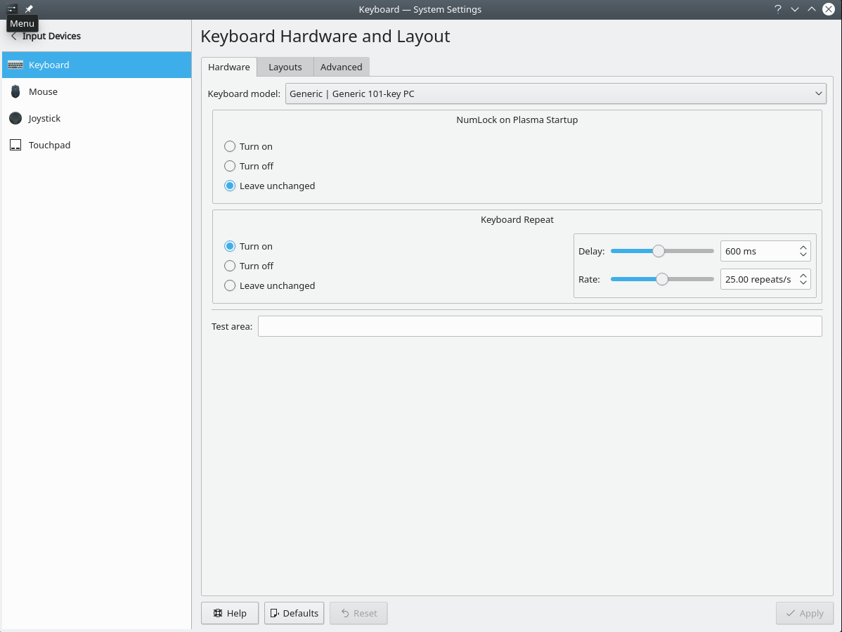

***Figure 3-41: Adding another keyboard layout Left: Xfce Right: KDE***

Here are the configuration steps you can take to localize your MX Linux after installation.

* Change the keyboard:

Xfce

* + Click **Start Menu > Settings > Keyboard**, Layout tab.
  + Uncheck “Use system defaults” then click on the **+Add** button at the bottom and select the keyboard(s) you want available.
  + Exit, then click Keyboard Switcher (flag) in the Notification Area to select active keyboard.

KDE/plasma

* + Click Start Menu > Settings > Input Devices > Keyboard Layouts Tab
  + Check “Configure Layouts” in the middle of the dialog, then click on the **+Add** button at the bottom and select the keyboard(s) you want available.
  + Exit, then click Keyboard Switcher (flag) in the Notification Area to select active keyboard.
* Get language packs for major applications: click **Start menu > System > MX Package Installer**, provide the root password, then click Language to find and install language packs for the applications you use.
  + Setting up Chinese Simplified Pinyin is a bit more complicated, see [here](https://mxlinux.org/wiki/other/chinese-simplified-input).
* Change time settings: click **Start Menu > System > MX Date & Time** and select your preferences. If you are using the digital clock DateTime, right-click > Properties to choose 12h/24h and other local settings.
* Get spellchecker to use your language: install the **aspell** or **myspell** package for your language (e.g., **myspell-es**).
* Get local weather info
  + Xfce: **right-click the Panel > Panel > Add New Items > Weather Update. Right-click > Properties**, and set the locale you want to see (it will guess by your IP address).
  + KDE: Right click on the desktop or panel depending on where the widget will appear and then Add Widget. Search for Weather and add the widget
* For Firefox localization, install the appropriate **firefox-l10n-** package for your language of interest; e.g., for Spanish (Spain), install firefox-l10n-es.
* For Thunderbird, click Edit > Preferences > General. Scroll down to the Language & Appearance section and select the one you want to use
* You may need or want to change the localization info (default language, etc.) available to the system. To do so, open a terminal, become root and enter: *dpkg-reconfigure locales* 
  + You will see a list with all the locales that you can scroll through using the up and down arrow keys.
  + Enable and disable what you want (or don’t want), using the space bar to make the asterisk in front of the locale appear (or disappear).
  + When done, click OK to advance to the next screen.
  + Use arrows to select the default language you want to use. For US users, for instance, that would typically be **en\_US.UTF-8**.
  + Click OK to save and exit.

MORE: [Ubuntu documentation](https://help.ubuntu.com/community/Locale)

***Figure 3-42: Re-setting the default language for the installed system***

### 3.7.3 Further notes

* You can temporarily change the language for a particular application by entering this code in a terminal (in this example, to change to Spanish):

LC\_ALL=es\_ES.UTF8 <command to launch>

This will work for most apps that are localized already.

* If you have selected the wrong language during installation you can change it once on the installed desktop, use MX Locales to correct it. You can also open a terminal and enter this command:

sudo update-locale LANG=en\_GB.utf8

Obviously you would need to change the language to the one that you want to use.

* It may happen that an individual application may not have a translation in your language; unless it is an MX application, we can do nothing about that, so you should send a message to the developer.
* Some desktop files that are used to create the Start menu may be missing a comment in your language, even though the application itself does have a translation in that language; please let us know with a post in the Translation Forum that supplies the correct translation.

## 3.8 Customization

Modern Linux Desktops like Xfce and KDE/plasma make it very easy to change basic function and look of a user’s configuration.

* Most importantly, remember: Right-click is your friend!
* Great control is available through the (Xfce) All Settings and (KDE/plasma) SystemSettings (Panel icons).
* User changes are stored in config files in the directory: ~/.config/. These can be queried in a terminal, see [the MX/antiX Wiki](https://mxlinux.org/wiki/xfce/xfce-commands-and-other-useful-stuff" \l "List configuration settings).
* Most system-wide config files are in /etc/skel/ or /etc/xdg/

MORE: [Xfce Tips and tricks](http://pclosmag.com/download.php?f=XfceTipsTricksSE.pdf) (PDF)

### 3.8.1 Default Theming

Default theming is controlled by a number of customized elements.

**Xfce**

* Login screen (modify with All Settings > LightDM GTK+ Greeter Settings)
  + Theme: Adwaita-dark (MX-21)
  + Background: in */usr/share/backgrounds/MXLinux/lightdm/*
  + Login box: modified default theme /usr/sbin/lightdm-gtk-greeter
* Desktop:
  + Wallpaper: All Settings > Desktop/. When selecting from another location, keep in mind that after using the entry "Other" you need to navigate to the folder you want, then click "Open"; only then can you select a particular file in that location.
  + All Settings > Appearance. Sets GTK Themes and Icons. Bundled settings in MX Tweak – Themes (Section 3.2).
  + All Settings > Window Manager. Sets window border themes.

**KDE/Plasma**

* Login screen (modify with System Settings > Startup and Shutdown then choose Login Screen, SDDM configuration)
  + Breeze
* Desktop:
  + Wallpaper: Right-click on desktop and select “Configure Desktop and Wallpaper”

Appearance

* + Global Themes – bundled theme set combinations  
    Plasma Style – Set theme of plasma desktop objects
  + Application Style

Application Style – Configure application elements

Window decorations – Minimize, maximize and close button styles

* + Colors, Fonts, Icons and cursors acan also be configured.
  + Application menu settings
    1. Right-click on menu icon to get configuration options. Default panel is in the standard application panel

### 3.8.3 Panels

#### 3.8.3.1 Xfce Panel

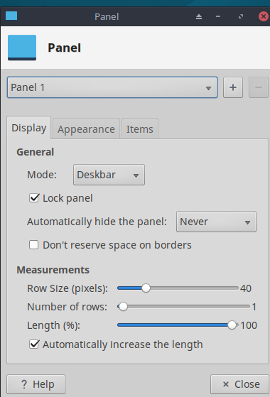

***Figure 3-43: Preferences screen for customization of panels***

MX Linux now ships by default with [Docklike Taskbar](https://mxlinux.org/wiki/docklike-taskbar/) (xfce4-docklike-plugin) replacing the Xfce Window Buttons used in previous MX releases. This lightweight, modern, and minimalist taskbar for Xfce provides the same functionality as Xfce Window Buttons, while also providing more advanced “dock” features.

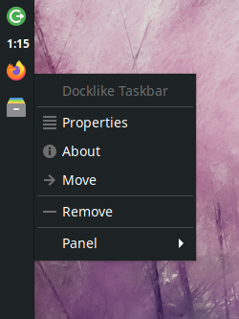Figure 3-44: The docklike taskbar with icons and context menu

To view docklike taskbar Properties: Ctrl + Right click any icon. Or: MX Tweak > Panel tab, click “Options” button under Docklike.

Window Buttons can be restored by right-clicking an empty space > Panel > Add New Items.

Tricks for panel customization

* To move the panel, unlock it by right-clicking a panel > Panel > Panel Preferences.
* Use MX Tweak to change the location of the panel: vertical or horizontal, top or bottom.
* To change display mode inside the Panel setting, select from the pull down menu: Horizontal, Vertical, or Deskbar.
* To automatically hide the panel, choose from pull down menu: Never, Always, or Intelligently (hides the panel when a window overlaps with it).
* Install new panel items by right-clicking an empty space in the panel > Panel > Add New Items. You then have 3 choices:
  + Select one of the items on the main list that pops up
  + If what you want is not there, select Launcher. Once it is in place, right-click > Properties, click the plus sign and select an item off the list that pops up.
  + If you want to add an item not on either list, then select the empty item icon below the plus sign and fill in the dialog box that pops up.
* New icons show up at the bottom of the vertical Panel; to move them, right-click > Move
* Change the look, orientation, etc. by right-clicking the panel > Panel > Panel Preferences.
* Right-click the clock plugin “DateTime” to change the format of layout, date or time. For a custom time format you need to use “strftime codes” (consult [this page](http://en.cppreference.com/w/c/chrono/strftime) or open a terminal and type *man strftime)*.
* Create a double row of icons in the Notification Area by right-clicking it > Properties, and decreasing Maximum icon size until it changes.
* Add or delete a panel in Panel Preferences, clicking on the plus or minus button to the right of the top panel pull-down menu.
* One-click horizontal panel installation is available from MX Tweak (Section 3.2).

MORE: [Xfce4 docs: Panel.](http://docs.xfce.org/xfce/xfce4-panel/start)

#### 3.8.3.2 KDE/plasma Panel

***Figure 3-45: Preferences screen for customization of panels***

Tricks for panel customization:

* To move the panel, Right click on panel then Edit panel. Hover over “Screen Edge” and move to location of your choice.
* Use MX Tweak to change the location of the panel: vertical (left), top or bottom. Or use the previous method to drag to any screen edge.
* To change display mode inside the Panel, once the Edit Panel dialog is open, Choose More Options Panel Alignment > left, center or right.
* To automatically hide the panel, once Edit Panel dialog is open, click “More Settings” and select “Auto Hide”
* Install new panel items by clicking on the panel >Add Widgets. You can select the desired widget to add from the dialog.
* Create a double row of icons in the Notification Area by using the Configure Panel dialog and selecting Height to change the height of the panel. Then using MX-Tweak > Plasma tab and setting the systray icon size larger or smaller as desired to create the double row effect. You can also have the System Tray icons scale automatically with the panel height by right clicking on the tray up arrow, Configure System tray and enabling scale with panel height.
* To show all open applications, click MX Tweak, Plasma tab, and enable “Show windows from all workspaces in panel.”

### 3.8.4 Desktop

[Customizing the desktop](https://www.youtube.com/watch?v=QWVd1-8xpYI)

[Things to do after installing MX Linux](https://youtu.be/aESEb8lTvz4)

The default desktop (AKA wallpaper, background) can be changed in various ways.

* Right-click any image > Set as wallpaper
* If you want the wallpapers available to all users, become root and put them in the /usr/share/backgrounds folder;
* If you want to restore the default wallpaper, it is in /usr/share/backgrounds/. There are also symlinks of the MX wallpaper sets in /usr*/s*hare/wallpapersfor easy MX-KDE usage.

Many other customization options are available.

* Change the theme
  + Xfce - **Appearance**. The default theme is an MX mx-comfort (light and dark) that has larger borders and specifies the appearance of Whisker menu. Be sure to select an icon theme that will show well, especially on the dark version.
  + KDE/plasma – **Global Theme–** MX theme is the default. You can also set individual theme elements in Plasma Style, Application Style, Colors, Fonts, Icons and cursors.
* To make thin borders easier to grab,
  + Xfce – Use one of the “thick border” **Window Manager** themes or consult [the MX/antiX Wiki](https://mxlinux.org/wiki/xfce/changing-border-size-with-xfce4-window-manager/).
  + KDE/plasma – In **Application Style** > **Window Decorations**, set the desired “Border Size” from the drop down menu provided.
* Xfce - Add standard icons such as Trash or Home to the desktop in **Desktop**, icons tab.
* Window behavior such as switching, tiling, and zooming can be customized
  + Xfce - **Window Manager Tweaks.**
    - Window switching via Alt+Tab can be customized to use a compact list instead of traditional icons
    - Window switching via Alt+Tab can also be set to show thumbnails instead of icons or a list, but it requires turning on [compositing](https://en.wikipedia.org/wiki/Compositing_window_manager) which some older computers may have difficulty supporting. To enable, first deselect Cycle on a list list on the “Cycling” tab, then click on the “Compositor” tab and check ’Show windows preview in place of icons’ when cycling.
    - Window tiling can be accomplished by dragging a window to a corner and releasing it there..
    - If compositing is turned on, Window zooming is available by using the Alt + Mouse Wheel combination.
  + KDE/plasma – **SystemSettings**
    - Window tiling can be accomplished by dragging a window to a corner and releasing it there.
    - Configuration of a variety of keystroke and mouse controls can be set as desired via the **Window Behavior** dialog**.**
    - Alt-tab configuration, including theme, can be done in the **Task Switcher** dialog.
* Wallpaper
  + Xfce – Use the Desktop settings to choose wallpapers. To select a different wallpaper for each Workspace, got to **Background** and uncheck the option ’Apply to all workspaces.’ Then select a wallpaper and repeat the process for each workspace by dragging the dialog box to the next workspace and selecting another wallpaper.
  + KDE/plasma – right click on the Desktop and select “Configure Desktop and Wallpaper”.

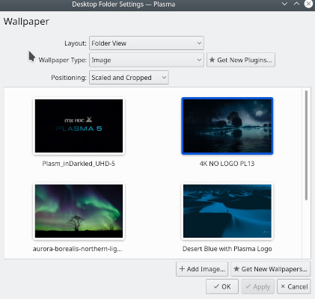

Figure 3-46: Unchecked box allows different backgrounds for each workspace Left: Xfce, ***Right: KDE.***

#### Conky

You can display almost any kind of information on the desktop by using Conky

* Both Conky Manager and MX Conky are installed by default.
* When you click on MX Conky, a dialog box will pop up if there are updates available.
* Click **Start menu > Accessories** to find Conky Manager. MX Conky is part of MX Tools.
* A set of conkies that will work OOTB is included by default. You can import other sets using the gear icon at the right end of the menu bar in Conky Manager
* Highlight each conky and hit Preview to see what it looks like. Be sure to close each preview before going to another.
* Check the box to select any conky you want to use. It will be auto-installed.
* The configuration files are stored in the folder  ~/.conky/ in individual theme files; they can be edited by highlighting the conky in the list and clicking on the edit icon (pencil).

HELP: [MX/antiX Technical Wiki](https://mxlinux.org/wiki/help-files/help-mx-conky)

MORE: [Conky home page](http://conky.sourceforge.net/index.html)

***Figure 3-47: Main screen of Conky Manager showing one of the conkies available***

#### Pull-down terminal

[Customizing the drop-down terminal](https://www.youtube.com/watch?v=_X4tVjO8uzo)

MX Linux ships with a very handy drop-down terminal triggered with F4. If you wish to disable it: Xfce - **Start menu > All Settings > Keyboard,** Applications Shortcuts tab.   
 KDE/plasma - System Settings > Startup and Shutdown > Startup and Shutdown deleteYakuake.

The drop down terminals are very configurable.

Xfce – right click on the terminal window and select Preferences  
 KDE/plasma – select the “hamburger” menu in the lower right-hand corner of the terminal.

### 3.8.5 Touchpad

Xfce - General options for the touchpad on a laptop are found by clicking Settings > Mouse and Touchpad. Systems that are more sensitive to touchpad interference have a couple of options:

* Use MX-Tweak, Other tab to change the touchpad driver
* Install **touchpad-indicator** to see fine control of behavior.. Right-click the icon in the Notification Area to set important options such as autostart.

KDE/Plasma – touchpad options are found in System Settings > Hardware > Input Devices. There is also a touchpad widget that can be added to the Panel (right click panel > add widgets)

Detailed changes be made manually by editing the 20-synaptics.conf file under */etc/X11/xorg.conf.d* (file is just "synaptics.conf on MX-19).

### 3.8.6 Menu

### 3.8.6.1 Xfce (“Whisker”)

[Customizing Whisker menu](https://www.youtube.com/watch?v=QWVd1-8xpYI)

[Fun with the Whisker menu](https://www.youtube.com/watch?v=bgPn68jMqd0)

MX Linux XFCE uses by default with the Whisker Menu, though a classic menu can be easily installed by right-clicking a panel > Panel > Add New Items > Applications Menu. Whisker Menu is highly flexible.

* Right-click the menu icon > Properties to set preferences, e.g.,
  + Move categories column to be next to the Panel.
  + Change location of Search box from top to bottom.
  + Decide which action buttons you want to show.
* Favorites are easy to add: right-click any menu item > Add to Favorites.
* Simply drag and drop Favorites to arrange them as wished. Right-click any entry to sort or remove.

MORE: [Whisker menu features](http://gottcode.org/xfce4-whiskermenu-plugin/)

#### Editing

Menu entries can be edited with two applications (the menu entry “desktop” files are located in */usr/share/applications/* and can also be edited as root directly).

* **MX Menu Editor** (Section 3.2).
* Right-click on an entry in Whisker menu and you can edit a launcher on a user-specific basis.
* Click **Start menu > Accessories > Application Finder** (or **Alt-F3**), and right-click any entry. Context menu contains Edit and Hide (the latter can be very useful). Selecting Edit brings up a screen where you can change name, comment, command and icon.

***Figure 3-48: Menu entry edit screen***

### 3.8.6.2 KDE/plasma (“kicker”)

MX Linux KDE/plasma uses the Application Launcher menu by default, although alternates are easily installable via right-click on the menu icon and choosing “Show Alternatives alternates”. “Favorite” applications are shown as icons on the left of the menu.

* Right-click the menu icon > Configure Application Menu to set preferences, e.g.,
  + Show applications as name only or Name/Description combinations
  + Change location of Search results
  + Show recent or often-used items
  + Flatten menu sublevels.
* Favorites are easy to add: right-click any menu item > Show in Favorites.
* Simply drag and drop Favorites to arrange them as wished. Right-click any entry to sort.To remove from Favorites right click the icon then Show in Favorites and deselect the appropriate Desktop or Activity.

#### Editing

Menu entries can be edited via Right-click on an entry in the menu and you can edit a launcher on a user-specific basis. The menu entry “desktop” files are located in */usr/share/applications/* and can also be edited as root directly.

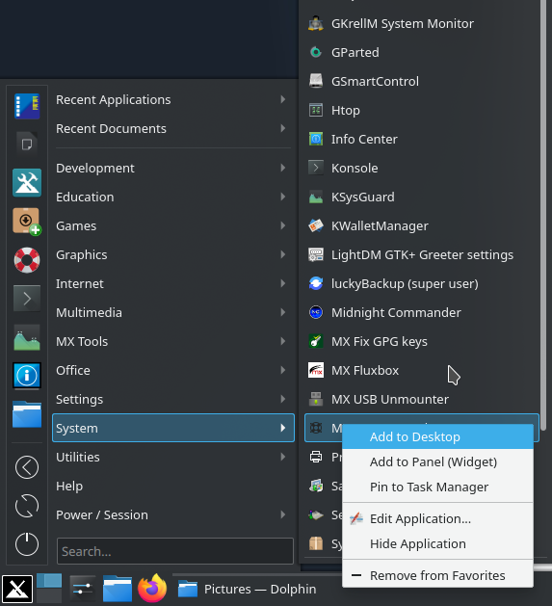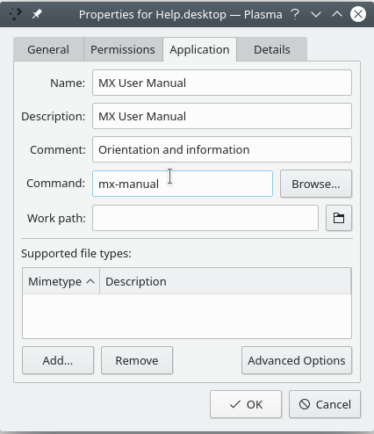

***Figure 3-49: Menu entry edit screen***

### 3.8.7 Login greeter

The user has a number of tools to customize the login greeter. Xfce isos use the lightdm greeter, while KDE/plasma isos use SDDM.

**Lightdm**

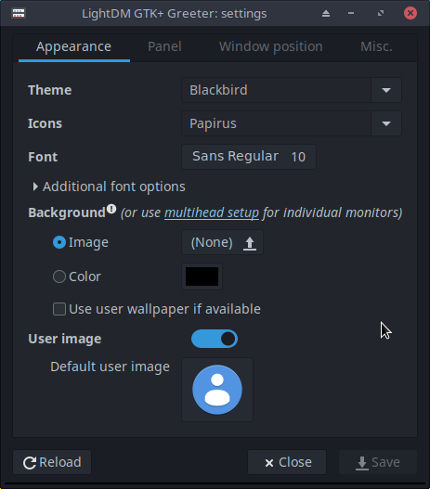

***Figure 3-50: the Lightdm configuration app***

* Click **Start menu > Settings > All Settings > LightDM GTK+ Greeter settings** to adjust position, background, font, etc.
* Autologin can be (in)activated from MX User Manager, Options tab.
* Some properties of the default login box are set in the code for the default theme (greybird-thick-grip) and a few related themes. Change theme for greater choice.
* You can have the login greeter show an image as follows:
  + **Start menu > Settings > About Me** (Mugshot)
    - Fill in details you want to add.
    - Click on the icon, navigate to the image you want to use. Close.
  + **Manual**
    - Create or select an image, and use gThumb or another photo editor to resize it to about 96x96 pixels
    - Save that image in your home folder as **.face** (make sure to include the dot and do not add any extension such as jpg or png).
    - Click All Settings > LightDM GTK+ Greeter Settings, Appearance tab: turn on the User image switch.
  + Whichever way you choose, log out, and you will see the image next to the login box; it will also show up in Whisker menu once you are logged back in.

**SDDM**

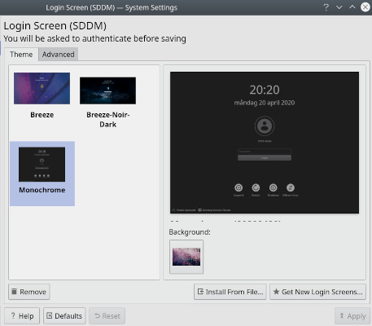

***Figure 3-51: the SDDM configuration app***

* + The sddm settings are all in Plasma desktop’s System Settings. A shortcut launcher for System Settings can be found on MX’s default panel, or you can in any case search for it in the Applications Menu. In the Settings, go to Startup and Shutdown >> Login Screen (SDDM).
  + The settings page for sddm will allow you to:
    - select between different themes if you have more than one installed;
    - choose to customise a background for your selected theme;
    - remove (ie delete) an installed theme; and
    - to get/install new themes either directly from KDE Store online or from a file on your storage drive/media (see below)
  + root password required – since desktop manager is a system program, any changes to it or its configuration will affect files in the root partition, which is why you will be asked for your root password.
  + background selection – you can change the background of your selected sddm theme. Some themes come with their own preinstalled default background picture which will be displayed if you do not make any changes. This will also require root password.
  + New sddm themes can be found i[n the KDE Store](https://store.kde.org/browse/cat/101/order/latest). You can also browse the themes directly from within the System Settings page for sddm.
  + In SystemSettings > Startup and Shutdown > Login Screen (SDDM), Get New Login Screens at the bottom of the window.
  + To install a theme:
    - from a downloaded zip file, click on the “Install from File” button in the System Settings page for sddm, then select the targeted zip file from file chooser that opens up.
    - While in the System Settings in-built sddm theme browser, simply click on the “Install” button of the selected theme.

TAKE NOTE: Some themes in KDE Store may be incompatible. MX 21 uses Plasma version 5.20, which is the stable version available for Debian, Bullseye but the latest version of Plasma is already at version 5.22 (as at beginning of January 2021). You may therefore find that some of the latest sddm themes built to utilize the latest features in Plasma may not work with Plasma 5.20’s sddm. Thankfully sddm comes with a fallback login screen so that if a theme that you applied does not work, you can still log back into your desktop and from there change to another sddm theme. Do some testing; some very new themes work while others don’t.

### 3.8.8 Bootloader

The bootloader (GRUB) of an installed MX Linux can be modified with common options by clicking **Start menu > MX Tools > MX Boot Options** (see Section 3.2.2). For other functions, install **Grub Customizer**. This tool should be used with caution, but it allows users to configure Grub settings such as the boot entry list configuration, names of partitions, color of menu entries, etc. Details [here](https://answers.launchpad.net/grub-customizer/+faq/1355).

### 3.8.9 Xfce System and Event sounds

Computer beeps are silenced by default in the “blacklist” lines in the file */etc/modprobe.d/pc-speaker.conf*. Comment out (# at the beginning) those lines as root if you wish to restore them.

Event sounds can be turned on system-wide by clicking **Start menu > Settings > Appearance, Other tab**: check Enable event sounds and, if you wish, Enable input feedback sounds. They can be managed with MX System Sounds (Section 3.2). If you do not start hearing small sounds when you close a window or logout, for instance, try these steps:

* Log out and back in.
* Click Start menu > Multimedia > PulseAudio Volume Control, Playback tab, and adjust the level as needed (start with 100%).
* Click the start menu, type "!alsamixer" (don’t forget the exclamation point). A terminal window will appear with a single audio control (Pulseaudio Master).
  + Use F6 to select your audio card, and then adjust the channels that appear to higher volumes.
  + Look for channels like "Surround", "PCM" "Speakers", "Master\_Surround", "Master\_Mono" or "Master". The channels that are available depend on your particular hardware.

Three sound files are supplied by default: Borealis, Freedesktop and Fresh and Clean. All are located in /usr/share/sounds. Find others in the repos or with a web search.

### 3.8.10 Default applications

#### General

The default applications to be used for general operations are set by clicking **Application menu > Settings > Default Applications (Xfce) or System Settings > Applications > Default Applications (KDE/plasma).** where you can set four preferences (Xfce: separate tabs for Internet and Utilities).

* Web browser
* Mail reader
* File manager
* Terminal emulator

#### Particular

Many defaults for specific file types are set during an application’s installation. But often multiple options exist for a given file type, and a user would like to determine which application would launch the file—such as the music player to open an \*.mp3 file.

Xfce’s Default Applications app has a third tab, “Others,” where these MIME types can be set using a handy searchable table to find the type, then double-clicking the Default Application space to set the desired application.

**General method**

* Right-click any example of the file type you are interested in
* Make one of the following selections:
  + **Open with <listed application>**. This will open the file with the selected application for this particular instance, but will not affect the default application.
  + **Open with Other Application**. Scroll down the list to highlight the one you want (including “Use a custom command”), then check Open. The box at the bottom “Use as default for this kind of file” is unchecked by default, so check it if you want your selection to become the new default application that is launched when you click on any file of that particular type. Keep it unchecked for one-time usage.

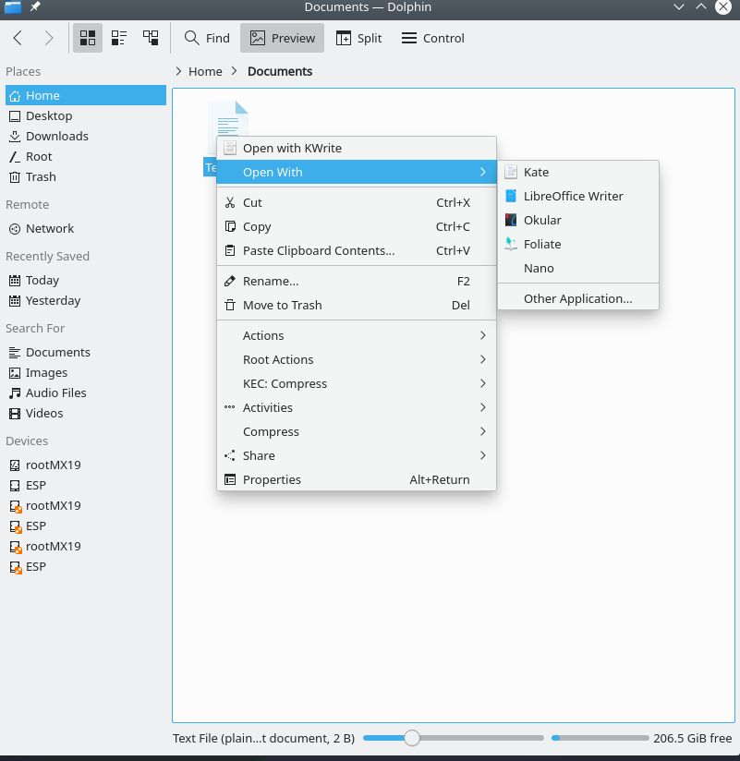

***Figure 3-52: Changing default application*** Left: Thunar Right: dolphin

### 3.8.11 Limited accounts

For some purposes, it may be desirable to lock down an application or system in order to protect it from users. Examples include computers in a school or public location for general use, where the file system, desktop and internet access need to be closed. There are a number of options available.

* Some components of Xfce that support kiosk mode. Details in [the Xfce Wiki](https://wiki.xfce.org/howto/kiosk_mode).
* KDE has an administrative mode, consult [the KDE Userbase](https://userbase.kde.org/KDE_System_Administration).
* Check the browser you use to see if it has a kiosk mode.
* The dedicated kiosk distro [Porteus](http://porteus-kiosk.org/index.html).

More: [Alan D. Moore's guide](http://www.alandmoore.com/blog/2011/11/05/creating-a-kiosk-with-linux-and-x11-2011-edition/) (somewhat dated).

# 4 Basic use

## 4.1 Internet

### 4.1.1 Web browser

* MX Linux comes with the popular browser **Firefox** installed, which has a large set of add-ons to augment the user’s experience.

[Firefox home page](https://www.mozilla.org/)

[Firefox add-ons](https://addons.mozilla.org/en-US/firefox/)

* Upgrades of Firefox come through the MX Linux repos, and are usually available to users within 24 hours of release. For direct download, see Section 5.5.5.
* Localization files for Firefox can be installed easily with MX Package Installer.
* Firefox has a sync service that facilitates transferring bookmarks, cookies, etc. from an existing Firefox installation.
* Other browsers are available for easy download and installation via the MX Package Installer. Check the [MX/antiX Wiki](https://mxlinux.org/wiki/applications/) for configuration tips and tricks.

### 4.1.2 Email

* [**Thunderbird**](https://www.mozilla.org/thunderbird/) is installed by default in MX Linux. This popular email client integrates well with Google Calendar and Google Contacts. The most recent versions available can be found with the MX Package Installer > MX Test Repo.
* Localization files for Thunderbird can be installed easily with MX Package Installer.
* For help with links no longer opening a browser, consult [the MX/antiX Wiki](https://mxlinux.org/wiki/applications/thunderbird/).
* Other lightweight email clients are available from the MX Package Installer.

### 4.1.3 Chat

* HexChat. This IRC chat program is installed by default in MX Linux, and makes the exchange of text messages easy for the user.

[HexChat home page](https://hexchat.github.io/)

* Pidgin. This graphical, modular instant messaging client is capable of using multiple networks at once. MX Package Installer.

[Pidgin home page](http://pidgin.im/)

#### Video Chat

* [Zoom](https://zoom.us/). This very popular video chat program is cross-platform and can be installed on MX Linux without problem using the **MX Package Installer > Messaging**. It integrates automatically with PulseAudio, which is installed by default.
* Gmail has a talk function built in, now called [**Duo**](https://duo.google.com/). See Section 4.10.6
* Skype. A popular proprietary program for instant messaging as well as voice and video chat.

[Skype home page](https://www.skype.com/en/)

Troubleshooting

* If your voice is not being picked up even after you use the app’s own tools, try this:
  + Sign into your video chat app, click on Options and go to the Sound Devices tab.
  + Click on the button to start a test call. While the call is going on, open PulseAudio Volume Control and go to the Recording tab.
  + Still while the test call is going on - change the Skype to the Webcam microphone.

## 4.2 Multimedia

Listed here are some of the many multimedia applications available in MX Linux. Advanced professional applications also exist, and can be found through targeted searches in Synaptic.

### **4.2.1 Music**

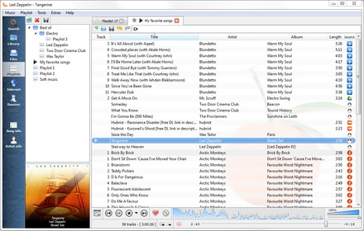

***Figure 4-1: Playing a CD track with Clementine***

* Players
  + Clementine. A modern music player and library organizer that can play every source from a CD to a Cloud Service. Installed by default.

[Clementine home page](https://www.clementine-player.org/)

* + Audacious. A full-featured music player and manager. MX Package Installer.

[Audacious home page](http://audacious-media-player.org/)

* + DeaDBeeF. A lightweight player with a small memory footprint, robust set of basic features, and a focus on music playback. MX Package Installer.

[DeaDBeeF home page](http://deadbeef.sourceforge.net/)

* Rippers and editors
  + Asunder. A graphical Audio CD ripper and encoder that can be used to save tracks from Audio CDs. Installed by default.

[Asunder home page](http://littlesvr.ca/asunder/)

* + EasyTAG. A simple application for viewing and editing tags in audio files.

[EasyTAG home page](https://wiki.gnome.org/Apps/EasyTAG)

### **4.2.2 Video**

[UPDATE: Netflix on 32 bit Linux](https://www.youtube.com/watch?v=fY_PqMJ5kG4)

* Players
  + VLC. Plays a large range of video and audio formats, DVDs, VCDs, podcasts, and multimedia streams from various network sources. Installed by default.

[VLC home page](http://www.videolan.org/vlc/)

* + A YouTube Browser for SM Player is installed by default.

[SMplayer home page](http://smplayer.sourceforge.net/)

* + Netflix. Desktop capability of streaming Netflix is available for Firefox and Google Chrome.

[Netflix home page](https://www.netflix.com/us/)

***Figure 4-2: Running desktop Netflix in Google Chrome***

* Rippers and editors
  + HandBrake. A video ripper that is easy to use, fast and simple. MX Package Installer.

[HandBrake home page](https://handbrake.fr/)

* + DeVeDe. This utility automatically converts material to formats compatible with audio CD and video DVD standards.

[DeVeDe home page](http://www.rastersoft.com/programas/devede.html)

* + DVDStyler. Another good authoring utility. MX Package Installer.

[DVDStyler home page](http://www.dvdstyler.org/en/)

* + OpenShot. A simple-to-use and feature-rich video editor. MX Package Installer.

[OpenShot home page](http://www.openshot.org/)

### 4.2.3 Photos

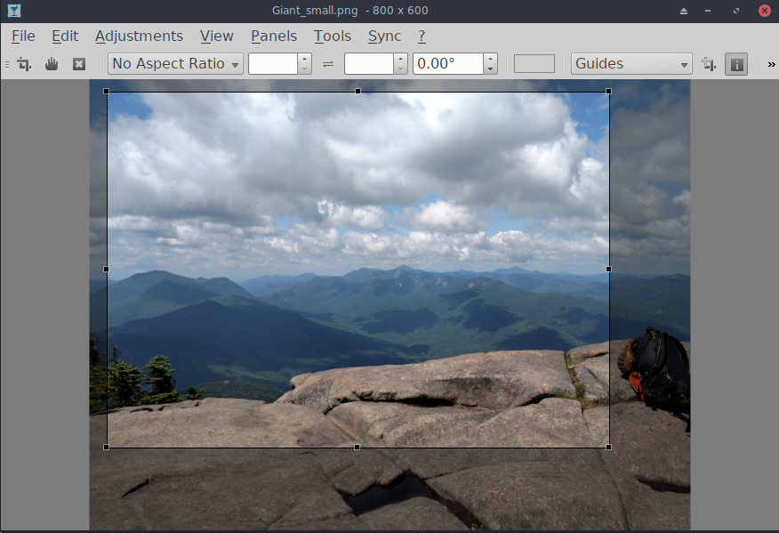

***Figure 4-3: Using the crop tool in Nomacs***

* Nomacs. A fast and powerful image viewer installed by default.

[Nomacs home page](https://nomacs.org/)

* Mirage. This speedy application is easy to use and allows you to view and edit digital photos. MX Package Installer.

[Mirage project page](http://sourceforge.net/projects/mirageiv.berlios/)

* Fotoxx. This fast application allows easy photo editing and collection management while serving the needs of serious photographers. MX Package Installer > MX Test Repo.

[Fotoxx home page](http://www.kornelix.net/fotoxx/fotoxx.html)

* GIMP. The premier image manipulation package for Linux. Help (**gimp-help**) must be installed separately, and is available in many languages. Basic package installed by default, full available from MX Package Installer.

[GIMP home page](http://www.gimp.org/)

* gThumb. an image viewer and browser from the GNOME Developers that also includes an importer tool for transferring photos from cameras. Default in MX-21.

[gThumb Wiki](http://gthumb.sourceforge.net/features.html)

* LazPaint, a cross-platform lightweight image editor with raster and vectorial layers. Default in MX-21.

[LazPaint documentation](https://wiki.freepascal.org/LazPaint)

* Gwenview, the KDE project image viewer

***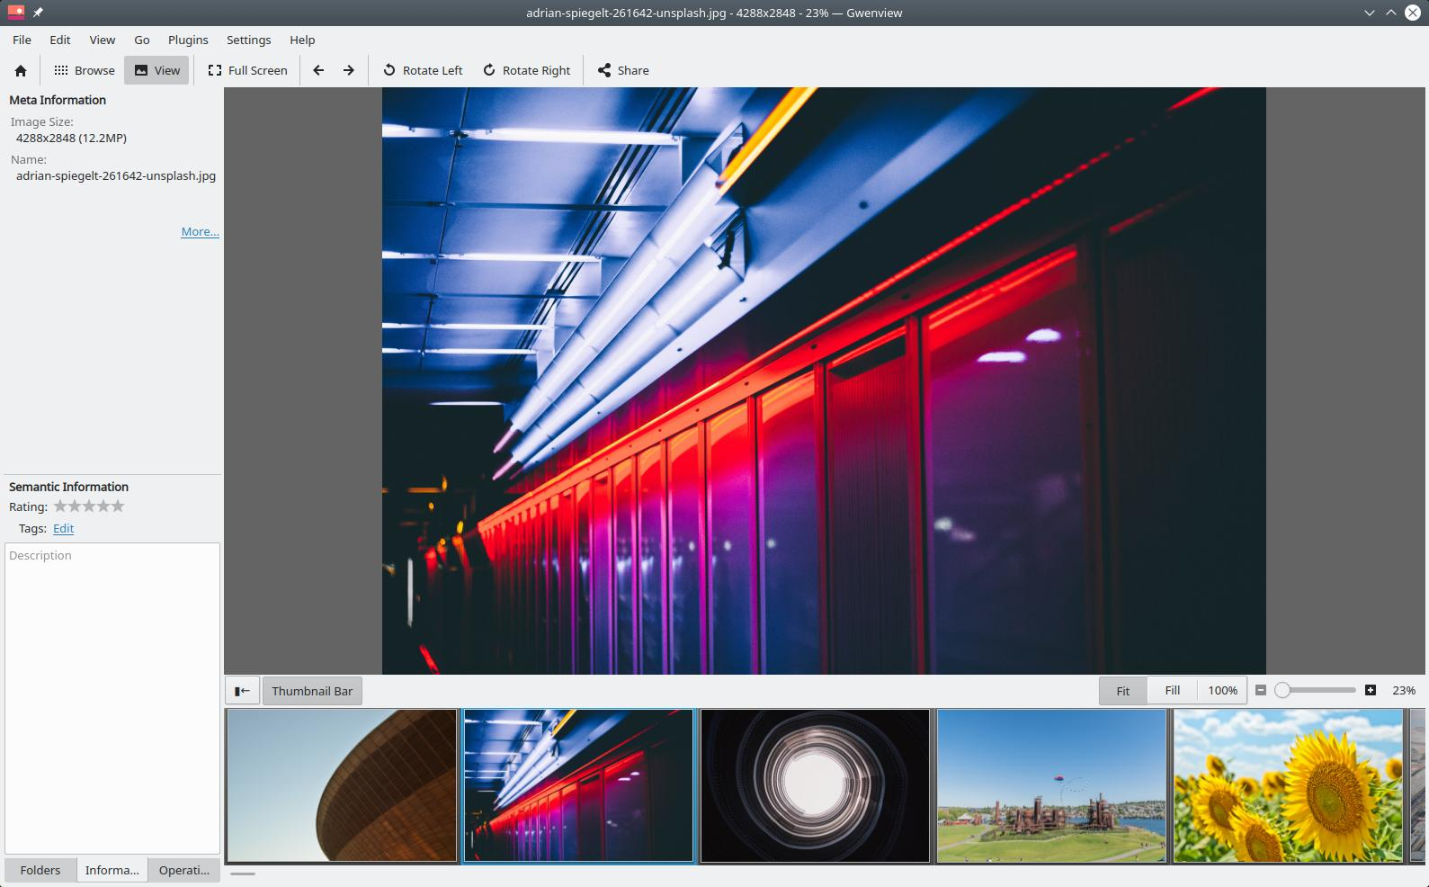***

***Figure 4-4: Gwenview***

### 4.2.4 Screencasting

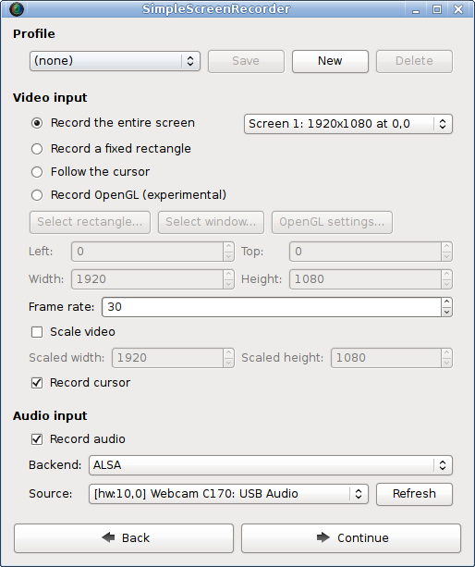

***Figure 4-5: Main screen of SimpleScreenRecorder***

* Simple ScreenRecorder. A simple but powerful program to record programs and games. MX Package Installer.

[SimpleScreenRecorder home page](http://www.maartenbaert.be/simplescreenrecorder/)

* RecordMyDesktop. Captures audio-video data of a linux desktop session. MX Package Installer.

[RecordMyDesktop home page](http://recordmydesktop.sourceforge.net/about.php).

### 4.2.5 Illustrations

* mtPaint. An easily learned application for creating pixel art and manipulating digital photos.

[mtPaint home page](http://mtpaint.sourceforge.net/)

* LibreOffice Draw. Diagrams, drawings and pictures can be created and modified with this application.

[LO Draw home page](http://www.libreoffice.org/discover/draw/)

* Inkscape. This illustration editor has everything needed to create professional-quality computer art. MX Package Installer.

[Inkscape home page](https://inkscape.org/en/)

## **4.3 Office**

### **4.3.1 Office suites**

***4.3.1.1 On the desktop***

LibreOffice

MX Linux comes with a great free office suite called LibreOffice, which is the Linux equivalent and near drop-in replacement for Microsoft Office®. The suite is available under **Application Menu > Office > LibreOffice**. LibreOffice supports the .docx, .xlsx and .pptx file formats of Microsoft Office 2007 and above.

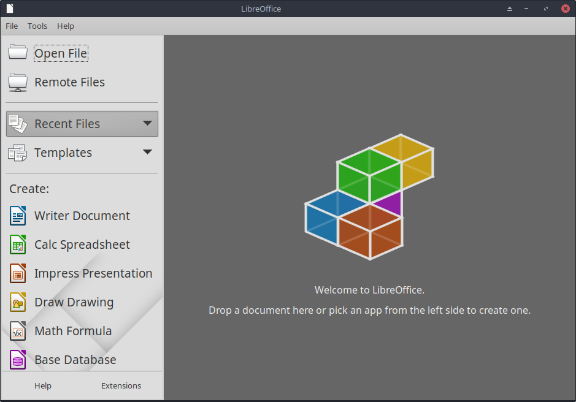

***Figure 4-6: Main dashboard in LibreOffice 6***

* The latest version available in the default repos is installed by default.
  + Word Processor: LibreOffice Writer. An advanced word processor compatible with .doc and .docx files.
  + Spreadsheet: LibreOffice Calc. An advanced spreadsheet compatible with .xls and .xlsx files.
  + Presentation: LibreOffice Impress. Presentations, compatible with .ppt and .pptx files.
  + Draw: LibreOffice Draw. Used to create graphics and diagrams.
  + Math: LibreOffice Math. Used for for mathematical equations.
  + Base: LibreOffice Base. Used to create and manipulate databases. If using this application to create or use databases in the native LibreOffice format, you must also install **libreoffice-sdbc-hsqldb** and **libreoffice-base-drivers** matched to version.
* Users can get more recent versions by a number of different methods:
  + Download directly from the LibreOffice. See [the MX/antiX Wiki](https://mxlinux.org/wiki/applications/libreoffice/) for details.
  + Download from MX Package Installer, Backports tab.
  + Download the flatpak (MX Package Installer) or the [appimage](https://www.libreoffice.org/download/appimage/).

LINKS

* [LibreOffice home page](https://www.libreoffice.org/).
* [MX/antiX Wiki](https://mxlinux.org/wiki/applications/libreoffice).

Other desktop suites are available as well.

* [Softmaker Free Office](https://www.freeoffice.com/) -- MX Package Installer: Popular applications
* [Calligra Suite](https://www.calligra.org/) (part of the KDE project) -- MX Package Installer: Test Repo

***4.3.1.2 In the cloud***

*Google*

Google’s [Docs and Office Suite](https://www.google.com/docs/about/) (the latter requires subscription) offers excellent online applications that include three standard office components: Docs, Sheets and Slides. It is easy to share files and the export options are very handy.

*Microsoft*

Microsoft products are not FOSS, yet many users need or want to have access to the, especially for business, institutional and other such contexts. Although Microsoft Office suite applications can't be natively installed under Linux, Microsoft's [Office365](https://www.office.com/) (paid service) or [On-line Office](https://products.office.com/en-us/office-online/documents-spreadsheets-presentations-office-online) (free) are just regular web pages that run fine inside any modern browser on MX Linux. Details in [the MX/antiX Wiki](https://mxlinux.org/wiki/applications/microsoft-office/).

*Other options*

* [OnlyOffice](https://www.onlyoffice.com/) (paid service for enterprises)

### 4.3.2 Office finances

* GnuCash. Financial software for office use. It is easy to learn, and allows you to track bank accounts, stocks, income and expenses. Can import data in QIF, QFX and other formats, and supports double entry accounting. MX Package Installer. The Help package (**gnucash-docs**) needs to be installed separately.
* [GnuCash home page](http://gnucash.org/)

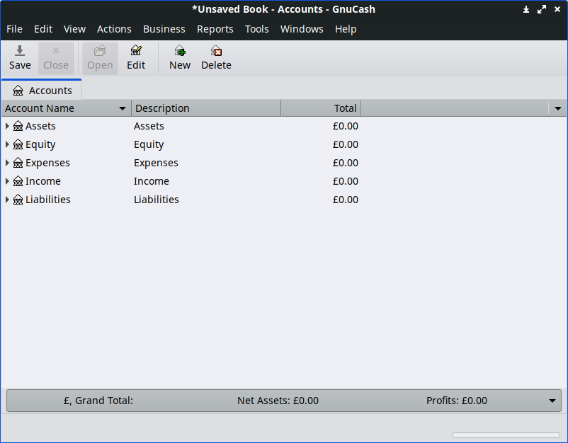

***Figure 4-7: New account in GnuCash***

### 4.3.3 PDF

* QPDFview. A fast and lightweight viewer that includes a number of basic tools. Installed by default.

[QpdfView home page](https://launchpad.net/qpdfview)

* Okular, the KDE project PDF and document reader

[Okular documentation](https://okular.kde.org/)

* Adobe Reader for Linux offers greater functionality (such as commenting or form filling). MX Package Installer (under Office).

[Adobe Reader home page](http://www.adobe.com/products/reader.html)

* PDFShuffler makes simple the reordering, deleting and adding of PDF pages. Installed by default.

[PDFShuffler home page](http://pdfshuffler.sourceforge.net/)

* gscan2pdf is a handy method of scanning documents to PDF in addition to serving general scanning needs. MX Package Installer ([MX/antix Wiki](https://mxlinux.org/wiki/applications/gscan2pdf)).

[gscan2pdf home page](http://gscan2pdf.sourceforge.net/)

* SimpleScan is minimal scan software that works very well for everyday tasks. Installed by default on MX-21.

[SimpleScan home page](https://gitlab.gnome.org/GNOME/simple-scan)

* For other functions (e.g., creating a PDF form), see [MX/antiX Wiki](https://mxlinux.org/wiki/applications/pdf).

### 4.3.4 Desktop publication

* Scribus. Professional page layout that produces press-ready output. Available via MX Package Installer.

[Scribus home page](https://www.scribus.net/)

### 4.3.5 Project time tracker

* Kapow punch clock. Simple but feature-rich app to record project time.

[Kapow home page](https://gottcode.org/kapow/)

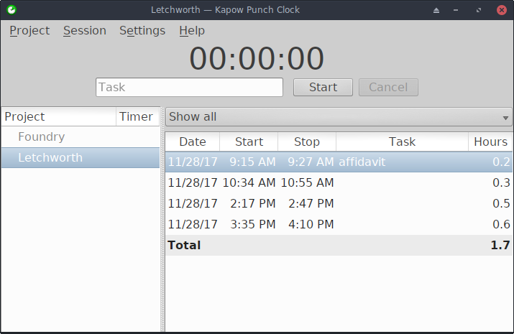

***Figure 4.8 Kapow set to track work on a project***

* [Other options](https://www.linuxlinks.com/timetracking/)

### 4.3.6 Video meeting and remote desktop

* [AnyDesk](https://anydesk.com/en). Allows easy remote access. MX Package Installer, along with other options.
* TeamViewer. Cross-platform application for Remote Support and Online Meetings. Free for private use. MX Package Installer.

[TeamViewer home page](https://www.teamviewer.us/)

## 4.4 Home

### 4.4.1 Finances

* HomeBank. Easy management of your personal accounting, budget and finance.

[HomeBank home page](http://homebank.free.fr/en/)

* Grisbi is very useful for the home. It can import QIF/QFX files, and has an intuitive interface. Perhaps better suited to banks outside the US.

[Grisbi home page](http://www.grisbi.org/)

### 4.4.2 Media Center

* Plex Mediaserver. Lets you bring together all your media and view it in one place. MX Package Installer.

[Plex home page](https://www.plex.tv/)

* Kodi Entertainment Center (formerly XBMC) allows users to play and view videos, music, podcasts, and media files from local and network storage media. MX Package Installer.

[Kodi home page](http://kodi.tv/)

### 4.4.3 Organization

* Notes. This handy Xfce plugin (**xfce4-notes-plugin**) allows you to create and organize sticky notes for your desktop.

[Notes home page](http://goodies.xfce.org/projects/panel-plugins/xfce4-notes-plugin)

* KDE Pim Application, a suite of applications to manage personal information.

<https://community.kde.org/KDE_PIM>

* Osmo. Nice compact application that includes calendar, tasks, contacts and notes.

[Osmo home page](http://clayo.org/osmo/)

***Figure 4-9: The personal information manager Osmo***

## 4.5 Security

### 4.5.1 Firewall

* Gufw. A personal firewall configuration utility that makes it easier for the user to configure the firewall. Installed by default.

[Gufw home page](http://gufw.org/)

[Wikipedia: Personal firewall](http://en.wikipedia.org/wiki/Personal_firewall)

### 4.5.2 Antivirus

* ClamAV. Useful to stop Linux users from unknowingly passing virus-infected emails and other documents to susceptible Windows users.

[ClamAV home page](https://sourceforge.net/projects/clamav/)

### 4.5.3 AntiRootkit

* chkrootkit. This application scans systems for known and unknown rootkits, backdoors, sniffers and exploits.

[chkrootkit home page](http://www.chkrootkit.org/)

### 4.5.4 Password protection

* Passwords and Keys. A password and key manager installed by default. Details on usage in [the MX/antiX Wiki](https://mxlinux.org/wiki/applications/passwords-and-keys).

[Passwords and Keys help](https://help.gnome.org/users/seahorse/stable/)

* KeePassX. A password manager or safe that helps you to manage your passwords in a secure way. MX Package Installer.

[KeePassX home page](http://www.keepassx.org/)

### 4.5.5 Web access

* Most modern browsers have add-ons that permit easy web filtering.
* FoxFilter is a well-established example that installs on Firefox, Chrome and Opera.

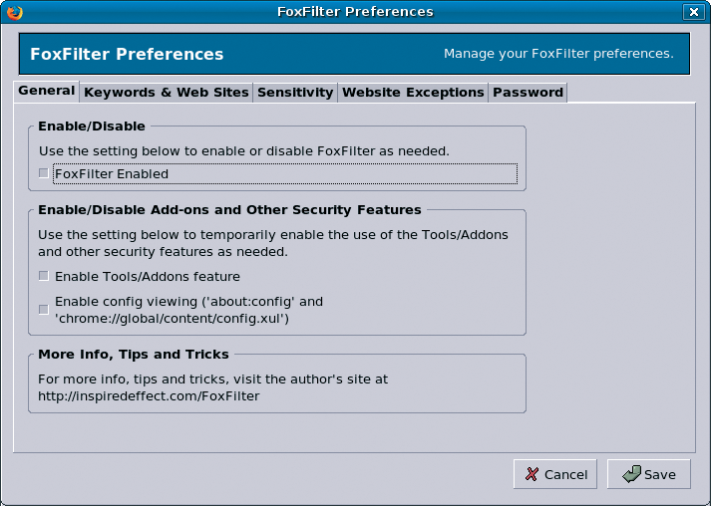

***Figure 4-10: The preferences tab for FoxFilter***

## 4.6 Accessibility

Various open-source utilities exist for MX Linux users with disabilities.

* On-screen keyboard. Onboard is installed by default, and Florence is in the repos.
* Xfce. Click Application Menu > Settings > Accessibility, and tick Enable Assistive Technologies. Change the available options to suit your liking.

[Xfce4 documentation: Accessibility](http://docs.xfce.org/xfce/xfce4-settings/accessibility)

* KDE maintains a large collection of accessibility aids.

[KDE Accessibility applications](https://userbase.kde.org/Applications/Accessibility)

* Debian. Many other tools are available within Debian itself.

[Debian Wiki](https://wiki.debian.org/accessibility)

## 4.7 System

### 4.7.1 Root privileges

There are two common commands to obtain root (AKA administrator, superuser) privileges that you need to make system changes (e.g., installing software) using a terminal.

* su: requires the root password and grants privileges for entire terminal session
* sudo: requires your user password and grants privileges for a short time period

In other words, su lets you switch user so that you’re actually logged in as root, while sudo lets you run commands in your own user account with root privileges. Also, su uses the environment (user-specific configuration) of the user root, while sudo allows root-level changes but keeps the environment of the user issuing the command. Starting with MX-21, MX Linux uses by default sudo, which Forum members will generally recommend as well.

The user can decide whether to use “Root” or “User” on the “Other” tab of MX Tweak.

MORE: click Application Menu > enter “#su” or “#sudo” (without the quotes) in the search space and return to see the detailed man pages.

#### Running a root application

Some applications that can be found in the Application Menu require that the user have root privileges: gparted, lightdm gtk+ greeter, etc. Depending on how the launch command is written, the dialog box that pops up may show that root access will be stored (default setting) for as long as your session lasts (i.e., until you log out).

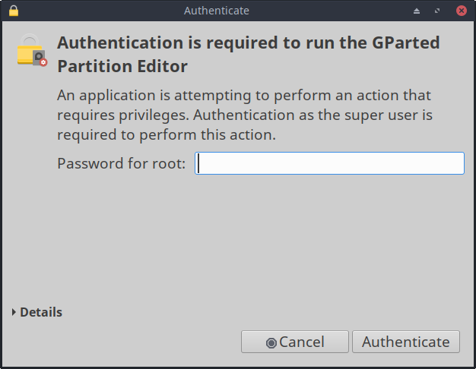

***Figure 4-11: Dialog box when the command pkexec is used with no storage of root password***

### 4.7.2 Get hardware specs

* Click **Application Menu > System > System Profiler and Benchmark** for a nice graphic display that includes the results of various tests.
* Click **Application Menu > MX Tools > Quick System Info**. The output is automatically copied to the clipboard, and can also be pasted into a Forum post complete with code tags.

See Section 6.5 for the many other features of inxi.

### 4.7.3 Create symbolic links

A symbolic link (also soft link or symlink) is a special kind of file that points to another file or folder, much like a shortcut in Windows or an alias in Macintosh. A symbolic link does not contain any actual data (as a hard link does), it just points to another location somewhere in the system.

There are two ways to create a symlink: File Manager or the command line.

* Thunar
  + Navigate to the file or folder (target of the link) that you want to point to from another location or under another name
  + Right-click what you want to link > Create Symlink, and a symlink is created where you currently are
  + Right-click the new symlink > Cut
  + Navigate to where you want the link to be, right-click an open area> Paste. Change if desired the link name.
* dolphin/KDE-plasma
* Use Create New > Basic Link to File or Directory
* Command line: Open a terminal and type:

*ln -s TargetFileOrFolder LinkName*

* + For example, to symlink a file named “foo” in your Downloads folder to your Documents folder, enter this:

*ln -s ~/Downloads/foo ~/Documents/foo*

### **4.7.4 Find files and folders**

#### GUI

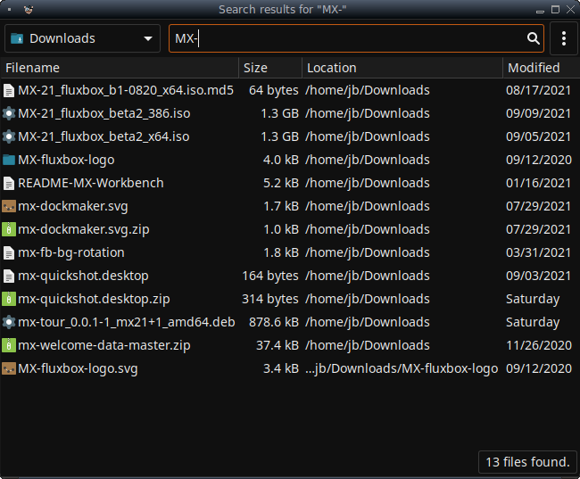

***Figure 4-12: Search screen of Catfish* looking for “MX-” in the Downloads folder**

**Catfish** is installed by default in MX Linux Xfce, and can be launched from the **Application Menu > Accessories,** or simply by starting to type “search” in the top search entry field. It is also integrated into Thunar so that the user can right-click a folder > Find files here.

[Catfish home page](http://www.twotoasts.de/index.php/catfish/)

KDE/plasma users can access the find dialog built into the dolphin file manager toolbar.

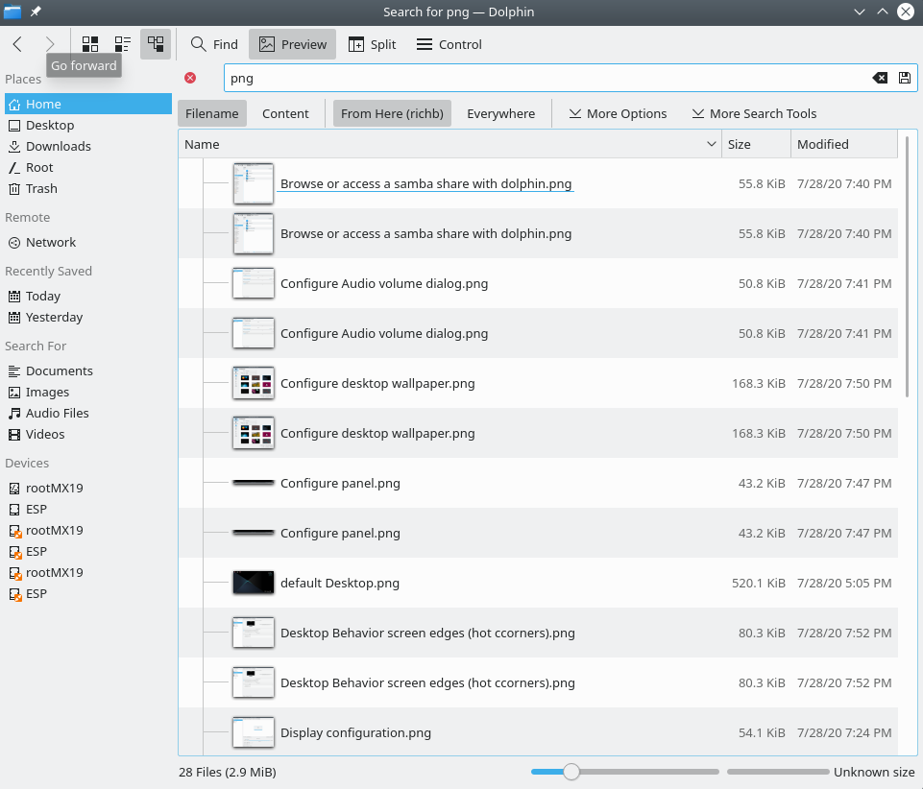

***Figure 4-13: dolphin Find search results***

Other more advanced search software is available in the repos such as [recoll](https://www.lesbonscomptes.com/recoll/).

#### CLI

There are some very handy commands for use in a terminal.

* *locate*. For each given pattern, locate searches one or more databases of file names and displays the ones that contain the pattern. For example, typing:

*locate firefox*

will return an extremely long list with every single file that has the word “firefox” in its name or its path. This command is similar to [find](http://www.tecmint.com/35-practical-examples-of-linux-find-command/) and is best used when the exact file name is known.

[Locate examples](http://www.thegeekstuff.com/2012/03/locate-command-examples/)

* *whereis*. Another command-line tool, installed by default. For each given pattern, whereis searches one or more databases of file names and displays the file names that contain the pattern, but it ignores paths so the return list is much shorter. For example, typing:

*whereis firefox*

will return a much shorter list something like this:

firefox: /usr/bin/firefox /etc/firefox /usr/lib/firefox

/usr/bin/X11/firefox /usr/share/firefox /usr/share/man/man1/firefox.1.gz

[Whereis examples](http://www.cyberciti.biz/faq/unix-linux-whereis-command-examples-to-locate-binary/)

* *which*: Arguably the most convenient tool of all, this command attempts to identify the executable. For example, typing:

*which firefox*

returns a single item:

/usr/bin/firefox

[Which examples](http://www.thegeekstuff.com/2013/04/linux-which-whatis-whereis/)

### 4.7.5 Kill runaway programs

* Desktop
  1. Press **Ctrl-Alt-Esc** to change the cursor into an “x”. Click on any open screen to kill it, right-click to cancel. Be careful not to click on the desktop or your session will end abruptly.
  2. Xfce - Task Manager: **Application Menu > Favorites**, or click **Application Menu > System > Task Manager**. Select the process you want and right-click to stop, terminate or kill.
  3. KDE/plasma – **Application Menu > Favorites**, or click **Application Menu > System > System Monitor**
  4. A traditional tool is also available: click **Application Menu > System > Htop**, which brings up a terminal showing all running processes. Locate the program you want to stop, highlight it, press F9, then Return.
* Terminal: Press **Ctrl-C**, which will usually stop a program/command you started in a terminal session.
* If the above solutions don’t work, try these more extreme methods (listed in increasing severity).
  1. Restart X. Press **Ctrl-Alt-Bksp** to kill all session processes, leaving you back at the login screen. Any unsaved work will be lost.
  2. Use magic SysRq key (REISUB). Hold down the **Alt** key (sometimes only the left Alt key will work) along with the **SysRq** (can be also labeled **Print Screen** or **PrtScrn)** key with another hand, then slowly, without releasing Alt-SysRq, press the keys **R-E-I-S-U-B** one after the other. Hold down each key of the REISUB sequence for about 1 or 2 second before moving on to the next key; your system should shut down correctly and reboot. The purpose of this magic key is to go through several stages that nurse your system safely out of a failure of some sort, and often only the first 2 letters are sufficient. This is what happens when you go through the letters:
     + R - switch the keyboard mode. This is said to "Switch the keyboard from raw mode, the mode used by programs such as X11 and svgalib, to XLATE mode" (from [Wikipedia](https://en.wikipedia.org/wiki/Magic_SysRq_key)), but it is unsure if this would normally have any notable effect.
     + E - gracefully terminate all running programs. This sends the SIGTERM signal to all processes except init and thereby asks them to gracefully terminate, giving them a chance to tidy up and free their resources, save data, etc...
     + I - forcibly kill all running programs. This is similar to the E, but sends the SIGKILL signal to all processes except init, which kills them immediately and forcibly.
     + S - sync all disks and flush their caches. All your disks normally have a write cache, a piece of RAM where the system caches data it wants to save on the device, to speed the access up. Syncing tells the system to flush these caches now and perform all remaining writes. That way you do not lose any data that has already been cached but not been written yet, and it protects from leaving the file system in an inconsistent state.
     + U - unmount all disks and remount them read-only. This is again pretty unspectacular, it simply makes all mounted disks read-only to prevent any further (partial) writes.
     + B - reboot the system. This reboots the system. However, it does not perform a clean shutdown, but instead a hard reset.

[Wikipedia: REISUB](https://en.wikipedia.org/wiki/Magic_SysRq_key)

* 1. If nothing else works, hold down the power button of your computer for 10 seconds or so until it shuts down.

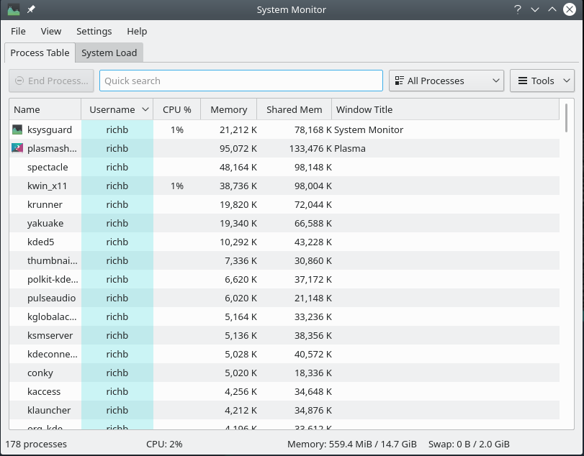 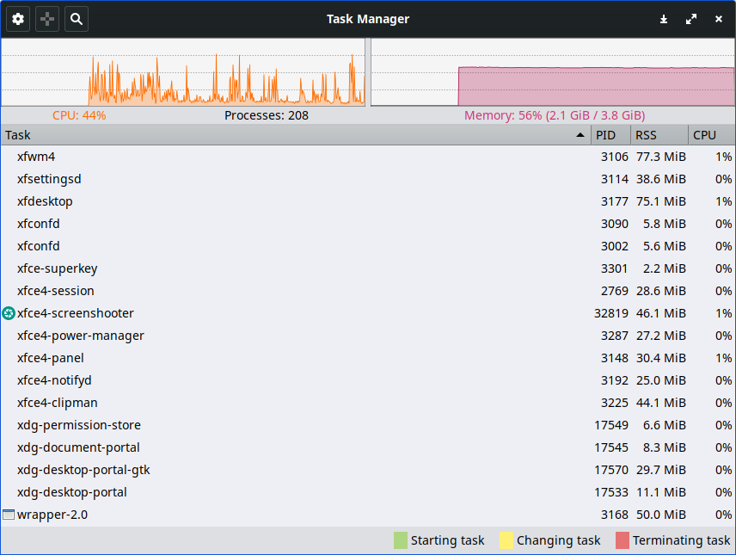

***Figure 4-14: Task Manager, ready to kill a process. TOP: KDE/plasma BOTTOM: Xfce***

### 4.7.6 Track performance

#### General

* GUI
  + Click Application Menu > System > System Profiler and Benchmark, where you can not only see a great many specifications but also run performance tests.
  + Many conkies show system performance; use Conky Manager to preview them for your needs and preferences. See Section 3.8.3.
  + Xfce plugins. Xfce 4.12 brings a number of plugins for monitoring the system that can be placed in the Panel, including Battery Monitor, CPU Frequency Monitor, CPU Graph, Disk Performance Monitor, Free Space Checker, Network Monitor, Sensor plugin, System Load Monitor, and Wavelan. They can all be installed with the metapackage **xfce4-goodies.** KDE/plasma has a similar set of panel and desktop widgets.

[Xfce4 Goodies home page](http://goodies.xfce.org/projects/panel-plugins/start)

* CLI
  + lm-sensors. This hardware health monitoring package is installed by default in MX Linux. Open a terminal, become root, and enter:

*sensors-detect*

Click Return to answer yes to all questions. When it has finished, you will be able to get detailed information about the readings of the sensors that are available on your system by opening a terminal and entering: *sensors*.

[Lm-sensors home page](https://wiki.archlinux.org/index.php/Lm_sensors)

#### Battery

Battery level is monitored by the Power Manager plugin on the Panel. A dedicated Panel plugin called *Battery Monitor* is also available by right-clicking the Panel > Panel > Add New Items ... KDE has a Battery Monitor panel widget installed by default.

### 4.7.7 Schedule tasks

* GUI
  + MX Job Scheduler, see 3.2.11.
  + Scheduled tasks (**gnome-schedule**). A very handy way to schedule system tasks without having to directly edit system files. [Gnome-schedule home page](http://gnome-schedule.sourceforge.net/).
  + KDE has a [Task Scheduler](https://userbase.kde.org/System_Settings/Task_Scheduler) with similar capabilities.

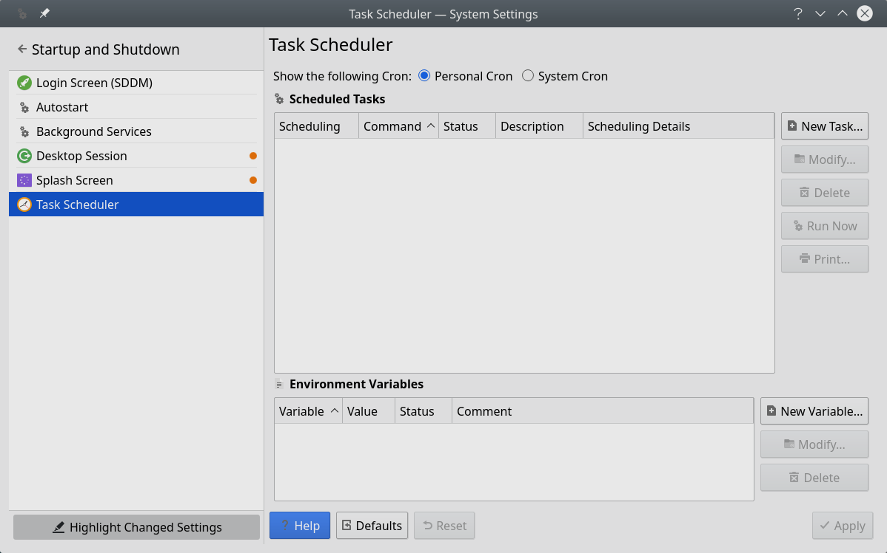

***Figure 4-15: Main screen of KDE’s Task Scheduler***

* CLI
  + You can edit **crontab**, a text file with a list of commands to be run at specified times.

[Crontab overview](https://mxlinux.org/wiki/system/crontab/)

[Easy crontab generator](http://crontab-generator.org/)

### 4.7.8 Correct time

Correct time setting is normally taken care of at Live boot or during the installation. If your clock time is always wrong, there are 4 possible issues:

* wrong timezone
* wrong selection of UTC versus local time
* BIOS clock set wrong
* time drift

These issues are most easily addressed by using the appropriate Date & Time application ; for command line techniques, see [the MX/antiX Wiki](https://mxlinux.org/wiki/system/time-settings).

### 4.7.9 Show Key Lock

On many laptops there is no indicator light for the activation of the CapsLock or NumLock keys, which can be very annoying. To solve this with an onscreen notifier, install **indicator-keylock** from the repos.

## 4.8 Good practices

### 4.8.1 Backup

The most important practice is to [back up your data and configuration files](https://wiki.archlinux.org/index.php/Backup_programs) regularly, a process that is easy in MX Linux. It is highly recommended that you back up to a different drive than the one your data is on! The average user will find one of the following graphical tools convenient.

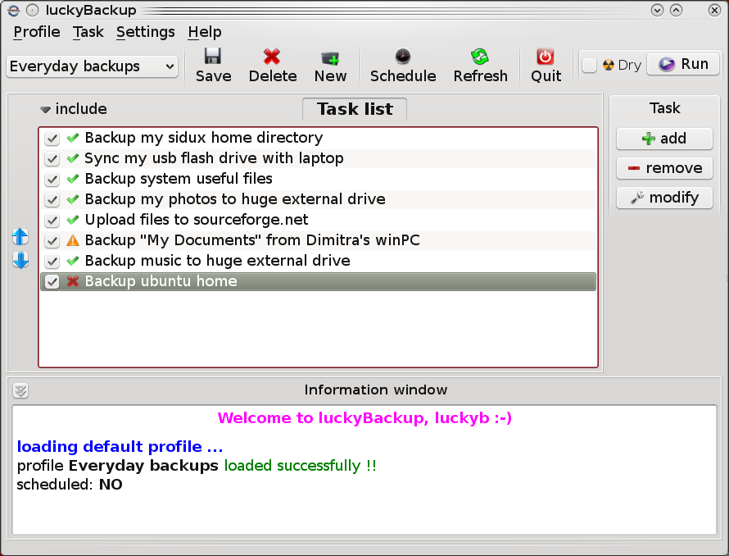

***Figure 4-16: Main screen of Lucky Backup***

* gRsync, a graphical frontend for [rsync](https://en.wikipedia.org/wiki/Rsync).

[Overview of gRsync](https://www.dedoimedo.com/computers/grsync.html)

* LuckyBackup. An easy program to back up and sync your files. Installed by default.

[LuckyBackup manual](http://luckybackup.sourceforge.net/manual.html)

* Déjà Dup. A simple but very effective backup tool.

[Déjà Dup home page](https://launchpad.net/deja-dup)

* BackInTime. A well-tested app available from MX Package Installer > MX Test Repo (preinstalled on MX KDE)
* Cloud service. There are many cloud services that can be used for backing up or synching your data. DropBox and Google Drive are probably the best known, but many others exist.
* Cloning. Create a complete image of the hard drive.
  + Clonezilla. Download Clonezilla Live from the [Clonezilla home page](http://clonezilla.org/), and then reboot into it.
  + Timeshift. Full system backup/restore; in the repos. [Timeshift home page](https://github.com/teejee2008/timeshift) includes a detailed overview and how-to.
  + Save the system to a live ISO (Section 6.6.3).
  + CLI tools. See the discussion in the [Arch Wiki: Cloning](https://wiki.archlinux.org/index.php/disk_cloning)
* CLI commands for doing backups (rsync, rdiff, cp, dd, tar, etc.).

#### Data

Make sure you back up your data, including documents, graphics, music, and mail. By default, most of this is stored in your /home directory; we recommend that if possible you have a separate data partition, best in an external data location.

#### Configuration files

Here is a list of items to consider for backup.

* /home. Holds most of the personal configuration files.
* /root. Holds the changes you have made as root.
* /etc/X11/xorg.conf. X configuration file, if there is one.
* The GRUB2 files /etc/grub.d/ and /etc/default/grub.

#### List of installed program packages

It’s also a good idea to save in your /home directory or in the cloud (Dropbox, Google Drive, etc.) a file that contains the list of programs that you have installed with Synaptic, apt-get or Gdebi. If in the future you need to reinstall, you can recover the names of the files for reinstallation.

A handy tool to list packages installed since the system was initially installed can be found by right-clicking on the **MX Updater** icon in the Notification Area > Apt History. A list of programs you installed via the apt system will appear that you can copy and paste into a document for storage and reference.

You can create an inventory of all packages on your system installed since installation by copying this long command and running it in a terminal:

dpkg -l | awk '/^[i|h]i/{ print $2 }' | grep -v -e ^lib[0-q\|s-z] -e ^libr[0-d\|f-z] -e ^libre[0-n\|p-z] -e -dev$ -e -dev: -e linux-image -e linux-headers | awk '{print $1" installed"}' | column -t > apps\_installed.txt

That will create a text file in your home directory called “apps\_installed.txt” that contains all the package names.

To reinstall ALL those packages at once: make sure that all needed repositories are enabled, then issue these commands one at a time:

*su*

*dpkg \SpecialChar nobreakdash\SpecialChar nobreakdashset-selections < apps\_installed.txt*

*apt-get update*

*apt-get dselect-upgrade*

**NOTE**: this should not be attempted between MX releases based on different Debian versions (e.g., from MX-14.4 to MX-15 or MX-16)

There is a tool [**aptik**](https://mxlinux.org/wiki/other/application-migration-aptik)in the repos that can help if used with caution. It was developed for Ubuntu but will save a lot of effort in MX Linux as well, especially with respect to settings files that tend to be overlooked.

### 4.8.2 Disk maintenance

As a system ages, it often accumulates data that is no longer being used and gradually fills up the disk. Such problems can be alleviated by periodic use of MX Cleanup.

Let us look at an example. When her machine was slowing down, one user checked free space on the disk using *inxi -D* and was startled to see that the disk was 96% full. Clicking on the Run Disk Usage Analyzer button in MX Cleanup provided a good graphical analysis, and clicking on the big red segments revealed that the cache was bloated.

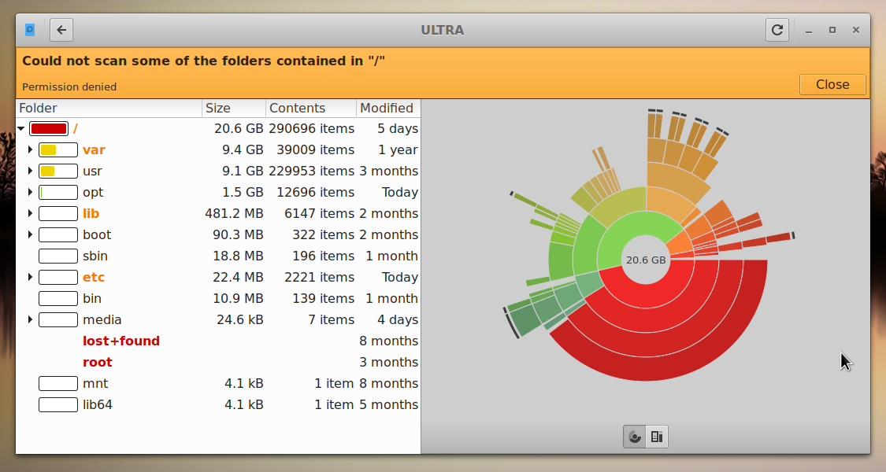

***Figure 4-17. Disk Usage Analyzer displaying a root directory almost full***

After it had been cleaned using MX User Manager, the percentage dropped to about 63% and the sluggishness was gone.

### 

***Figure 4-18. The results of clearing out the cache as represented by Disk Usage Analyzer***

#### Defragging

Users coming from Windows may wonder about the need to defrag the drive periodically. Defrag is not likely to be needed on the MX default ext4 file system but if it's almost full and hasn't got a contiguous area big enough to allocate your file, you'll end up with fragmentation. You can check the status if necessary with this command:

sudo e4defrag -c /

You will see after a few seconds a score and a simple statement about whether it needs defragmentation or not.

### 4.8.3 Error checking

Many error messages are written to the appropriate file in */var/log/* covering problems in applications, events, services and system.Some important ones include:

* */var/log/boot*
* */var/log/dmesg*
* */var/log/kern.log*
* */var/log/messages*
* */var/log/Xorg.0.log*

They are not always easy to read, but often worth looking at if you suspect a problem. You can look at them in a terminal by using the command *cat* followed by the location of the log you want to see.

## 4.9 Games

Browsing the extensive list of games available through Synaptic (click Sections > Games at the bottom of the left panel) or following the links below will bring up many other titles for your enjoyment.

The following list contains some examples to whet your appetite.

### 4.9.1 Adventure and Shooter Games

* Chromium B.S.U.: A fast paced, arcade-style, top-scrolling space shooter. Installed by default.

[Chromium B.S.U. home page](http://chromium-bsu.sourceforge.net/)

* Beneath A Steel Sky: A science-fiction thriller set in a bleak post-apocalyptic future.

[Beneath a Steel Sky home page](https://en.wikipedia.org/wiki/Beneath_a_Steel_Sky)

* Kq: A console-style role playing game, similar to Final Fantasy.

[Kq home page](http://kqlives.sourceforge.net/)

* Mars. “A ridiculous shooter.” Protect planet from your jealous neighbors!

[Mars home page](http://mars-game.sourceforge.net/?page_id=972)

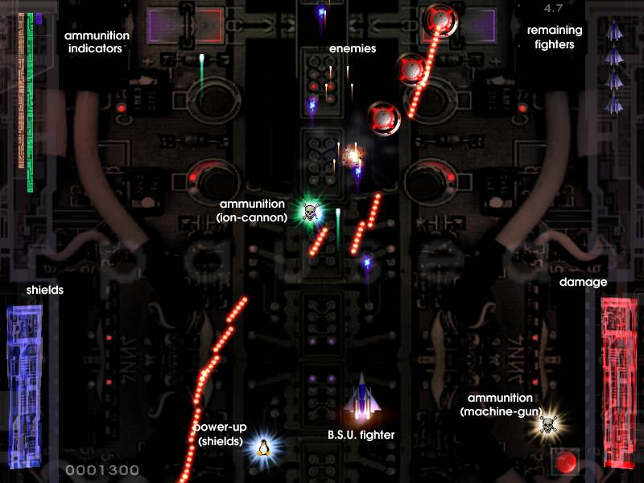

**Figure 4-19: Enemy warships on the attack in Chromium B.S.U**

### 4.9.2 Arcade Games

* Defendguin: A clone of Defender, where your mission is to defend little penguins.

[Defendguin home page](http://www.newbreedsoftware.com/defendguin)

* Frozen Bubble: Colored bubbles are frozen at the top of the playing screen. As the Ice Press descends, you must pop out groups of frozen bubbles before the Press reaches your shooter.

[Frozen Bubble home page](http://www.frozen-bubble.org/)

* Planet Penguin Racer: a fun racing game with your favorite penguin.
* [Tuxracer home page](http://tuxracer.sourceforge.net/)
* Ri-li: A toy train game.

[Ri-li home page](http://ri-li.sourceforge.net/)

* Supertux: A classic 2D jump’n’run side-scrolling game in a style similar to the original SuperMario games.

[Supertux home page](http://supertux.lethargik.org/)

* Supertuxkart: A much improved version of tuxkart.

[Supertuxcart home page](http://supertuxkart.sourceforge.net/)



***Figure 4-20: Ri-li train needs to turn soon***

### 4.9.3 Board Games

* Gottcode games: of the ones available, Peg-E (Peg solitaire game) installed by default.

[Gottcode home page](http://gottcode.org/)

* Mines (gnomines): A minesweeper game for 1 player.

[Mines home page](https://wiki.gnome.org/Apps/Mines)

* Do’SSi Zo’la: The goal of the basic Isola game is to block the opponent by destroying the squares which surround him.

[Do'SSi Zo'la home page](http://dossizola.sourceforge.net/)

* Gnuchess: A chess game.

[Gnuchess home page](http://www.gnu.org/software/chess)

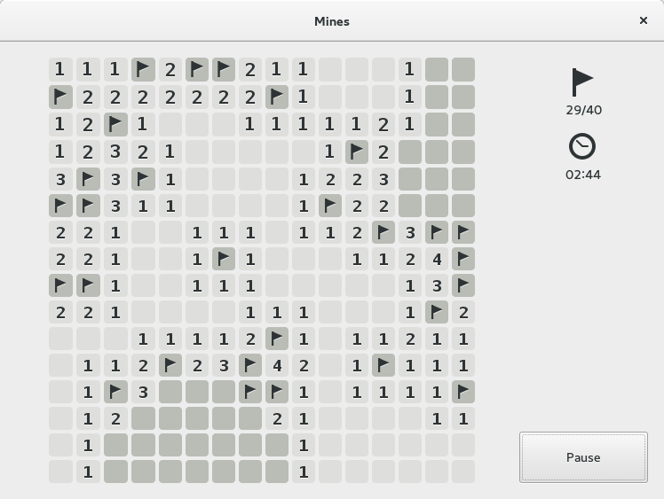

***Figure 4-21: High-tension moment in Mines.***

### 4.9.4 Card Games

Here are some fun card games available from the repos.

* Pysolfc: Over 1,000 solitaire games from a single application.

[Pysolfc home page](http://pysolfc.sourceforge.net/)

### 4.9.5 Desktop Fun

* Xpenguins. Penguins walk around your screen. Can be customized with other characters like Lemmings and Pooh Bear (need to allow programs to run in root window).

[Xpenguins home page](http://xpenguins.seul.org/)

* Oneko. A cat (neko) follows your cursor (the mouse) around the screen. Can be customized with a dog or other animal.

[Wikipedia: Neko](https://en.wikipedia.org/wiki/Neko_(software))

* Algodoo. This free game presents a 2D physics sandbox where you can play with physics like never before. The playful synergy of science and art is novel, and makes it as educational as it is entertaining.

[Algodoo home page](http://www.algodoo.com/)

* Xteddy. Puts a cute teddy on your desktop. Alternatively you can add your own image.

[Xteddy homepage](http://staffwww.itn.liu.se/~stegu/xteddy/index.html)

* Tuxpaint. A drawing program for kids of all ages.

[Tuxpaint home page](http://www.tuxpaint.org/)

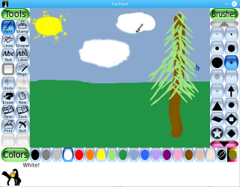

***Figure 4-22: Budding genius at work in Tuxpaint***

### 4.9.6 Children

* Three packages of games and educational applications are available from MX Package Installer.
* In addition, [Scratch](https://scratch.mit.edu/) is a free programming language and online community where you can create your own interactive stories, games, and animations. MX Package Installer.

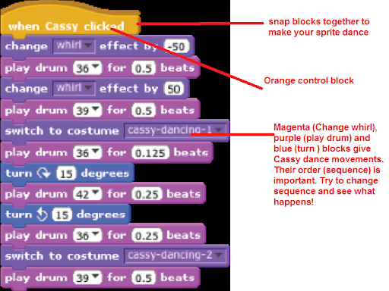

**Figure 4-23: Coding screen for Dance Party using Scratch**

### 4.9.7 Tactics & Strategy Games

* Freeciv: A clone of Sid Meyer’s Civilization© (version I), a turn-based multiplayer strategy game, in which each player becomes the leader of a stone age civilization, trying to gain ascendency as the ages progress.

[Freeciv home page](http://www.freeciv.org/)

* Lbreakout2: LBreakout2 is a breakout-style arcade game where you use your paddle to aim a ball at bricks until all bricks are destroyed. Many levels and surprises. Installed by default.

[Lgames home page](http://lgames.sourceforge.net/)

* Lincity: A clone of the original Simcity. You must build and maintain a city and keep its people satisfied so that your population grows.

[Lincity home page](http://lincity.sourceforge.net/)

* Battle for Wesnoth: A highly-rated turn-based strategy game with a fantasy theme. Build your army and fight to regain the throne.

[Battle for Wesnoth home page](http://www.wesnoth.org/)

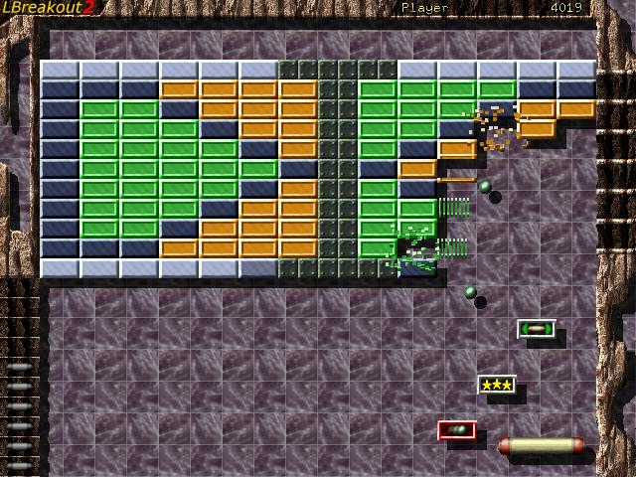

***Figure 4-24: Trying to break through the first wall in Lbreakout***

### 4.9.8 Windows games

A number of Windows games can be played in MX Linux by using a Windows emulator such as Cedega or DOSBox, or some may even run under Wine: see Section 6.1.

### 4.9.9 Game services

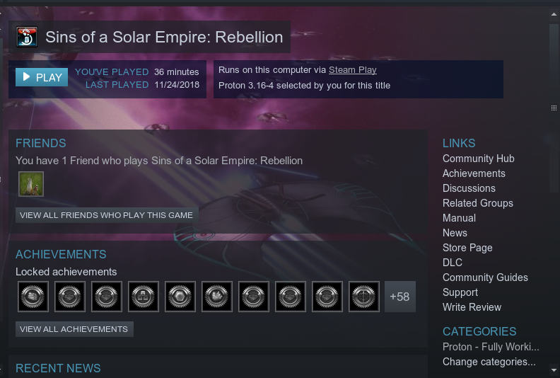

***Figure 4-25: Sins of a Solar Empire: Rebellion running on Steam with Proton***

There exist various collections and services for the user wishing to play games on MX Linux. Two of the best known are easily installable with MX Package Installer.

* PlayOnLinux. A graphical frontend for Wine (Section 6.1) that allows Linux users to easily install and use numerous games and apps designed to run with Microsoft® Windows®.

[PlayOnLinux homepage](https://www.playonlinux.com/en/).

* Steam. A proprietary digital distribution platform for purchasing and playing video games that provides installation and automatic updating of games. Includes Proton, a modified distribution of Wine.

[Steam homepage](https://store.steampowered.com/)

## 4.10 Google tools

### 4.10.1 Gmail

Gmail can be easily set up in Thunderbird following the prompts. It can also be easily accessed in any browser.

### 4.10.2 Google’s Contacts

Google’s Contacts can be linked into Thunderbird by using the add-on gContactSync.

[gContactSync home page](http://www.pirules.org/addons/gcontactsync/)

### 4.10.3 Gcal

Gcal can be set up on a tab in Thunderbird with the add-ons Lightning and Google Calendar Tab.

[Lightning calendar home page](https://www.mozilla.org/en-US/projects/calendar/)

### 4.10.4 Gtasks

Gtasks can be included in Thunderbird by ticking the Tasks entry of the calendar.

### 4.10.5 Google Earth

The easiest method of installing Google Earth is by using MX Package Installer, where it is in the “Misc” section.

There is also a manual method that may be useful in some installations.

* Install **googleearth.package** from the repos or directly from [the Google repo](https://www.google.co.uk/earth/download/gep/agree.html).
* Open a terminal and enter:

make-googleearth-package

* Once that is finished, become root and type:

dpkg -i googleearth\*.deb

* An error message will appear on screen about dependency problems. Correct that by entering this last command (still as root):

apt-get -f install

Now finally Google Earth will appear in **Application Menu > Internet**.

### 4.10.6 Google Talk

There is a browser plugin called **google-talkplugin** available from [the Google repos](https://tools.google.com/dlpage/hangoutplugin) that allows you to make a voice or video call from your Gmail account to another Gmail user. It has been superseded by [Google Duo](https://duo.google.com/) that can be run directly from Gmail opened in a browser

### 4.10.7 Google Drive

Convenient tools providing local access to your GDrive account exist.

* A free simple app called [Odrive](https://www.omgubuntu.co.uk/2019/02/odrive-google-drive-linux-client) installs and works well.
* The proprietary cross-platform app [Insync](https://www.insynchq.com/google-drive-linux) allows selective syncing and installation on multiple computers.

## **4.11** Bugs, issues and requests

Bugs are errors in a computer program or system that produce incorrect results or abnormal behavior. “Requests” or "enhancements" are additions requested by users, either as new applications or new features for existing applications. MX Linux deals with these in the following manner:

* Bugs are managed by means of [the](http://bugs.mxlinux.org/) [MX and antiX Linux Bug Tracker](https://us-bz3.devzing.com/mx_antix/).
* Requests can be made with a post in the [Bugs and Request Forum](https://forum.mxlinux.org/viewforum.php?f=97), being careful to provide information about hardware, system and other details
* Devs as well as Community members will respond to those posts with questions, suggestions, etc.

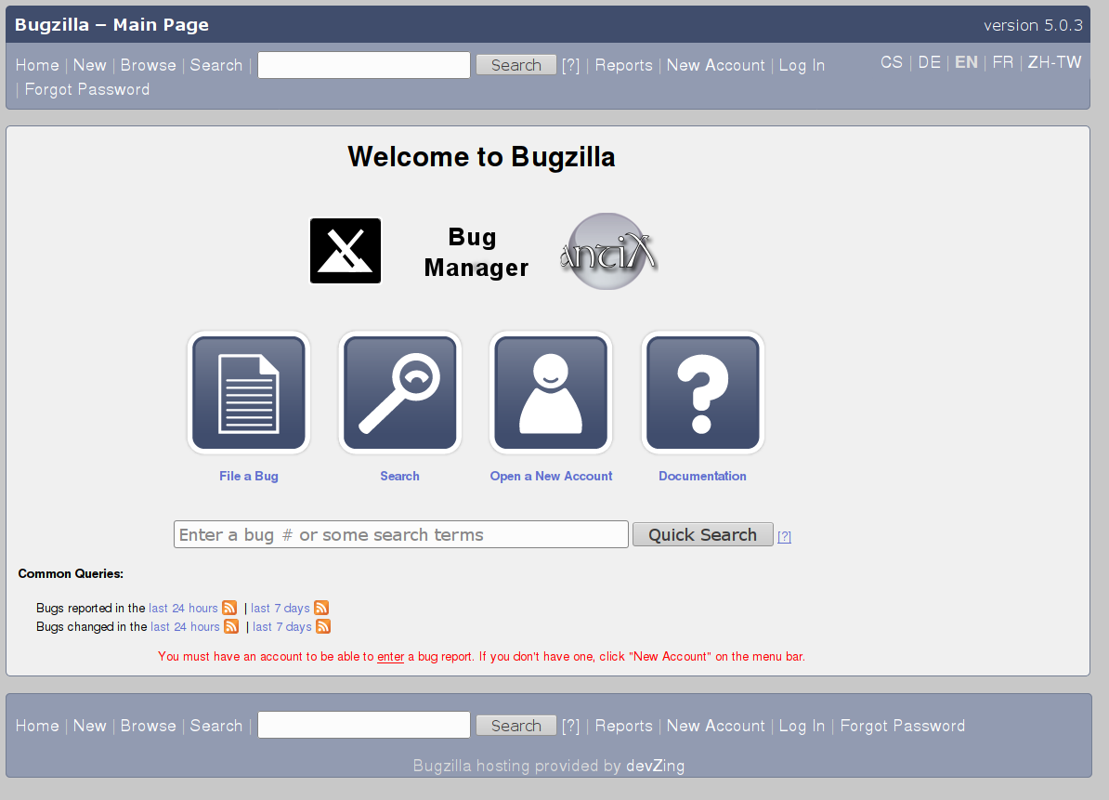

**Figure 4-26: dashboard of the bug manager**

# 5 Software Management

## 5.1 Introduction

### 5.1.1 Methods

MX Linux offers two complementary methods of software management:

* MX Package Installer (MXPI) for one-click installation/removal of popular apps, as well as apps in the Debian Stable, MX Test Repo, Debian Backports and the Flatpaks repo. See Section 3.2.11.
* Synaptic Package Manager, a full-featured graphical tool for a whole range of actions with Debian packages.

MXPI has a number of advantages over Synaptic:

* It's a lot faster!
* The Popular Applications tab is restricted to the packages most often used, so everything is easy to find.
* It correctly installs some packages that are otherwise complicated to do correctly (e.g., Wine).
* It includes other sources besides Debian Stable in a single app:
  + Our own MX Test Repo with newer packages than what Synaptic has by default.
  + Debian Backports.
  + Flatpaks, not available at all in Synaptic.

Synaptic has its own advantages:

* It has a large number of advanced filters set up such as Sections (categories), Status, etc.
* It offers detailed information about particular packages.
* It makes it very easy to add new software repositories.

This Section 5 concentrates on Synaptic, which is the recommended method for beginners to manage software packages beyond the capabilities of MX Package Installer. It will also look at other methods that are available and may be required for certain situations.

### 5.1.2 Packages

Software operations in MX are accomplished behind the scenes through the [Advanced Package Tool (APT)](https://en.wikipedia.org/wiki/APT_(Debian)) system. Software is provided in the form of a **package**: a discrete, non-executable bundle of data that includes instructions for your package manager about installation. Packages are stored on servers called repositories (repos), and can be browsed, downloaded, and installed through special client software called a package manager.

The majority of packages have one or more **dependencies**, meaning that they have one or more packages that must also be installed in order for them to work. The APT system is designed to automatically handle dependencies for you; in other words, when you try to install a package whose dependencies are not already installed, your APT package manager will automatically mark those dependencies for installation as well. It can happen that these dependencies can not be met, preventing the installation of a package; post such problems on the Forum.

## 5.2 Repos

APT repos are much more than just web sites with downloadable software. The packages on repository sites are specially organized and indexed to be accessed through a package manager, rather than browsed directly.

**WARNING: do not add other repositories blindly to MX Linux! This is especially true for Debian Sid or a PPA, which is very likely to break your installation beyond repair.**

### 5.2.1 Standard repos

MX Linux comes with a set of enabled repos that offer you both security and choice. If you are new to MX Linux (and especially if you are new to Linux), it is recommended that in general you stick with the default repos at first. For security reasons, these repos are digitally signed, meaning that packages are authenticated with an encryption key to make sure they are authentic. If you install packages from non-Debian repos without the key, you will get a warning that they could not be authenticated. To get rid of this warning and make sure your installations are secure, you need to install missing keys using **MX Fix GPG keys**.

Repos are most easily added, enabled/disabled, removed, or edited through Synaptic, though they can also be altered by hand by editing the files in **/etc/apt/** in a root terminal. In Synaptic, click **Settings > repos**, then click the button New and add the information. Repo information is often given as a single line, like this:

*deb http://mxrepo.com/mx/testrepo/ stretch test*

Be careful to note the location of the spaces, which separate the information into four chunks that are then entered into separate lines in Synaptic.

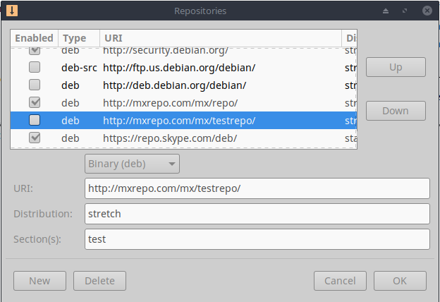

Figure 5-1: Repos, with the MX test repo highlighted

Some repos carry special labels:

* **contrib**, which depend on or are accessory to non-free packages.
* **non-free**, which do not meet the [Debian free software guidelines](https://en.wikipedia.org/wiki/Debian_Free_Software_Guidelines) (DFSG).
* **security**, which contain security-related updates only.
* **backports**, which contain packages from newer versions of Debian that have been backwards compiled for Debian Stable (the version MX is built with) to keep your OS up-to-date.
* **MX**, which contain the special packages that make MX what it is.

The current list of standard MX repos is kept in the [MX/antiX Wiki](https://mxlinux.org/wiki/system/repos-mx-linux).

### 5.2.2 Community repos

MX Linux has its own Community Repos with packages that our Packagers build and maintain. These packages are distinct from official MX packages coming from Debian Stable, and contain packages from other sources:

* Debian backports, from testing or even experimental
* Our sister distro [antiX](https://antixlinux.com/)
* Independent projects
* Open-source hosts such as [GitHub](https://en.wikipedia.org/wiki/GitHub)

The Community Repos are critical to MX Linux, since they permit an OS based on Debian Stable to stay abreast of important software developments.

In addition to the MX Main repo, the MX Test repo aims to get feedback from users before new packages are moved to Main. The easiest way to install from MX Test is with the MX Package Installer (Section 3.2), as it handles many steps automatically.

To find out more about what is available, who the packagers are, and even how to get involved, see [MX Community Packaging Project](https://mxlinux.org/community-repos/).

### 5.2.3 Dedicated repos

In addition to the general repos such as Debian, MX, and Community, there also exist a certain number of dedicated repos associated with a single application. When you add one of them, either directly or through Synaptic, then you will receive updates. Some are preloaded but not enabled, others you will add yourself.

Here is a common example (VirtualBox):

deb https://download.virtualbox.org/virtualbox/debian/stable contrib

New users coming from Ubuntu or one of its derivatives often ask about **PPA repos**; Ubuntu deviates from standard Debian, so such repos need to be treated with caution. Consult the [MX/antiX Wiki](https://mxlinux.org/wiki/system/add-ppa-repository).

### 5.2.4 Development repos

One final category of repository exists for acquiring the most recent (and thus least stable) build of an application. This is done through a version control system such as Git that can be consulted by the end user to stay current with development. A copy of the application source code can be downloaded into a directory on a local machine. The software repositories are a convenient method of managing projects using Git, and MX Linux keeps most of its code in [its own GitHub repo](https://github.com/MX-Linux).

More: [Wikipedia: Software repository](http://en.wikipedia.org/wiki/Software_repository)

### **5.2.5** Mirrors

MX Linux repos for both packages and ISOs are “mirrored” on servers at different sites around the world; the same is true for Debian repos. These mirror sites provide multiple sources of the same information, and function to reduce download time, improve reliability, and provide a certain resiliency in case of server failure. During installation, the most likely mirror will be automatically selected for you based on location and language. But the user may have reasons to prefer another:

* The automatic assignment at installation may be wrong in some cases
* The user may change residency
* A new mirror may become available that is much closer, faster or more reliable
* An existing mirror may change its URL
* The mirror being used may become unreliable or go offline

MX Repo Manager (Section 3.2) makes it easy to switch mirrors, enabling you to choose the one that works best for you. Be sure to take note of the button that selects the fastest mirror for your location.

## 5.3 Synaptic

The following section seeks to provide an up-to-date overview of Synaptic use. Note that your root password is required and, naturally, you will need to be connected to the Internet.

### 5.3.1 Installing and removing packages

#### Installing

Here are the basic steps for installing software in Synaptic:

* Click **Start menu > System > Synaptic Package Manager**, supplying the root password if asked.
* Hit the Reload button. This button causes Synaptic to contact the online repository servers and download a new index file with information on what packages are available, what versions they are, and what other packages are required for them to be installed. If you get a message that some of the repos failed to be contacted, wait a minute and then try again.
* If you already know the name of the package you are looking for, just click in the pane on the right and start typing; Synaptic will incrementally search as you type.
* If you don’t know the package’s name, use the Search box in the upper right corner to locate software based on name or keywords. This is one of Synaptic’s greatest advantages over other methods.
* Alternatively, use one of the filter buttons in the bottom left corner:
  + **Sections** provides subareas such as Editors, Games and Amusement, Utilities, etc. You will see a description of each package in the bottom pane, and can use the tabs to discover more information about it.
  + **Status** groups packages by their installation situation.
  + **Origin** will show packages from a specific repository.
  + **Custom Filter**s provides various filter options
  + **Search Results** will show a list of previous searches for the Synaptic session you are in.
* Click the empty box at the left end of the package you want and select Mark for Installation on the pop-up screen. If the package has dependencies, you will be notified and they will automatically be marked for installation as well. You can also just double-click the package if it is the only one you are installing.
* Some packages also have “Recommended” and “Suggested” packages that can be viewed via right-clicking the package name. These are additional packages that add functionality to the selected package, and it is a good idea to look them over.
* Click Apply to begin the installation. You can safely ignore any warning message: “You are about to install software that can’t be authenticated!”
* There may be additional steps: just follow the prompts as you receive them until the installation completes.

***Figure 5-2: Checking recommended packages during package installation.***

#### Removing

Removing software from your system with Synaptic seems as straightforward as installing, but there is more to it than meets the eye:

* To remove a package, simply click the same box as for installation and select Mark for Removal or Mark for Complete Removal.
  + Removal uninstalls the software, but leaves system configuration files in case you want to keep your settings.
  + Complete Removal removes the software and the system configuration files as well (purging). Your personal configuration files related to the package will not be removed. Check also for other configuration file remnants in Synaptic’s category **Not installed (residual config)**.
* When you have other programs that depend on the package being removed, those packages will have to be removed as well. This usually happens when you remove software libraries, services, or command-line applications that serve as back-ends to other applications. Make sure you read carefully the summary Synaptic gives you before clicking OK.
* Removing large applications that are composed of many packages can bring complications. Many times these packages are installed using a meta-package, which is an empty package that simply depends on all the packages you need for the application. The best way to remove a complicated package like this is to inspect the dependency list for the meta-package, and remove the packages listed there. Take care, however, that you don’t uninstall a dependency of another application you want to keep!
* You may find that the status category Autoremoveable begins to accumulate packages. These were installed by other packages and are no longer needed, so you can click on that status category, highlight all the packages in the right pane, and then right-click them to remove. Be sure to examine the list carefully when the verification box appears, because sometimes you may find that the dependencies listed for removal include packages you actually want to keep. Use ***apt -s autoremove*** to do a simulated (= the -s switch) dry run if you’re unsure.

***Figure 5-3: Getting ready to clear out the autoremovable packages.***

### 5.3.2 Upgrading and downgrading

Synaptic enables you to quickly and conveniently keep your system up-to-date.

#### Upgrading

Unless you are using a manual method in Synaptic or a terminal, upgrading is typically triggered by the a change in the MX Updater icon in the Notification Area (default: empty box turns green). There are two ways to proceed when this arrow appears.

* Left-click the icon. This is the faster method because there is no wait for software to load, run, etc. A terminal window appears with the packages to upgrade; examine them carefully, then click OK to complete the process.
* Right-click the icon to use Synaptic instead.
  + Click the Mark All Upgrades icon below the menu bar to select all available packages for upgrade, or click on the Installed (upgradable) link in the left panel to review the packages or to select upgrades individually.
  + Click Apply to begin the upgrade, ignoring the warning message. As the installation process begins, you have the option of watching the details in a terminal within Synaptic.
* With some package upgrades, you may be asked to confirm a dialog, enter configuration information, or decide whether or not to overwrite a configuration file you have altered. Pay attention here, and follow the prompts until the upgrade completes.

#### Downgrading

Sometimes you may want to downgrade an application to an older version, for instance because of problems that arose with the new one. This is easy to do in Synaptic:

1. Open Synaptic, supply the root password, and click Reload.
2. Click on Installed in the panel on the left, then find and highlight the package you want to downgrade in the panel on the right
3. On the menu bar, click Package > Force version...
4. Select from the available versions on the pull-down list. There may not be options available.
5. Click Force Version, then install in the usual manner.
6. To keep that lower version from immediately being upgraded again, you need to pin it.

***Figure 5-4: Using Force version to downgrade a package***

#### Pinning

Sometimes you may want to pin an application to a specific version to keep it from being upgraded in order to avoid problems with more recent ones. This is easy to do:

1. Open Synaptic, supply the root password, and click Reload.
2. Click on Installed in the panel on the left, then find and highlight the package you want to pin in the panel on the right.
3. On the menu bar, click Package > Lock version...
4. Synaptic will highlight the package in red and add a lock icon to the first column.
5. To unlock, highlight the package again and click Package > Lock version (which will have a check mark).
6. Note that pinning via Synaptic does not prevent the package from being upgraded when using the command line.

## 5.4 Troubleshooting

Synaptic is very reliable, but sometimes you may get an error message. A full discussion of such messages may be found in the [MX/antiX Wiki](https://mxlinux.org/wiki/applications-system/synaptic-errors), so here we will only mention a couple of the most common.

* You get a message that some repos failed to download repository information. This is usually a transient event and you simply need to wait and reload; or you can use MX Repo Manger to switch repos..
* If the installation of a package shows that software you want to keep will be removed, click Cancel to back out of the operation.
* It may happen with a new repository that you see an error message after reloading that says something like: W: GPG error: [some repository URL] Release: The following signatures couldn’t be verified . This message appears because apt includes package authentication in order to improve security, and the key is not present. To fix this, click **Start menu > System > MX Fix GPG keys** and follow the prompts. If no key is found, ask on the Forum.
* Occasionally, packages will not install because their install scripts fail one or more safety checks; for instance, a package might try to overwrite a file that is part of another package, or require downgrading another package due to dependencies. If you have an install or upgrade that is stuck on one of these errors, it is called a "broken" package. To fix this, click on the Broken packages entry in the left panel. Highlight the package and try first to fix the problem by clicking Edit > Fix Broken Packages. If that is not successful, then right-click the package to unmark or uninstall it.
* During installation or uninstallation, important messages sometimes appear about the process:
  + Uninstall? Occasionally, conflicts in package dependencies can cause the APT system to uninstall a large number of important packages in order to install some other package. This is rare with the default configuration, but becomes increasingly likely as you add unsupported repos. **BE VERY ATTENTIVE** whenever installing a package would require that others be removed! If a large number of packages are going to be removed, you may want to investigate another method of installing this application.
  + Keep? When upgrading, you may sometimes be informed that a new configuration file is available for a certain package, and be asked whether you want to install the new version or keep your current version.
    - If the package in question is from an MX repository, it is recommended that you “install the maintainer’s version”
    - Otherwise, answer “keep the current version” (**N**), which is also the default choice.

## 5.5 Other methods

### 5.5.1 Aptitude

Aptitude is a package manager that can be used instead of apt or Synaptic. It is available from the repos, and is particularly helpful when dependency problems arise. Can be run as a straight CLI or as a primitive GUI.

***Figure 5-5: Aptitude’s home screen (GUI), showing dependency resolver.***

For details on this option, see the [MX/antiX Wiki](https://mxlinux.org/wiki/applications-system/aptitude).

### 5.5.2 Deb packages

The software packages installed through Synaptic (and APT behind it) are in a format called deb (short for Debian, the Linux distribution that devised APT). You can manually install downloaded deb packages using the graphical tool Gdebi or the command-line tool dpkg. These are simple tools to install local deb packages. NOTE: if dependencies can not be satisfied, you will receive a notice and the program will stop.

***Figure 5-6: Gdebi ready to install.***

#### Installing \*.deb files with Gdebi

1. Navigate to the deb package you want to install (typically in the Downloads folder) and click on it. Gdebi will open the install dialog.
2. Click Install.
3. Enter your root password when prompted.
4. Gdebi will attempt to install the package, and report the results.

#### Installing \*.deb files with dpkg

1. Navigate to the folder containing the deb package you want to install.
2. Right-click an empty space to open a terminal and become root. Alternatively, click the arrow to move up one level and right-click the folder with the deb package > Open Thunar here.
3. Install the package with the command (substituting the real package name, of course):

dpkg -i packagename.deb

1. If you are installing multiple packages in the same directory at the same time (for instance if manually installing Libreoffice), you can do it all at once using:

dpkg -i \*.deb

**NOTE**: In a shell command, the asterisk is a wild card in the argument. In this case it will cause the program to apply the command to any file whose name ends with .deb.

1. If required dependencies are not installed on your system already, you will get unmet dependencies errors as dpkg does not automatically take care of them. To correct these errors and finish the installation, run this code to force the installation:

apt -f install

1. apt will attempt to rectify the situation by either installing the needed dependencies (if they are available from the repos) or removing your .deb files (if the dependencies can not be installed).

NOTE: the command used in Step 5 above reflects the change from the legacy name **apt-get**.

### 5.5.3 Self-contained packages

[Launchers and appimages](https://www.youtube.com/watch?v=RIvEMLWnkAU&t=3s)

[Appimages](http://appimage.org/), [flatpaks](https://en.wikipedia.org/wiki/Flatpak) and [snaps](https://snapcraft.io/) are self-contained packages that do not need to be installed in the usual sense. **Be aware that these packages are not tested by Debian or MX Linux, so they may not function as expected.**

* Appimages: simply download, move to /opt (recommended) and make executable by right-click > Permissions.
* Flatpaks: use MXPI to get apps from [flathub](https://flathub.org/).
* Snaps. Unreliable on MX Linux unless the user has booted into systemd. Workaround and details in the Wiki reference below.

One of the big advantages of self-contained packages is that any extra software they need is included, and so won't impact adversely on software already installed. This also makes them much bigger than the traditional installed packages.

HELP: the [MX/antiX Wiki](https://mxlinux.org/wiki/system/self-contained-packages)

### 5.5.4 CLI methods

It is equally possible to use the command line to install, remove, update, switch repos and generally to manage packages. Instead of launching Synaptic to carry out common tasks.

***Table 5: Common commands to manage packages***

|  |  |
| --- | --- |
| ***Command*** | ***Action*** |
| **apt install packagename** | Install a certain package |
| **apt remove packagename** | Remove a certain package |
| **apt purge packagename** | Completely remove a package (but not configuration/data in /home) |
| **apt autoremove** | Clear out leftover packages after a removal |
| **apt update** | Refresh the package list from the repos |
| **apt upgrade** | Install all available upgrades |
| **apt dist-upgrade** | Intelligently handle changing dependencies with new versions of packages |

### 5.5.5 More install methods

Sooner or later some software that you want to install will not be available in the repos and you may need to use other installation methods. These methods include:

* Blobs. Sometimes what you want is not actually an installable package but a “blob” or pre-compiled, non ".deb"collection of binary data stored as a single entity, especially closed-source. Such blobs are typically located in the directory /opt. Common examples include Firefox, Thunderbird and LibreOffice. For instance, to install the most recent LibreOffice version:
  + Web search "libreoffice download latest version." Click : https://www.libreoffice.org/download/download/
  + Select the version you want, your operating system (e.g., Linux x64) and your package format (deb)
  + Click on the download button; since I use this all the time, I always make a small donation
  + Once download is complete, go to the Downloads folder, and right-click the archive LibreOffice\_xxx > Extract Here
  + Click the folder that is extracted then right-click the folder DEBS > Open Terminal here
  + Enter this code

*sudo dpkg -i \*.deb*

* + Now it is installed and available in the Office category of the menu
  + You probably will want to remove the older version which you can do by using Synaptic to select and remove **libreoffice-core**, which will take the rest with it. Make sure you don't remove the new one!
  + Create a launcher by opening the Start Menu and right-clicking the plain LibreOffice entry > Add to Panel (or: Add to Desktop).
* RPM packages: Some distributions of Linux use the RPM packaging system. RPM packages are similar to deb packages in many ways, and there is a command-line program available from MX Linux to convert RPM packages to debs called **alien**. It does not come installed with MX Linux, but is available from the default repos. After you have installed it on your system, you can use it to install an rpm package with this command (as root): **alien -i packagename.rpm**. That will place a deb file with the same name in the location of the rpm file that you can then install as described above. For more detailed information on alien, see the internet version of its man page in the Links section at the bottom of this page.
* Source code: Any open-source program can be compiled from the programmer’s original source code if there is no other option. In ideal circumstances, this is actually a pretty simple operation, but sometimes you can run into errors that require more skill to sort through. Source is usually distributed as a tarball (tar.gz or tar.bz2 file). Your best option is usually to make a package request on the Forum, but see the Links for a tutorial on compiling programs.
* Miscellaneous: Many software developers package software in their own custom ways, usually distributed as tarballs or zip files. They may contain setup scripts, ready-to-run binaries, or binary installer programs similar to Windows setup.exe programs. In Linux, the installer often ends in **.bin**. Google Earth, for example, is often distributed this way. When in doubt, consult the installation instructions provided with the software.

### 5.5.6 Links

* [MX/antiX Wiki: Synaptic errors](https://mxlinux.org/wiki/applications-system/synaptic-errors)
* [MX/antiX Wiki: Installing Software](https://mxlinux.org/wiki/system/installing-software)
* [MX/antiX Wiki: Compiling](https://mxlinux.org/wiki/system/compiling)
* [Gdebi](https://launchpad.net/gdebi )
* [The Debian package management tools](http://www.debian.org/doc/FAQ/ch-pkgtools.en.html )
* [Debian package management tools](./•%20http://www.debian.org/doc/FAQ/ch-pkgtools.en.html)
* [Debian APT Guide](https://www.debian.org/doc/manuals/apt-guide/ch2.en.html)
* [Debian APT Guide](https://www.debian.org/doc/manuals/apt-guide/ch2.en.html)
* [Wikipedia: Alien](https://en.wikipedia.org/wiki/Alien_(software))

# 6 Advanced use

## 6.1 Windows programs under MX Linux

There are a certain number of applications, both open-source and commercial, that will allow Windows applications to run under MX Linux. (When only a particular application is involved, it is called a **wrapper**—for example, [NDISwrapper](https://en.wikipedia.org/wiki/NDISwrapper)). They are referred to as emulators, meaning that they replicate the functions of Windows on a Linux platform. Many MS Office applications, games and other programs can be run using an emulator with varying degrees of success ranging from near-native speed and functionality to only basic performance.

### 6.1.1 Open-source

**Wine** is the primary open-source Windows emulator for MX Linux. It is a kind of compatibility layer for running Windows programs, but does not require Microsoft Windows to run the applications. Best installed through MX Package Installer (under Misc); if installing with Synaptic, select "winehq-staging" to get all [wine-staging](https://wine-staging.com/) packages. Wine versions are rapidly packaged by the Community Repository members and made available to users, with the latest version coming from the test repo.

NOTE: In order to run Wine when running Live, you need to use home persistence (Section 6.6.3).

* [Wine Home Page](http://www.winehq.org/)
* [MX/antiX Wiki: Wine](https://mxlinux.org/wiki/system/wine)

**DOSBox** creates a DOS-like environment intended for running MS-DOS-based programs, especially computer games.

* [DOSBox homepage](http://dosbox.sourceforge.net/)
* [DOSBox Wiki](http://dosbox.sourceforge.net/wiki)

**DOSEMU** is software available from the repos that allows DOS to be booted in a virtual machine, making it possible to run Windows 3.1, Word Perfect for DOS, DOOM, etc.

* [DOSEMU Home Page](http://www.dosemu.org/)
* [MX/antiX Wiki: DOSEMU](https://mxlinux.org/wiki/system/dosemu)

Figure 6-1: Photoshop 5.5 running under Wine

### 6.1.2 Commercial

**CrossOver Office** allows you to install many popular Windows productivity applications, plugins and games in Linux, without needing a Microsoft Operating System license. Supports Microsoft Word, Excel and PowerPoint (up to 2003) particularly well.

* [CrossOver Linux Home Page](http://www.codeweavers.com/products/cxoffice)
* [Wikipedia: Crossover](http://en.wikipedia.org/wiki/CrossOver)
* [Application Compatibility](http://www.codeweavers.com/compatibility/browse/rank)

#### Links

* [Wikipedia: Emulator](http://en.wikipedia.org/wiki/Emulator)
* [DOS Emulators](https://mxlinux.org/wiki/system/dosemu/)

## 6.2 Virtual machines

Virtual machine applications are a class of programs that simulate a virtual computer in memory, allowing you to run any operating system on the machine. It is useful for testing, running non-native applications, and providing users the feeling of having a machine of their own. Many MX Linux users make use of virtual machine software to run Microsoft Windows “in a window” to seamlessly provide access to software written for Windows on their desktop. It is also used for testing to avoid installation.

### 6.2.1 Setup

[Virtual Box: set up a shared folder (14.4)](https://www.youtube.com/watch?v=adpalUl4LqI)

A number of virtual machine software applications for Linux exist, both open-source and proprietary. MX makes it particularly easy to use [**VirtualBox**](https://www.virtualbox.org/wiki/VirtualBox) **(VB)** so we will focus on that here. For details and the most recent developments, see the Links section below. Here is an overview of the basic steps to set up and run VirtualBox:

* **Installation**. This is best done via the MX Package Installer, where VB appears in the Misc section. This will enable the VB repository, download and install the latest version of VB. The repository will be left enabled, allowing automatic updates via MX Updater.
* **64bit**. VB requires hardware virtualization support to run a 64bit guest, the settings for which (if they exist) are located in the BIOS. Details in [the VB Manual](https://www.virtualbox.org/manual/ch03.html" \l "intro-64bitguests).
* **Reboot**. It is a good idea to let VB set itself up completely by rebooting after installation.
* **Post-installation**. Check that your user belongs to the vboxusers group. Open MX User Manager > Group Membership tab. Select your username and make sure that ’vboxusers’ in the Groups list is ticked. Confirm and exit.
* **Extension Pack**. If you install VB from the MX Package Installer, the Extension Pack will be included automatically. Otherwise, you should download and install it from the Oracle web site (see Links). After the file is downloaded, navigate to it with Thunar and click on the file’s icon. The Extension Pack will open VB and install automatically.
* **Location**. Virtual machine files are stored by default in your /home folder. They can be fairly large and if you have a separate data partition you may consider making the default folder there. Go to File > Preferences > General tab and edit the folder location.

***Figure 6-2: Windows 2000 running in VirtualBox***

### 6.2.2 Use

* **Create a Virtual Machine**. To create a virtual machine start VB, click the New icon on the toolbar. You will need a Windows CD or a Linux ISO (32bit only). Follow the wizard, accepting all suggested settings unless you know better — you can always change them later. If your ISO has PAE, click on System > Options tab and enable it. You may need to increase the memory allocated to the Guest above the minimum default figure, still leaving sufficient memory for your Host OS. For Windows Guests, consider creating a larger virtual HD than the 10GB default – while it is possible to increase the size later, it is not a straightforward process. Select a Host Drive or Virtual CD/DVD Disk File
* **Select a mount point**. Once the machine is set up, then you can select the mount point to be either the Host Drive or a Virtual CD/DVD Disk File (ISO). Click **Settings > Storage**, and a dialog box will pop up where you will see in the middle a Storage Tree with an IDE Controller and a SATA Controller below it. By clicking on the CD/DVD Drive icon in the Storage Tree, you will see the CD/DVD Drive icon appear in the Attributes section in the right side of the window. Click on the CD/DVD Drive icon in the Attributes section to open a drop-down menu where you can assign the Host Drive or a Virtual CD/DVD disc file (ISO) to be mounted on the CD/DVD Drive. (You can select a different ISO file by clicking on Choose a Virtual CD/DVD disk file and navigating to the file.) Run the machine. The device you selected (ISO or CD/DVD) will be mounted when you start the virtual machine and your OS can be installed.
* **GuestAdditions**. Once your Guest OS is installed, be sure to install VB GuestAdditions by booting into the Guest OS, then clicking Devices > Insert GuestAdditions and pointing toward the ISO that it will automatically locate. This will allow you to enable sharing files between Guest and Host and to adjust your display in various ways so that it suits your environment and habits. If the app is unable to locate it, you may need to install the package **virtualbox-guest-additions** (done automatically if you used Package Installer)
* **Moving**. The safest way to move or change the settings of an existing Virtual Machine is to clone it: right-click the name of an existing machine > Clone, and fill in the information. To use the new clone, create a new Virtual Machine and in the wizard when you select the Hard Disk, choose "Use existing hard disk" and select the new clone’s \*.vdi file.
* **Documentation**. Detailed documentation for VB is available through Help on the menu bar or as a PDF from the website.

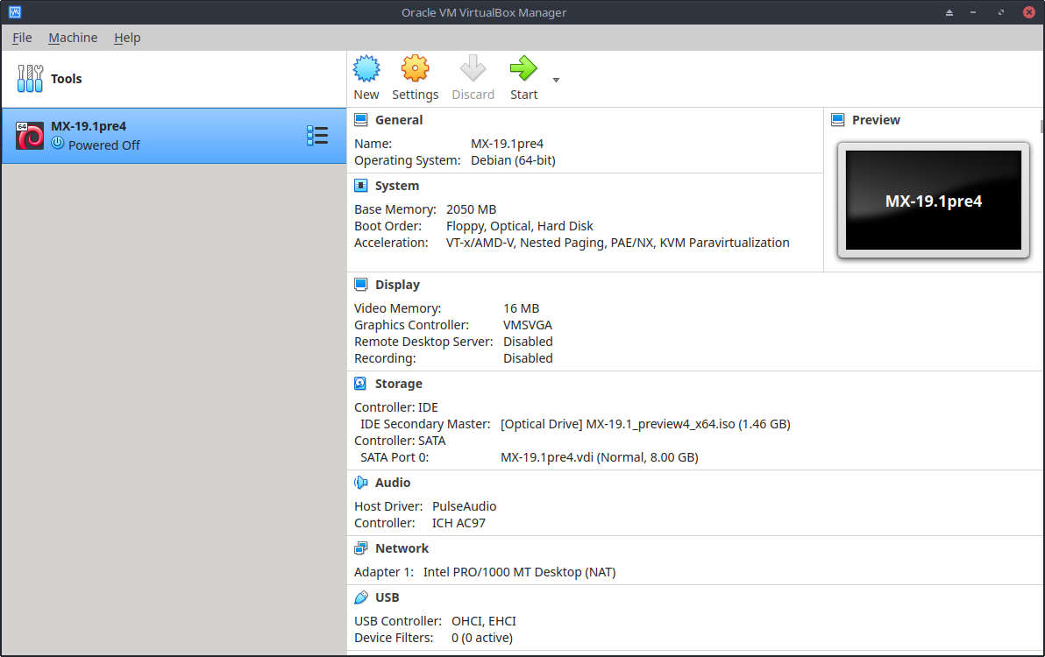

***Figure 6-3: Settings screen for MX-19.1 in VirtualBox***

#### Links

* [Wikipedia: Virtual Machine](http://en.wikipedia.org/wiki/Virtual_machine )
* [Wikipedia: Comparison of virtual machine software](http://en.wikipedia.org/wiki/Comparison_of_platform_virtualization_software )
* [VirtualBox home page](http://www.virtualbox.org/)
* [VirtualBox Extension Pack](http://www.virtualbox.org/wiki/Downloads )

## 6.3 Alternate Window Managers

***Figure 6-4: MATE running on top of MX-15 Linux, with YouTube Browser open***

A window manager (originally WIMP: Window, Icon, Menu, and Pointing device) in Linux is essentially the component which controls the appearance of [Graphical user interfaces](http://en.wikipedia.org/wiki/Window_manager) and provides the means by which the user can interact with them.

The three MX Linux versions use Xfce, KDE or Fluxbox by definition. But other possibilities exist for users. MX Linux makes it easy to install many popular alternatives through the MX Package Installer, as described below.

* Budgie Desktop, a simple and elegant desktop using GTK+
  + - [Budgie Desktop](https://budgie-desktop.org/home/)
* Compiz, an OpenGL WM with compositing.
  + [Compix Window Manager](https://en.wikipedia.org/wiki/Compiz" \l "External_links)
* Gnome Base, a GTK+ based display manager and desktop that provides an ultra-light desktop environment.
  + [Gnome Ultra (GOULD), an ultra-light desktop environment](http://sourceforge.net/projects/gould)
* KDE5 Standard, a very large and powerful environment adapted to the MX Linux environment. See the [MX/antiX Wiki](http://mxlinux.org/wiki/system/kde-on-mx-linux).
  + [KDE Home Page](http://www.kde.org/)
* LXDE is a fast and light desktop environment whose components can be installed separately.
  + [LXDE home page](http://lxde.org/)
* MATE is the continuation of GNOME 2 providing an intuitive and attractive desktop environment.
  + [MATE home page](http://mate-desktop.org/)
* IceWM is a very light-weight all-in-one desktop environment and stacking window manager.
  + [IceWM home page](https://ice-wm.org/)

Once installed, you can choose the window manager you want from the Session Button in the upper right corner of the top bar on the default login screen; log in to as you normally would. If you replace the login manager with another from the repos, make sure you always have at least one available upon reboot.

MORE: [Wikipedia: X Window Managers](http://en.wikipedia.org/wiki/Comparison_of_X_Window_System_desktop_environments)

## 6.4 Command Line

Although MX offers a complete set of graphical tools for installing, configuring, and using your system, the command line (also called the console, terminal, BASH, or shell) is still a useful and at times indispensable tool. Here are some common uses:

* Launch a GUI application to see its error output.
* Speed up system administration tasks.
* Configure or install advanced software applications.
* Execute multiple tasks quickly and easily.
* Troubleshoot hardware devices.

The default program to run a terminal in an MX desktop window is **XFCE Terminal**, which can be found at **Start Menu > System > Xfce Terminal (Terminal Emulator)**. Some commands are only recognized for super user (root), while others may vary the output depending on user.

To obtain temporary root permissions, use one of the methods described in Section 4.7.1. You will recognize when Xfce Terminal is running with root privileges by looking at the prompt line right before the space where you type. Instead of a **$**, you will see a **#**; in addition, the user name changes to **root** written in red.

NOTE: If you try to run as a regular user a command that requires root privileges such as **iwconfig**, you may receive an error message that the command was not found, see a message box that the program must be run as root, or simply find yourself at the prompt again with no message at all.

***Figure 6-5: User now has administrative (root) privileges***

### 6.4.1 First steps

* For more information on running Xfce Terminal for solving system problems, please refer to the topic **Troubleshooting** at the end of this section. Also, it is advisable to make backups of the files you are working on as a root user with the commands **cp** and **mv** (see below).
* Though terminal commands can be fairly complex, understanding the command line is just a matter of putting together simple things. To see how easy it can be, open Xfce Terminal and try a few basic commands. This will all make more sense if you do it as a tutorial exercise rather than just reading it. Let’s start with a simple command: **ls**, which lists the contents of a directory. The basic command lists the contents of whatever directory you are currently in:

ls

* That’s a useful command, but it’s just a few short columns of names printed across the screen. Suppose we want more information on the files in this directory. We can add a **switch** to the command to make it print out more information. A **switch** is a modifier we append to a command to change its behavior. In this case, the switch we want is:

ls -l

* As you can see on your own screen if you are following along, this switch provides more detailed information (especially about permissions) on the files in any directory.
* Of course, we might want to see the contents of another directory (without going there first). To do this, we add an **argument** to the command, specifying which file we want to look at. An **argument** is a value or reference we add to a command to target its operation. By giving an argument of **/usr/bin**/, we can list the contents of that directory, rather than the one where we currently are.

ls -l /usr/bin

* There are a lot of files in **/usr/bin**/! It would be nice if we could filter this output so that only entries that contained, say, the word “**fire**”would be listed. We can do this by **piping** the output of the **/ls/** command into another command, **grep**. The **pipe**, or │ character, is used to send the output of one command to the input of another. The command **grep** searches for the pattern you give it and returns all matches, so piping the output of the previous command to it filters the output.

ls -l /usr/bin | grep fire

* Finally, suppose we want these results saved in a text file for use at a later time. When we issue commands, the output is usually directed to the console display; but we can redirect this output somewhere else, such as to a file, using the **>** (redirect) symbol to instruct your computer to make a detailed list of all the files that contain the word “**fire**” in a particular directory (by default your Home directory, and to create a text file containing that list, in this case named “**FilesOfFire**”

ls -l /usr/bin | grep fire > FilesOfFire.txt

* As you can see, the command line can be used to perform complex tasks very easily by combining simple commands in different ways.

### 6.4.2 Common commands

#### Filesystem navigation

***Table 6: Filesystem navigation commands***

|  |  |
| --- | --- |
| ***Command*** | ***Comment*** |
| **cd /usr/share** | Changes current directory to the given path: “/usr/share”. With no argument, **cd** takes you to your home directory. |
| **pwd** | Prints the current working directory path |
| **ls** | Lists the contents of the current directory. Use the **-a** switch to show hidden files as well, and the **-l** switch to show details on all files. Often combined with other terms. **lsusb** lists all the usb devices, **lsmod** all the modules, etc. |

#### File management

***Table 7: File management commands***

|  |  |
| --- | --- |
| ***Command*** | ***Comment*** |
| **cp sourcefile destinationfile** | Copy a file to another filename or location. Use the **-R** switch (“**recursive**”) to copy entire directories. |
| **mv sourcefile destinationfile** | Move a file or directory from one location to another. Also used to rename files or directories and to make a backup: for example before changing a critical file such as **xorg.conf** you might use this command to move it to something like **xorg.conf\_bak**. |
| **rm filename** | Delete a file. Use the **-R** switch to delete a directory, and the **-f** switch (“**force**”) if you don’t want to be prompted to confirm each deletion. |
| **cat file.txt** | Prints the contents of a file on the screen. Only use on text files. |
| **grep** | Find a given string of characters in a given piece of text, and print the entire line it was on. Usually used with a pipe, e.g. cat **somefile.txt Ⅰ grep /somestring/** will display the line from somefile.txt that contains **somestring**. To find a network usb card, for instance, you could type: **lsusb | grep -i Network**. The grep command is case sensitive by default, so using the **-i** switch makes it case-insensitive. |
| **dd** | Copies anything bit by bit, so can be used for directories, partitions, and whole drives. Basic syntax is **dd if=<some file> of=<some other file>** |

#### Symbols

***Table 8: Symbols***

|  |  |
| --- | --- |
| ***Command*** | ***Comment*** |
| **|** | The pipe symbol used to send the output of one command to the input of another. Some keyboards show two short vertical bars instead |
| **>** | The redirect symbol, used to send the output of a command into a file of device. Doubling the redirect symbol will cause the output of a command to be added to an existing file rather than replacing it. |
| **&** | Adding the ampersand to the end of a command (with a space before it) causes it to run in the background so that you don’t have to wait for it to complete to issue the next command. Double ampersand indicates that the second command should only be run if the first has been successful. |

#### Troubleshooting

For most new Linux users, the command line is mainly used as a troubleshooting tool. Terminal commands give quick, detailed information that can be easily pasted into a forum post, search box, or email when seeking help on the web. It is strongly recommended that you keep this information at hand when asking for help. Being able to refer to your specific hardware configuration will not only speed up your process of obtaining help, but also it will let others offer you more accurate solutions. Here are some common troubleshooting commands (see also Section 3.4.4). Some of them may not output information, or not as much information unless you are logged in as root.

***Table 9: Troubleshooting commands***

|  |  |
| --- | --- |
| ***Command*** | ***Comment*** |
| **lspci** | Shows a quick summary of detected internal hardware devices. If a device shows as /unknown/, you usually have a driver issue. The **-v** switch causes more detailed information to be displayed. |
| **lsusb** | Lists attached usb devices. |
| **dmesg** | Shows the system log for the current session (i.e. since you last booted). The output is quite long, and usually this is piped through **grep**, **less** (similar to **most**) or **tail** (to see what happened most recently). For example, to find potential errors related to your network hardware, try **dmesg Ⅰ grep -i net**. |
| **top** | Provides a real-time list of running processes and various statistics about them. Also available from the Start menu as **Htop** along with a nice graphical version **Task Manager**. |

Accessing documentation for commands

* Many commands will print out a simple “usage information” message when you use the *--help* or *-h* switch. This can be helpful for quickly recalling the syntax of a command. For example: *cp --help*
* For more detailed information on how to use a command, consult the command’s man page. By default, man pages are displayed in the terminal’s **less** pager, meaning that only one screenful of the file is displayed at a time. Keep these tricks in mind to navigate the resulting screen:
  + The space bar (or PageDown key) advances the screen.
  + The letter **b** (or PageUp key) moves the screen backward.
  + The letter **q** exits the help document.

#### Alias

You can create an **alias** (personal command name) for any command, short or long, that you want; most easily done with the tool MX Bash Config. Details in the [MX/antiX Wiki](http://mxlinux.org/wiki/system/alias).

### 6.4.3 Links

* [BASH Beginners Guide](http://tldp.org/LDP/Bash-Beginners-Guide/html/index.html)
* [Command Line Basics](http://www.linuxcommand.org/)

## 6.5 Scripts

A script is a simple text file that can be written directly from a keyboard, and consists of a logically sequenced series of operating system commands. The commands are handled one at a time by a command interpreter which in turn requests services from the operating system. The default command interpreter in MX Linux is **Bash**. The commands must be understandable to Bash, and command lists have been established for programming use. A shell script is the Linux counterpart of batch programs in the Windows world.

Scripts are used throughout the Linux OS and applications that run on it as an economical method of executing multiple commands in an easily created and modified manner. During boot, for instance, many scripts are invoked to start up specific processes such as printing, networking, etc. Scripts are also used for automated processes, system administration, application extensions, user controls, etc. Finally, users of all kinds can employ scripts for their own purposes.

### 6.5.1 A simple script

Let’s do a very simple (and famous) script to get the basic idea.

1. Open your text editor (**Start Menu > Accessories**), and type:

#!/bin/bash  
clear   
echo Good morning, world!

1. Save that file in your home directory with the name **SimpleScript.sh**
2. Right-click the file name, select Properties, and check “Allow this file to run as a program” on the Permissions tab.
3. Open a terminal and type:

sh /home/<username>/SimpleScript.sh

1. The line “Good morning, world!” will appear on your screen. This simple script doesn’t do very much, but it does establish the principle that a simple text file can be used to send commands to control your system’s behavior.

NOTE: All scripts open with a [**shebang**](https://en.wikipedia.org/wiki/Shebang_(Unix)) as in the beginning of the first line: it is a combination of a hash sign (#), an exclamation point, and the path to the command interpreter. Here, Bash is the interpreter and it is found in the standard location for user applications.

### 6.5.2 A useful script

Let’s look at a useful script for the ordinary user that reduces all the moves involved in backing up multiple sets of files into a single keystroke. The script below relies itself on a system script called r**diff-backup** that would need to be installed from the repos for the script to work. It copies one directory to another, keeping a record of the differences in a special subdirectory so you can still recover files lost some time ago. (Incidentally, rdiff-backup relies in turn on a script called **diff**.)

In this example, a user named “newbie” wants to set up a script to back up documents, music, mail and pictures from the /home directory to an external drive.

 1 #!/bin/bash

 2 #

 3 # This Rdiff-Backup script backs up to a second hard drive

 4 # It must be run as root in order to mount the second hard drive

 5

 6 # To restore files, issue the command: cp -a /mnt/sda1/username /home

 7 # To restore, but not overwrite:

 8 # cp -a -i \SpecialChar nobreakdash\SpecialChar nobreakdash”reply=no /mnt/sda1/username /home

 9

 10 # Mount the external devices

 11

 12 mount /dev/sdb1

 13 mount /dev/sdb2

 14 mount /dev/sdb3

 15

 16 # Execute the backup

 17

 18 rdiff-backup /home/newbie/Documents /mnt/sdb2/Documents

 19 rdiff-backup /home/newbie/Music /mnt/sdb1/Music

 20 rdiff-backup /home/newbie/Mail /mnt/sdb2/Mail

 21 rdiff-backup /home/newbie/Pictures /mnt/sdb3/Pictures

 22

 23 # Unmount the external devices

 24

 25 umount /dev/sdb1

 26 umount /dev/sdb2

 27 umount /dev/sdb3

Now let’s look at this script’s components:

* Lines 2-8: a hash or number sign has been placed in front of these lines (called “commenting them out”) to indicate to Bash that they are not part of the sequence of commands to be executed. Their purpose here is to provide anyone who looks at this script with information about such things as the script’s origin, creator, purpose, and license (metadata).
* Line 10: good scripts separate the commands into clearly labeled procedural sections, also in lines 16 and 22.
* Lines 12-14: the three devices to be used for the backup have to first be mounted so they are available to the system.
* Lines 18-21: here bash is told to use the system script rdiff-backup to compare the original directories (sources) with the backup directories (targets), copy over the differences it finds, and keep a record of the changes.
* Lines 25-27: once the backup work is done, the external drives are unmounted from the system.

Anyone who wanted to use such a script would have to carry out a few execution steps:

1. Copy the whole script.
2. Right-click the desktop and select **Create New > Text file**...
3. Give the file a name that makes sense (no spaces, though), and add the “sh” extension so you will recognize it is a script. For this example, you might select **Backup\_DocsMusicMailPictures.sh**
4. Open the new text file and paste in the script.
5. Change any names, locations, etc. to what they are on your particular system. In the example above, you may well have different names and/or locations for the directories to be backed up, and different devices where they are supposed to go.
6. Save that script in a place you can easily find it when you need it, let’s say you make a new directory **/home/scripts** for it.
7. Right-click the script, select Properties, click on the Permissions tab, and check the **Is executable** box and click OK.
8. When you are ready to backup, open a terminal and type:

sh /home/scripts/Backup\_DocsMusicMailPictures.sh

**HINT**: use the tab key to autocomplete the file name after you type the first few letters.

**Links**

* [Bash Beguinners Guide](http://www.tldp.org/LDP/Bash-Beginners-Guide/html/Bash-Beginners-Guide.html)
* [Linux Shell Scripting Tutorial](http://www.freeos.com/guides/lsst)
* [Directory of Linux Commands](http://www.linuxdevcenter.com/linux/cmd/)

### 6.5.3 Special script types

Some scripts require special software ([scripting language](https://en.wikipedia.org/wiki/Scripting_language)) to run, rather than just launching them in Bash. The most common for regular users are Python scripts, which take the form \*.py.

To run them, you need to call python to carry out the execution providing the correct path. If you downloaded a python script named “tryme.py” to your Desktop, for instance, you could do one of three things:

* + Just click on it. MX Linux has a small program called Py-Loader that will launch it using python.
  + Open a terminal and type:

*python ~/Desktop/tryme.py*

* + Alternatively, you could open a terminal inside the folder itself, in which case you would type:

*python ./tryme.py*

Scripting languages are very advanced, and lie outside the scope of this Manual.

### 6.5.4 Pre-installed user scripts

The following scripts allow users to help keep their MX Linux installation up-to-date and running as a rolling release.

#### smxi

When run, smxi allows users to install a new kernel, install ATI and Nvidia graphics drivers, run apt-get upgrade or apt-get dist-upgrade safely, and lots more! Written by a programmer known as “[h2](http://smxi.org/)”, the script is pretty much self explanatory, but for usage options, execute *smxi -h*.

smxi must be run outside of the X window system (i.e., not from the desktop) for most functions.

* From your desktop:
  + Press *Ctrl-Alt-F1* to get to a terminal prompt.
  + Log in as root (“root” and password)
  + Run command:

*smxi*

* At boot:
  + Type e when on the GRUB menu to be able to edit it
  + Add “3” to the end of the kernel line in GRUB’s menu entry for MX Linux, just after the word “quiet”
  + The system will boot directly to the console.
  + Log in as “root” (without quotation marks) and supply the appropriate password
  + Run command:

smxi

smxi will ask a series of questions the first time it is run, including which system options you want to run. The following options are recommended:

* continue-no-changes
* apt-get
* apt-get dist-upgrade

After smxi has completed its operations it will ask if you want to restart the desktop. **NOTE**: Running smxi -G in a root terminal while inside a running X session allows certain features of smxi to run, such as removing unwanted kernels etc.

[smxi home page](http://smxi.org/)

[smxi documentation](http://smxi.org/docs/)

#### sgfxi

This h-2 script runs inside smxi or separately, and deals with installing graphical drivers. Sgfxi currently supports ATI, fglrx and Nvidia drivers. It also supports converting from or to xorg free drivers like ati, intel, or nv. Follow the procedure above to start the script, replacing smxi with sgfxi.

Sgfxi requires a working internet connection! Some wireless internet connections may be dropped when operating outside of X. If this applies to your internet connection either temporarily switch over to a wired internet connection before proceeding or use the ’Partial install in X, completion outside of X method’ instructions in the next section below.

The sgfxi script automatically downloads and installs the kernel headers and everything else it needs. Then it downloads the binary graphic driver installers from either Nvidia or ATI, prepares system, installs, then sets up **xorg.conf**, all in a fairly clean, reasonably intuitive way. Plus it updates itself so any new drivers released will be installed. Finally, sgfxi allows you to easily switch between proprietary non free drivers like ATI’s fglrx and Nvidia’s nvidia driver and the free xorg drivers.

NOTE: running sgfxi on an nvidia chipset system will remove **ddm-mx**, the software package used by the MX Tools installers, so you need to reinstall it if you wish to use it.

[sgfxi manual](http://smxi.org/docs/sgfxi-manual.htm)

#### inxi

A third script from h-2 included in MX Linux is inxi, a convenient command-line system information script. Enter *inxi -h* in a terminal to see all the options available, which include an entire range from sensor output to the weather. This is the command running behind MX Quick System Info.

MORE: [MX/antiX Wiki](https://mxlinux.org/wiki/antix-faqs-applications/guide-smxisgfxiinxi)

### 6.5.5 Tips and tricks

* Double-clicking a shell script opens it in the Featherpad editor by default instead of running the script. This is by design as a security measure to prevent accidentally running scripts when you didn't intend to. To change that behavior, click Settings > Mime Type Editor. Locate *x-application/x-shellscript* and change the default application to bash.
* A more advanced editor for programming scripts is [geany](https://www.geany.org/), installed by default. It is a decent, GUI, lightweight, cross-platform, flexible and powerful [IDE](https://en.wikipedia.org/wiki/Integrated_development_environment)/editor.

## 6.6 Advanced MX Tools

In addition to the configuration MX Apps discussed in Section 3.2, MX Linux includes utilities for the advanced user available from MX Tools.

### 6.6.1 Chroot rescue scan (CLI)

A set of commands that allow you to get into a system even if its initrd.img is broken. It also let’s you get into multiple systems without rebooting. Details and images in the HELP file.

HELP: [here](https://mxlinux.org/wiki/system/chroot-rescue-scan/).

### 6.6.2 Live-usb kernel updater (CLI)

[Change your kernel on an antiX or MX live-USB](https://www.youtube.com/watch?v=UWvwbwTGOZ8&t=2s)

**WARNING**: for use in a Live session only!

This command line application can update the kernel on an MX LiveUSB with any kernel that has been installed. This application will only show in MX Tools when running a Live session.

***Figure 6-6: The live-usb kernel updater tool ready to switch to a new kernel***

HELP: [here](https://mxlinux.org/wiki/help-files/help-live-usb-kernel-updater).

### 6.6.3 MX Live Usb maker

Use to create a live-usb starting from an iso file, a live -cd/dvd or an existing live-usb or even a running live system. Although UNetbootin is also available by default (see Section 2.2.3), live-usb maker has a number of advantages:

* It is faster.
* Saves state files across reboots
* LiveUSB-Storage for saving files directly on the live-usb
* Persistence
* Remastering
* Now offers [dd](https://en.wikipedia.org/wiki/Dd_(Unix)) option
* Live kernel updating

**NOTE**: the CLI form (**live-usb-maker**, run as root) offers many advanced options.



***Figure 6-7: The live-usb maker tool ready to select the ISO to use***

HELP: [here.](https://mxlinux.org/wiki/help-files/help-live-usb-maker)

### 6.6.4 Live remaster/persistence (RemasterCC)

[Make a snapshot of an installed system](https://www.youtube.com/watch?v=ExVkxXcVDAw)

[MX-17: make a live-USB with persistence](https://www.youtube.com/watch?v=2vF_dw6Kpo8)

[MX-17: install apps on a live-USB with persistence](https://www.youtube.com/watch?v=6BsCx1-v3Ro)

**NOTE:** this application will only show in MX Tools when running a Live session.

#### Remaster

**WARNING**: for use in a Live session only!

The primary purpose of live remastering is to make it as safe, easy, and convenient as possible for users to make their own customized version of MX Linux that can be distributed to other computers.

The idea is that you use a LiveUSB (or a LiveHD, a "frugal install;" see the [MX/antiX Wiki](https://mxlinux.org/wiki/system/frugal-installation)) to a hard drive partition as the development and testing environment. Add or subtract packages and then when you are ready to remaster, use a simple remaster script or GUI to do the remaster and then reboot. If something goes horribly wrong, simply reboot again with the rollback option and you will boot into the previous environment.

MX Community members use Live remastering to produce unofficial spins, such the set of tools known as Workbench.

[MX 16 - Remaster your Live-USB](https://www.youtube.com/watch?v=LpI_a4xPKdM)

[MX Spins: Workbench!](https://www.youtube.com/watch?v=zwLz2vLc_qg)

[MX Spins: Stevo's KDE!](https://www.youtube.com/watch?v=87Qb3_S8dGA)

#### **Persistence**

**WARNING**: for use in a Live session only!

**WARNING**: may fail with large upgrades that can overwhelm the RAM. Alternative procedures are available.

* Carry out the upgrade in stages, using small (e.g., 200MB) amounts each time
* Wait for the next monthly snapshot, and reinstall. Make sure to copy any non-system folders off the stick beforehand

[Live USB with persistence (legacy mode)](https://www.youtube.com/watch?v=RC4SmhsG3K0)

[Live USB with persistence (UEFI mode)](https://www.youtube.com/watch?v=DJmukS-bSxw)

Persistence is a hybrid between a LiveMedium and a full install; it allows you to retain any files you install or add during a live session. Programs installed or removed from, and customizations to, the "demo" user files during live persistence will be carried over to the installed system.

***Figure 6-8: The remaster and persistence tool***

HELP: [here.](https://mxlinux.org/wiki/help-files/help-live-remasterpersistence-remastercc)

### 6.6.5 Snapshot

This tool makes a copy of your running system and creates an ISO from it.

The ISO can be put on a LiveMedium in the usual manner (see Section 2.2). To then install from the LiveMedium, open a root terminal and enter the command: *minstall*.

***Figure 6-9: Opening screen of Snapshot***

HELP: [here.](https://mxlinux.org/wiki/help-files/help-mx-save-system-iso-snapshot)

## 6.7 SSH

[SSH (Secure Shell)](http://en.wikipedia.org/wiki/Secure_Shell) is a protocol used to securely log onto remote systems. It is the most common way to access remote Linux and Unix-like computers. MX Linux comes with the main packages necessary to run SSH in active mode, the main one being OpenSSH, a free implementation of the Secure Shell that consists of a whole suite of applications.

* Start or restart the ssh daemon as root with the command:

/etc/init.d/ssh start

* To start the ssh daemon automatically when the computer starts, click **All Settings > Session and Startup > Application Autostart**. Click the Add button, then in the dialog box insert a name such as StartSSH, a short description if you want, and the command

/etc/init.d/ssh start

Press OK and you are done. The next time you restart, the SSH daemon will be active.

* KDE users on MX Linux can do the same using **Preferences > Settings > Start & Stop > Automatic Start**.

### 6.7.1 Troubleshooting

Occasionally, SSH does not work in passive mode, sending a message of denied connection. Then you can try the following:

* Edit as root the file ’/etc/ssh/sshd-config’. About line 16 you will find the parameter ’UsePrivilegeSeparation yes’. Change that to

 UsePrivilegeSeparation no

* Add yourself (or the intended users) to the group ’ssh’ using MX User Manager or editing as root the file /etc/group.
* Sometimes the certificates can be missing or outdated; an easy way to rebuild them is to run (as root) the command

 ssh-keygen -A

* Check if sshd is running by typing

 /etc/init.d/ssh status

The system should answer ’[ ok ] sshd is running.’

* If you are using a firewall, check that port 22 is not blocked. It must allow IN and OUT traffic.

MORE: [Openssh manual](http://www.openssh.com/manual.html)

## 6.8 Synchronization

[File synchronization](https://en.wikipedia.org/wiki/File_synchronization) (or syncing) allows files in different locations to remain identical. It takes one of two forms:

* one-way (“mirroring”), where one source computer is copied to others but not the reverse
* two-way, where multiple computers are kept identical

For instance, MX Linux users find it handy when managing multiple installations for themselves, family members or other groups, thus eliminating the need to update more than once. There is a large amount of [syncing software](https://en.wikipedia.org/wiki/Comparison_of_file_synchronization_software) available, but the following two have tested and proved useful to MX Linux users:

* [unison-gtk](https://www.cis.upenn.edu/~bcpierce/unison/) (in the repos)
* [FreeFileSync](https://www.freefilesync.org/)

# 7 Under the hood

## 7.1 Introduction

MX Linux ultimately inherits its fundamental design from Unix, an operating system that has been around in various forms since 1970, much earlier than MS Windows. From that Linux was developed, from which Debian produces its distribution. The base operating system is the topic of this section. Users coming from MS Windows typically find a lot of unfamiliar concepts, and get frustrated trying to do things the way they are accustomed to doing them.

This section will give you a conceptual overview of some basic aspects of MX Linux, and how they differ from other systems to help ease your transition.

**Links**

* [Wikipedia: Unix](http://en.wikipedia.org/wiki/Unix)
* [Linux Home Page](http://www.linux.org/)
* [Wikipedia Debian](http://en.wikipedia.org/wiki/Debian)

## 7.2 The file system structure

There are two basic uses of the term “file system”.

* The first is the Operating System’s Filesystem. This refers to the files and their organization that the operating system uses to keep track of all the hardware and software resources it has as its disposal while running.
* The other use of the term file system refers to the Disk Filesystem, designed for the storage and retrieval of files on a data storage device, most commonly a disc drive. The Disk Filesystem is set when the disk partition is first formatted, prior to writing any data on the partition.

### The Operating System’s Filesystem

If you If you open Thunar and click on File System in the left pane, you will notice a number of directories with names based on the [Unix Filesystem Hierarchy Standard](https://refspecs.linuxfoundation.org/FHS_3.0/fhs/index.html).

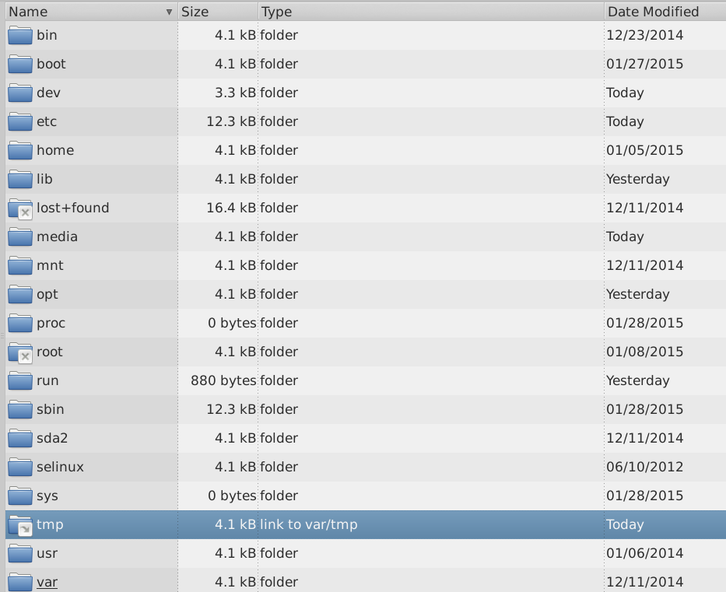

Figure 7-1: The MX filesystem viewed in Thunar

Here is a simple description of the major directories in MX Linux along with an example of when users commonly work with files in those directories:

* /bin
  + This directory contains binary program files which are used by the system during startup, but which also may be required by user actions once the system is fully up and running.
  + Example: Many basic command-line programs, such as the Bash shell, and utilities like /dd/, /grep/, /ls/, and /mount/ are located here, in addition to programs only used by the OS.
* /boot
  + As you might guess, files that Linux needs to boot are located here. The Linux kernel, the core of the Linux operating system, is kept here, as are bootloaders such as GRUB.
  + Example: no file here is commonly accessed by users.
* /dev
  + In this directory are special files that link to the various input/output devices on the system.
  + Example: no file here is commonly accessed directly by users, except in CLI mounting commands.
* /etc
  + This directory contains configuration files for the system as well as application configuration files.
  + Example: The file /etc/fstab specifies mount points for additional filesystems on devices, partitions, etc. that can be configured for your optimal use.
  + Example: display problems sometimes involve editing the file /etc/X11/xorg.conf.
* /home
  + Here the user’s personal directories (data and settings) reside. If there is more than one user, a separate subdirectory is set up for each. No user (except root) can read another user’s home directory. The user’s directory contains both hidden (where the filename is preceded by a dot) and visible files; hidden files can be revealed by clicking View >Show Hidden Files (or Ctrl-H) in Thunar.
  + Example: users typically organize their own files at first by using default directories such as Documents, Music, etc.
  + Example: a Firefox profile is located in the hidden directory .mozilla/firefox/
* /lib
  + This directory contains shared object libraries (analogous to Windows DLL’s) that are required at boot time. In particular, kernel modules will be found here, under /lib/modules.
  + Example: no file here is commonly accessed by users.
* /media
  + Files for removable media such as CDroms, floppy drives, and USB memory sticks are installed here when the media are automounted.
  + Example: After dynamically mounting a peripheral device like a flash drive, you may access it here.
* /mnt
  + Physical storage devices must be mounted here before they can be accessed. After drives or partitions are defined in the file /etc/fstab, then their file system is mounted here.
  + Example: Users can access drives and partitions mounted here.
* /opt
  + This is the intended location of major third-party application subsystems installed by the user.
  + Example: if you install Google Earth, this is where it will be installed. Some distros also place user-installed programs in /opt subdirectories.
* /proc
  + The location for process and system information
  + Example: no file here is commonly accessed by users
* /root
  + This is the home directory for the root user (administrator). Note that this is not the same as “/” the file system root.
  + Example: no file here is commonly accessed by users, but files saved while logged in as the root user may be saved here.
* /sbin
  + Programs are installed here if they are required by the system startup scripts but will not normally be run by users, other than root—in other words, system administration utilities.
  + Example: no file here is commonly accessed by users, but this is where files like modprobe and ifconfig are located.
* /tmp
  + This is the location of temporary files produced by programs—such as compilers—as they run. In general, these are short-term temporary files, of use to a program only while it is running.
  + Example: no file here is commonly accessed by users.
* /usr
  + This directory contains many files for user applications, and is analogous in some ways to the Windows directory “Program Files”.
  + Example: many executables are located in (/usr/bin)
  + Example: documentation (/usr/docs) and configuration files, graphics and icons are in (/usr/share).
* /var
  + This directory contains files that are constantly changing while Linux is running, e.g. logs, system mail and queued processes.
  + Example: you can look in /var/log/ when trying to determine what happened during a process such as installing a package.

### The Disk Filesystem

The disk file system is something about which the average user does not need to be much concerned. The default disk file system used by MX Linux is called ext4, a version of the ext2 file system that is journaled —i.e., it writes changes to a log before enacting them, rendering it more robust. The file system ext4 is set during installation when your hard drive is formatted.

By and large, ext4 has more years on its track record than any of its rivals, and combines stability and speed; for these reasons, we do not recommend installing MX Linux onto a different disk file system unless you are well-educated in the differences. However, MX Linux can read and write to many other formatted disk filesystems, and may even be installed on some of them, if for some reason one of them is preferred over ext4.

**Links**

* [Wikipedia Filesystem](http://en.wikipedia.org/wiki/File_system)
* [Wikipedia. Comparison of filesystems](http://en.wikipedia.org/wiki/File_system)
* [Wikipedia Ext4](http://en.wikipedia.org/wiki/Ext4)

## 7.3 Permissions

MX Linux is an account-based operating system. This means that no program can run without a user account to run under, and any running program is thereby limited by the permissions granted to the user who started it.

NOTE: Much of the security and stability that Linux is known for hinges on the proper use of limited user accounts, and the protection provided by default file and directory permissions. For this reason, you should operate as root only for a procedure that requires it. Never log into MX Linux as root to run the computer for normal activities–running a web browser as root user, for instance, is one of the few ways you could get a virus on a Linux system!

### Basic information

The default file permissions structure in Linux is fairly simple, but more than adequate for most situations. For each file or folder, there are three permissions that can be granted, and three entities (owner/creator, group, others/world) to which they are granted. The permissions are:

* Read permission means that data can be read from the file; it also means the file can be copied. If you don’t have read permission for a directory you can’t even see the names of files listed in it.
* Write permission means that the file or folder can be changed, appended, or deleted. For directories, it specifies whether a user can write to files in the directory.
* Execute permission means whether or not the user can run the file as a script or program. For directories, it determines whether or not the user can enter and make it the current working directory. Every file and folder acquires a single user designated as its owner when it is created on the system. (Note that if you move a file from another partition where it has a different owner, it will keep the original owner; but if you copy and paste it, it will be assigned to you.) It also has a single group designated as its group, by default the group to which the owner belongs. The permissions you grant to others affect everyone who isn’t the owner or in the owning group.

NOTE: For advanced users, there are additional special attributes beyond read/write/execute that can be set: sticky bit, SUID, and SGID. For more information, see Links section below.

#### Viewing, setting and changing permissions

There are many tools available in MX Linux to view and manage permissions.

* GUI
  + Thunar. To view or change a file’s permissions, right-click the file and select Properties. Click the Permissions tab. Here you can set the permissions granted to the owner, group, and others using the pull-down menus. For some files (like scripts , for instance), you need to check the box to make them executable, and for folders you can check a box to limit the deletion of files inside it to the owners.
  + NOTE: you must be operating as root to change the permission of a file or directory whose owner is root. On bigger folders you MUST refresh your Thunar window or else the permissions will show incorrectly, even though the permissions have actually changed. Just hit F5 to refresh the window or else you will see the original permissions.
  + MX User Manager is an easy way to change permissions by associating a user with specific groups.
* CLI
  + Internal partitions. By default, the root/superuser password is required to mount internal partitions. To change this behavior, click on MX Tweak, Other tab.
  + New external partitions. Formatting a new partition with ext4 requires root permissions, which can lead to unexpected or undesired result of the regular user not being able to write any files to the partition. To change this behavior, consult [the MX/antiX Wiki](https://mxlinux.org/wiki/system/format-ext4-filesystem-be-owned-regular-user).
  + Manual operations. Although MX User Manager covers most daily situations, sometimes it can be preferable to deal with the command line. Basic permissions are represented by r (read), w (write) and x (execute); a dash indicates no permissions. To view permissions of a file on the command line, type this: *ls -l NameofFile*. You may need to use the full location of the file (e.g., /usr/bin/gimp). The -l switch will cause the file to be listed in long format, displaying its permissions among other information.

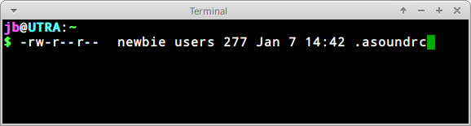

Figure 7-2: Viewing file permissions

The characters right after the opening dash (indicating it is a regular file) contain the three permissions (read/write/execute) for owner, group and others: 9 characters total. Here it shows that the owner has read and write but not execute (rw-), but the group and others can only read. The owner in this case is specified to be “newbie” who belongs to the group “users”.

If for some reason it was necessary to change the ownership of this file to root using the command line, you would use the chown command like in this example:

*chown root /home/newbie/.asoundrc*

For details on using chown, as well as the more detailed chmod, see Links section.

**Links**

* [MX/antiX Wiki: Permissions](https://mxlinux.org/wiki/system/permissions)
* [File Permissions](http://www.linux.com/learn/tutorials/309527-understanding-linux-file-permissions)

## 7.4 Configuration files

### 7.4.1 User config files

Files that hold individual user settings (such as high scores for your games, or the layout of your desktop) are stored within a Users home directory, typically as a hidden file or directory, and can only be edited by that user or by root. These personal configuration files are actually less often edited directly than system files because most of the user configuration is done graphically through the applications themselves. When you open an application and click Edit > Preferences, for example, your selections are written to a (usually hidden) configuration file in your user directory. Likewise in Firefox, when you type about:config in the address bar, you are editing the hidden configuration files. The Xfce configuration files are stored in ~/.config/.

### 7.4.2 System config files

Files that hold system-wide configurations or defaults (such as the file that determines which services automatically launch during boot up) are largely stored in the /etc/ directory and are only editable by root. Most of these files are never touched directly by regular users, such as these for instance:

* */etc/rc.d/rc5.d* — Contains files to control runlevel 5 into which MX Linux boots after login.
* */etc/sysconfig/keyboard* — Used to configure the keyboard.
* */etc/network/interfaces* — Defines internet interfaces on the system.

Some configuration files can contain just a few lines, or even be empty, while others may be quite long. The important point is that if you are looking for a configuration file for an application or process, head for the /etc directory and look around. Caution: because these files affect the whole system, 1) back up any file you intend to edit (easiest in Thunar: copy and paste back in, adding BAK at the end of the file name), and 2) be very careful!

### 7.4.3 Example

Sound problems can be solved with a number of graphical and command-line tools, but once in a while a user needs to edit directly the system-wide configuration file. For many systems, this will be */etc/modprobe.d/snd-hda-intel.conf*. It is a simple file whose top paragraph looks like this:

*# some chips require that the model be set manually  
 # for example asus g71 series may need model=g71v*

*options snd-hda-intel model=auto*

To try to get sound, you might decide to substitute the exact information about the sound model in place of the word “auto”. To find out your sound model, you could open a terminal and type:

*lspci | grep Audio*

The output will depend on the system, but it will take the following form:

*00:05.0 Audio device: nVidia Corporation MCP61 High Definition Audio (rev a2)*

Now you can plug that information back into the configuration file:

# some chips require that the model be set manually  
 # for example asus g71 series may need model=g71v  
 options snd-hda-intel model=nvidia

You would save the file, reboot the machine, and hopefully your sound should be working. You could also try more precision by using *model=nvidia mcp61* instead, if the first did not work.

Links

* [Understanding Linux Configuration Files](https://mxlinux.org/wiki/system/permissions)
* [File Permissions](http://www.linux.com/learn/tutorials/309527-understanding-linux-file-permissions)

## 7.5 Runlevels

MX Linux boots up by default using sysVinit. (A different method, systemd, is also present as an option; it does not use runlevels in the same manner.) After completing the boot process, init executes all startup scripts in a directory specified by the default runlevel (this runlevel is given by the entry for id in /etc/inittab). Like most other Linux versions, MX Linux has 7 runlevels:

Table 10: Runlevels in MX Linux

|  |  |
| --- | --- |
| **Runlevel** | **Comment** |
| 0 | Halt the system |
| 1 | Single-user mode: provides a root console without logon.  Useful if you lose your root password |
| 2 | Multiuser with no network |
| 3 | Console logon, no X (i.e. no GUI) |
| 4 | Not used/custom |
| 5 | Default GUI logon |
| 6 | Reboot the system |

MX Linux defaults to runlevel 5, therefore any init scripts set up in the level 5 config file will run at boot.

#### Use

Understanding runlevels can be handy. When users have a problem with X Window Manager, for instance, they can not correct it on the default runlevel 5, because X is running on that level. But they can get to runlevel 3 to work on the problem in one of two ways.

* From the Desktop: press Ctrl-Alt-F1 to get out of X. To actually drop to runlevel 3, become root and type *telinit 3*; this will stop all the other services still operating on runlevel 5.
* From the GRUB menu: press **e** (for edit) when you see the GRUB screen. On the subsequent screen, add a space and the number 3 at the end of the line (by default where the word „quiet” is) that starts with “linux” located one above the lowest line (the actual boot command). Press F-10 to boot.

Once the cursor is at a prompt, login with your normal username and password. If necessary, you can also login as “root” and provide the administrative password. Useful commands when you are looking at the prompt on runlevel 3 include:

Table 11: Common runlevel 3 commands

|  |  |
| --- | --- |
| **Command** | **Comment** |
| runlevel | Returns the number of the runlevel you are on. |
| halt | Run as root. Shuts the machine down. If that does not work on your system, try poweroff. |
| reboot | Run as root. Reboots the machine. |
| <application> | Runs the application, as long as it is not graphical. For instance, you can use the command nano to edit text files, but not leafpad. |
| Ctrl-Alt-F7 | If you used Ctrl-Alt-F1 to drop out from a running desktop but did not continue down to runlevel 3, this command brings you back to your desktop. |
| telinit 5 | Run as root. If you are on runlevel 3, enter this command to get to the login manager lightdm. |

NOTE: these commands may change in the future if MX Linux switches to a new system manager.

**Links**

* [Wikipedia: Runlevel](http://en.wikipedia.org/wiki/Runlevel)
* [The Linux Information Project: Runlevel Definition](http://www.linfo.org/runlevel_def.html)

## 7.6 The kernel

### 7.6.1 **Introduction**

This Section covers common user-centered interactions with the kernel. Consult the Links for other, more technical aspects

### 7.6.2 Upgrading/Downgrading

#### Basic

Unlike other software on your system, the kernel is not upgraded automatically except below the minor revision level (indicated by the third number in the kernel name). Before you change your current kernel, you would do well to ask yourself some questions:

* Why do I want to upgrade the kernel? Is there a driver I need for new hardware, for instance?
* Should I downgrade the kernel? For example, Core2 Duo processors tend to have odd issues with the default MX-Linux kernel that are solved by switching to the default Debian 4.9 kernel (using MX Package Installer).
* Am I aware that unnecessary changes might bring problems of one kind or another?

MX Linux provides an easy method of upgrading/downgrading the default kernel: open MX Package Installer and click on the “Kernel” category. There you will see a number of kernels that are available to the user. Select the one you want to use (ask on the Forum if unsure) and install it.

Once you check and install the new kernel, reboot and make sure the new kernel is highlighted; if not, click on the options line and select what you want.

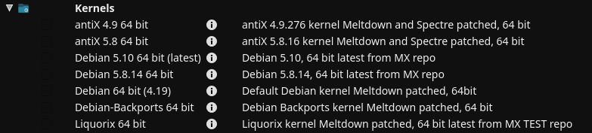

Figure 7-3: Kernel options in MX Package Installer for 64bit architecture

#### Advanced

Here is a basic approach for manually upgrading the Linux kernel on your system.

* First, find out what you currently have installed. Open a terminal and enter *inxi S*. For instance, a user of MX-19 64 bit version might see something like this:

Kernel: 5.8.0-2-amd64 x86\_64 bits

Be sure to write down the name of the kernel from the output of that command.

* Second, select and install a new kernel. Open Synaptic, search on linux-image and look for a higher kernel number that matches the architecture (e.g., 686) and processor (e.g., PAE) that you already have, unless you have a good reason to change. Install the one you want or need in the usual manner.
* Third, install the linux-headers package that match the new kernel you selected. There are two methods of doing this.
  + Look carefully at the Synaptic entries beginning linux-headers and match the kernel.
  + Alternatively, you can install the headers more easily after rebooting into the new kernel by typing the following code in a root terminal:

*apt-get install linux-headers-$(uname -r)*

Headers will also be installed if you use a command such as *m-a prepare*.

* When you reboot, you should automatically boot into the highest available kernel. If it doesn’t work, you have the option to return to what you were using: reboot, and when you see the GRUB screen highlight Advanced Options for whatever partition you want to boot into, then select the kernel and press Enter.

### 7.6.3 Kernel upgrade and drivers

[Dynamic Kernel Module Support (DKMS)](https://en.wikipedia.org/wiki/Dynamic_Kernel_Module_Support) automatically recompiles all DKMS driver modules when a new kernel version is installed. This allows drivers and devices outside of the mainline kernel to continue working after a Linux kernel upgrade. The exception concerns proprietary graphics drivers (Section 3.3.2).

* NVidia drivers
  + If installed with sgfxi, they must be rebuilt with sgfxi, see Section 6.5.3
  + If installed with the MX Nvidia driver installer or via synaptic/apt-get, the kernel modules may need to be rebuilt. Re-running MX Nvidia driver installer from the menu should offer to reinstall and rebuild the modules. If your reboot gets stuck at a console prompt, become root and enter "*ddm-mx -i nvidia*" to reinstall and rebuild the driver modules.
* Intel drivers
  + You may need to upgrade the driver, depending on the kernel you select for upgrade target.

### 7.6.4 More options

Other considerations and choices exist with respect to kernels:

* Other pre-rolled kernels exist such as the Liquorix kernel, which is a version of the Zen kernel and is intended to provide a better desktop use experience in terms of responsiveness, even under heavy loads such as during gaming, plus low latency (important for audio work). MX Linux updates the Liquorix kernels frequently, so it is most easily installed through the MX Package Installer, in the Kernel section.
* Distros (e.g., MX’s sister distro antiX) often roll their own.
* Knowledgeable individuals may compile a specific kernel for particular hardware.

### 7.6.5 Links

* [Wikipedia: Linux kernel](http://en.wikipedia.org/wiki/Linux_kernel)
* [Anatomy of the Linux kernel](http://www.ibm.com/developerworks/library/l-linux-kernel)
* [Linux kernel archives](http://www.kernel.org/)
* [Interactive map of Linux kernel](http://www.makelinux.net/kernel_map)

### 7.6.6 Kernel panic and recovery

A kernel panic is a relatively rare action taken by the MX Linux system when it detects an internal fatal error from which it can not safely recover. It can be caused by a number of different factors that range from hardware problems to a bug in the system itself. When you get a kernel panic, try rebooting with the MX Linux LiveMedium, which will overcome temporarily any software problems and hopefully allow you to see and offload your data. If that doesn’t work, then unplug all unnecessary hardware and try again.

Your first concern is to access and secure your data. Hopefully, you have it backed up somewhere. If not, you can use one of the data recovery programs such **ddrescue** that is supplied with MX Linux. Your last resort is to take your hard drive to a professional recovery business.

There are a number of steps you might have to take to recover a functional MX Linux system once you have your data safe, although ultimately you may have to reinstall using the LiveMedium. Depending on the type of failure, the following steps may be undertaken:

1. Remove packages that broke the system.
2. Reinstall the graphic driver.
3. Reinstall GRUB using MX Boot Repair.
4. Reset the root password.
5. Reinstall MX Linux, selecting the check box on Screen 2 to keep /home so that your personal configurations will not be lost.

Be sure to ask on the Forum if you have any questions about these procedures.

**Links**

* [GNU C Library Home Page](http://www.gnu.org/software/libc)
* [Ddrescue](http://www.forensicswiki.org/wiki/Ddrescue)

## 7.7 Our positions

### **7**.7.1 Systemd

MX Linux ships with two [init](https://en.wikipedia.org/wiki/Init) systems: SysVinit (default) and [systemd](https://en.wikipedia.org/wiki/Systemd). Because the use of the ”systemd” as a system and service manager has been controversial, we want to be clear about its function in MX Linux: **systemd is included but not enabled.** You can scan your MX system and discover files bearing *systemd\** names, but those simply provide a compatibility hook/entrypoint when needed.

MX Linux uses *systemd-shim*, which emulates the systemd functions that are required to run the helpers without actually using the service. This means that SysVinit remains the default init yet MX Linux can use Debian packages that have systemd dependencies such as CUPS and Network Manager. This approach also allows the user to retain the ability to choose his/her preferred init at boot by selecting the systemd entry.

### **7**.7.2 Non-free software

MX Linux is fundamentally user-oriented, so includes a certain amount of [non-free software](https://www.gnu.org/philosophy/categories.en.html) to assure that the system works out of the box as much as possible. The user can see a list by opening a [console or terminal](https://fossbytes.com/difference-between-shell-console-terminal/) and typing:

*vrms*

Examples:

* The “wl” driver (broadcom-sta) and non-free firmware with proprietary components.
* A dedicated tool for installing Nvidia graphic drivers.
* Adobe Flash Player (distributed by permission).

Our rationale: it is much easier for advanced users to remove these drivers than it is for regular users to install them. And it's particularly difficult to install a driver for a network card without Internet access!

# 8 Glossary

Linux terms can be confusing and offputting at first, so this Glossary provides a list of the ones used in this Manual to get you started.

* **applet**: A program designed to be executed from within another application. Unlike an application, applets can not be executed directly from the operating system.
* **backend**: Also /back-end./ The backend includes the various components of a program that process the user input entered through the frontend. See also frontend.
* **backport**: Backports are new packages that have been recompiled to run on a released distribution in order to keep it up-to-date.
* **BASH**: The default shell (command-line interpreter) on most Linux systems as well as on Mac OS X, BASH is an acronym for Bourne-again shell.
* **BitTorrent**: Also/bit torrent/ or /torrent./ A method invented by Bram Cohen to distribute large files without the need for a single individual to provide the hardware, hosting and bandwidth resources required.
* **boot block**: An area of a disk outside the MBR having information for loading the operating system that is needed to start a computer.
* **bootloader**: Program that initially chooses an operating system to load after the BIOS has finished initializing the hardware. Extremely small in size. the bootloader’s only job is to hand control of the computer over to the Operating System’s kernel. Advanced bootloaders offer a menu to choose between several installed operating systems.
* **chainloading**: Also /chain loading./ Instead of directly loading an operating system, a boot manager like GRUB can use chain loading to pass control from itself to a boot sector on a hard disk partition. The target boot sector is loaded in from disk (replacing the boot sector from which the boot manager itself was loaded) and the new boot program is executed. In addition to when it is necessary, as in booting Windows from GRUB, the advantage to chainloading is that each operating system on the hard disk drive —and there could be dozens— can be responsible for having the correct data in it’s own boot sector. So GRUB residing in the MBR need not be rewritten every time there are any changes. GRUB can simply chainload the relevant information from the boot sector of a given partition whether it has changed or remained the same since the last boot time.
* **cheat code**: Codes can be entered when booting a LiveMedium to change the booting behavior. They are used to pass options to the MX Linux operating system to set parameters for particular environments.
* **command line interface (CLI)**: Also known as console, terminal, command prompt, shell, or bash. This is a UNIX-style text interface, which MS-DOS was also designed to resemble. A root console is one where administrative privileges have been acquired after entering the root password.
* **desktop environment**:The software which provides a graphical desktop (windows, icons, desktop, task bar, etc) for an operating system user.
* **disk image**: A file containing the complete contents and structure of a data storage medium or device such as a hard drive or DVD. See also ISO.
* **Distribution**: A Linux Distribution, or **distro**, is a particular packaging of the Linux kernel with various GNU software packages, and different desktops or window managers. Since—unlike the proprietary code used in the Microsoft and Apple OS’s—GNU/Linux is Free, Open-Source Software, literally anyone in the world who has the ability can freely build on what has been done and innovate a new vision of a GNU/Linux operating system. MX Linux is a distro based on the Debian Linux family.
* **file system**: Also file system. This refers to the way that files and folders are logically arranged on a computer’s storage devices so they may be found by the operating system. It can also refer to the type of formatting on a storage device, such as the common Windows formats NTFS and FAT32, or the Linux formats ext3, ext4 or ReiserFS, and in this sense refers to the method actually used to encode binary data on the Hard Disk Drive, floppy, flash drive, etc.
* **firmware**. The small programs and data structures that internally control the electronic components
* **free-as-in-speech**: The English word “free” has two possible meanings: 1) without cost, and 2) without restrictions. In part of the open-source software community, an analogy used to explain the difference is 1) “free” as in beer vs. 2) “free” as in speech. The word /freeware/ is used universally to refer to software that is simply without cost, whereas the phrase /free software/ loosely refers to software that is more properly called open-source software, licensed under some type of open source license.
* **frontend**: Also front-end. The frontend is the part of a software system that interacts directly with the user. See also backend.
* **GPL**: The GNU General Public License. This is a license under which many open-source applications are released. It specifies that you may view, modify, and redistribute the source code of applications released under it, within certain limits; but that you may not distribute the executable code unless you also distribute the source code to anyone who asks for it.
* **GPT:** A partitioning scheme used by native UEFI
* **Graphical User Interface (GUI)**: This refers to a program or operating system interface that uses pictures (icons, windows, etc), as opposed to text (command-line) interfaces.
* **home directory**: One of the 17 top-level directories branching from the root directory in MX Linux, /home contains a subdirectory for every registered user of the system. Within each Users home directory s/he has full read-write privileges. Further, most of the user-specific configuration files for various installed programs are stored in hidden subdirectories within the /home/username/ directory—as is downloaded email. Other downloaded files usually go by default into the home/username/Documents or /home/username/Desktop subdirectories.
* **IMAP**: The Internet Message Access Protocol is a protocol that allows an e-mail client to access a remote mail server. It supports both on-line and off-line modes of operation.
* **interface**: A point of interaction between computer components, often referring to the link between a computer and a network. Examples of interface names in MX Linux include **WLAN** (wireless) and **eth0** (basic wired).
* **IRC**: Internet Relay Chat, an older protocol to render the exchange of text messages easier.
* **ISO**: A disc image following an international standard that contains data files and file system metadata, including boot code, structures, and attributes. This is the normal method for delivering Linux versions such as MX Linux over the Internet. See also **disk image**.
* **kernel**: The layer of software in an operating system that interacts directly with the hardware.
* **LiveCD/DVD**: A bootable compact disc from which one can run an operating system, usually with a complete desktop environment, applications, and essential hardware functionality.
* **LiveMedium**: a general term that includes both LiveCD/DVD and LiveUSB.
* **LiveUSB**: A USB flash drive on which an operating system has been loaded in such a way that it can be booted and run. See LiveDVD.
* **mac address**: a hardware address that uniquely identifies each node (connection point) of a network. It is formed of a string of usually six sets of two-digits or characters, separated by colons.
* **man page**: Short for **manual**, man pages typically contain detailed information about switches, arguments, and sometimes the inner workings of a command. Even GUI programs often have man pages, detailing available command line options. Available in Start menu by typing a # before the name of the man page you want into the Search box, for example: *#pulseaudio*.
* **MBR**: Master Boot Record: the first 512-byte sector of a bootable hard disk drive. Special data written to the MBR enables the computer’s BIOS to pass the boot process off to a partition with an installed operating system.
* **md5sum**: A program that calculates and verifies a file’s data integrity. The MD5 hash (or checksum) functions as a compact digital fingerprint of a file. It is extremely unlikely that any two non-identical files will have the same MD5 hash. Because almost any change to a file will cause its MD5 hash to also change, the MD5 hash is commonly used to verify the integrity of files.
* **mirror**: Also mirror site. An exact copy of another Internet site, commonly used to provide multiple sources of the same information to supply reliable access to large downloads.
* **module**: Modules are pieces of code that can be loaded and unloaded into the kernel upon demand. They extend the functionality of the kernel without the need to reboot the system.
* **mountpoint**: The place on the root file system where a fixed or removable device is attached (mounted) and accessible as a subdirectory. All computer hardware needs to have a mountpoint in the file system to be usable. Most standard devices such as keyboard, monitor and your primary hard disk drive are mounted automatically at boot.
* **mtp**: MTP stands for Media Transfer Protocol and operates at the file level so that your device doesn’t expose its entire storage device. Older Android devices used USB mass storage for transferring files back and forth with a computer.
* **NTFS®**: Microsoft’s New Technology File System debuted in 1993 on the Windows NT Operating System, geared to business networks, and with revisions entered the mainstream Windows user’s desktop computers in later versions of Windows 2000. It has been the standard file system since Windows XP was introduced in late 2001. Unix/Linux-oriented folk say it stands for “Nice Try File System”!
* **open-source**: Software whose source code has been made available to the public under a license that allows individuals to modify and redistribute the source code. In some cases, open-source licenses restrict the distribution of binary executable code.
* **package**: A package is a discrete, non-executable bundle of data that includes instructions for your package manager about installation. A package doesn’t always contain a single application; it might contain only part of a large application, several small utilities, font data, graphics, or help files.
* **package manager**: A package manager such as (Synaptic or Gdebi) is a collection of tools to automate the process of installing, upgrading, configuring, and removing software packages.
* **Panel**: The highly configurable panel in Xfce4 appears by default at the left side of the screen and contains navigation icons, open programs and system notifications.
* **Partition Table**: A partition table is a hard disk architecture that expands on the older Master Boot Record (MBR) partitioning scheme using globally unique identifiers (GUID) to enable the existence of more than the original four partitions.
* **persistence**: the ability when running a LiveUSB to retain changes made during a live session.
* **port**: A virtual data connection that can be used by programs to exchange data directly, instead of going through a file or other temporary storage location. Ports have numbers assigned for specific protocols and applications, such as 80 for HTTP, 5190 for AIM, etc.
* **purge**: A command that removes not only the package named, but also any configuration and data files associated with it (though not those in a user’s home directory).
* **repo**: A shortened form of repository.
* **repository**: A software repository is an internet storage location from which software packages may be retrieved and installed via a package manager.
* **root**: Root has two common meanings in a UNIX/Linux OS; they are intimately connected, but the distinction is important to understand.
  + The **root file system** is the basic logical structure of all the files the operating system can access, whether programs, processes, pipes or data. It should follow the Unix Filesystem Hierarchy Standard, which specifies where in the hierarchy to locate all types of files.
  + The **root user** who owns the root file system —and so has all permissions necessary to do anything to any file. While it is sometimes necessary to temporarily assume the powers of the **/root user/** to install or configure programs, it is dangerous and violates the basic security structure of Unix/Linux to log in and operate as /root/ unless absolutely necessary. In a command line interface, a regular user can temporarily become root by issuing the command **su** then entering the root password.
* **runlevel**: A runlevel is a preset operating state on a Unix-like operating system. A system can be booted into any of several runlevels, each of which is represented by a single digit integer. Each runlevel designates a different system configuration and allows access to a different combination of processes (i.e., instances of executing programs). See Section 7.5.
* **script**: An executable text file, containing commands in an interpreted language. Usually refers to BASH scripts which are used extensively “under the hood” of the Linux operating system, but other languages may be used as well.
* **session**: A login session is the period of activity between a user logging in and logging out of a system. In MX Linux, this typically indicates the lifetime of a particular user “process” (the program code and its current activity) that Xfce invokes.
* **SSD**: A solid-state drive (SSD) is a nonvolatile storage device that stores persistent data on solid-state flash memory.
* **source code**: The human-readable code in which software is written prior to being assembled or compiled into machine-language code.
* **switch**: A switch (also /flag/, /option/ or /parameter/) is a modifier appended to a command to change its behavior. A common example is **-R** (recursive), which tells the computer to carry out the command through all subdirectories.
* **symlink**: Also symbolic link and soft link. A special type of file that points to another file or directory and not to data. It allows the same file to have different names and/or locations.
* **tarball**: An archiving format, like zip, popular on the Linux platform. Unlike zip files, though, tarballs may use one of a number of different compression formats, such as gzip or bzip2. They usually end in file extensions like .tgz, .tar.gz, or .tar.bz2.

Many archive formats are supported in MX with a graphical application called Archive Manager. Usually an archive can be extracted simply by right-clicking on it in Thunar.

* **(U)EFI:** Unified Extensible Firmware Interface is a kind of system firmware used on recent machines. It defines a software interface between an operating system and platform firmware, and represents the successor of old BIOS.
* **Unix**: Also UNIX. The operating system which Linux is modeled after, developed in the late 1960’s at Bell Labs and used primarily for servers and mainframes. Like Linux, Unix has many variations.
* **UUID (Universally Unique IDentifier)**. A universally unique identifier (UUID) is a 128-bit number that identifies unique Internet objects or data.
* **window manager**: A component of a desktop environment that provides the basic maximize/minimize/close/move functions for windows in the GUI environment. Sometimes it can be used as an alternative to a full desktop environment. In MX Linux, the default window manager is Xfce4.
* **X**: Also X11, xorg. The X Window System is a networking and display protocol which provides windowing on bitmap displays. It provides the standard toolkit and protocol to build graphical user interfaces (GUIs) on Unix-like operating systems and OpenVMS, and is supported by almost all other modern operating systems.